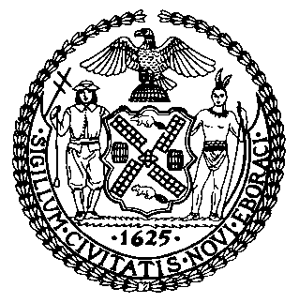 | The Council of the City of New York  Finance Division  Latonia Mckinney, Director  Fiscal Impact Statement  Proposed Int. No. 1209-A  Committee: Criminal Justice
Title: To amend the administrative code of the city of New York, in relation to requiring the department of correction to utilize doula services | Sponsors: By Council Members Rosenthal, Ampry-Samuel, Cornegy, Ayala, Yeger, Lander, Gennaro, Gibson, Cumbo, Koslowitz, Rivera, Brooks-Powers, Riley, Louis and Barron
Summary of Legislation: Proposed Int. No. 1209-A would require the Department of Correction (“DOC”) to retain an organization to provide doula services to incarcerated individuals twice a week, as well as during labor and delivery. DOC would be required to issue a report every six months regarding the delivery of doula services. The bill would also create a working group to review relevant reports and discuss ways to improve communication, collaboration, and efficiency related to pregnant individuals in custody.

Effective Date: This local law would take effect in 120 days.
Fiscal Year In Which Full Fiscal Impact Anticipated: Fiscal 2023
Fiscal Impact Statement:

 | Effective FY22 | FY Succeeding  Effective FY23 | Full Fiscal  Impact FY23
Revenues (+) | $0 | $0 | $0
Expenditures (-) | $0 | $0 | $0
Net | $0 | $0 | $0

Impact on Revenues: It is anticipated that there would be no impact on revenues resulting from the enactment of this legislation.
Impact on Expenditures: It is estimated that there would be no fiscal impact as a result of this legislation. Although DOC estimated that the fiscal impact of enacting the legislation would be $55,453, the Council estimates that there would be no impact on expenditures as the Department could use existing resources to comply with the requirements of the legislation.
Source of Funds To Cover Estimated Costs: N/A.
Source of Information: New York City Council Finance Division
New York City Department of Correction

Estimate Prepared by: Jack Storey, Financial Analyst

Estimate Reviewed by: Regina Poreda Ryan, Deputy Director
Eisha Wright, Unit Head
Stephanie Ruiz, Assistant Counsel

Legislative History: This legislation was introduced to the Council on October 31, 2018, as Intro. No. 1209 and was referred to the Committee on Criminal Justice (Committee). A hearing was held by the Committee, jointly with the Committee on Women and Gender Equity on April 27, 2021, and the bill was laid over. The legislation was subsequently amended and the amended legislation, Proposed Int. No. 1209-A will be considered by the Committee at a hearing on August 26, 2021. Upon successful vote by the Committee, Proposed Int. No. 1209-A will be submitted to the full Council for a vote on August 26, 2021.

Date Prepared: August 23, 2021

