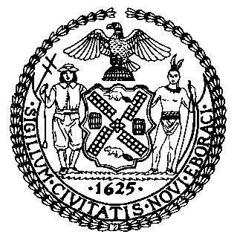 | The Council of the City of New York  Finance Division  Latonia Mckinney, Director  Fiscal Impact Statement  Proposed Intro. No: 2298-A  Committee: Consumer Affairs and Business Licensing
Title: A Local Law to amend the administrative code of the city of New York, in relation to the agreements between third-party food delivery services and food service establishments and the provision of toilet facility access to food delivery workers | Sponsor(s): Council Member Rivera, the Public Advocate (Mr. Williams), Menchaca, Chin, Louis, Ayala, Lander, Rosenthal, Van Bramer, Reynoso, Gjonaj and Brannan
Summary of Legislation: Proposed Int. No. 2298-A would require that the food delivery apps include a provision in the written agreements they are required to execute with the establishments they list on their platforms
include a provision requiring that a toilet facility is available for the use of food delivery workers lawfully on such establishment’s premises to pick up such establishment’s food or beverage for consumer delivery, except where access to such facilities would require walking through the establishment’s kitchen, food prep area, storage area or utensil washing area, when accessing the toilet facility would create an obvious health and safety risk to the food delivery worker or to the establishment; or in other cases identified by the Department of Consumer and Worker Protection (DCWP) through promulgated rules.

Effective Date: This bill would take effect on the same date as Int. 1897-A, in relation to the licensing of third-party food delivery services, takes effect. DCWP may promulgate rules or take any other necessary measures to implement the bill before it takes effect.

Fiscal Year In Which Full Fiscal Impact Anticipated: Fiscal 2023
Fiscal Impact Statement:

 | Effective FY22 | FY Succeeding  Effective FY23 | Full Fiscal  Impact FY23
Revenues | $0 | $0 | $0
Expenditures | $0 | $0 | $0
Net | $0 | $0 | $0

Impact on Revenues: It is anticipated that the enactment of this legislation would not generate any revenue.

Impact on Expenditures: It is estimated that there would be no impact on expenditures resulting from the enactment of this legislation because agencies responsible for implementing this legislation would be able to use existing resources.

Source of Funds To Cover Estimated Costs: N/A

Source of Information: New York City Council Finance Division

Estimate Prepared by: Florentine Kabore, Financial Analyst

Estimate Reviewed by: John Russell, Unit Head
Noah Brick, Assistant Counsel
Nathan Toth, Deputy Director

Legislative History: This legislation was introduced to the Council on April 29, 2021 as Int. No. 2298 and was referred to the Committee on Consumer Affairs and Business Licensing (Committee). The Committee held a hearing on June 8, 2021 and the legislation was laid over. The bill was subsequently amended, and the amended version, Proposed Int. No. 2289-A, will be heard by the Committee on September 2,3 2021. Upon successful vote by the Committee, the bill will be submitted to the full Council for a vote on September 23, 2021.
Date Prepared: September 21, 2021

