Health Committee Staff
Harbani Ahuja, Legislative Counsel
Sara Liss, Senior Legislative Counsel
Em Balkan, Senior Legislative Policy Analyst
Lauren Hunt, Finance Analyst
Brook Frye, Data Analyst

Hospital Committee Staff
Harbani Ahuja, Legislative Counsel
Em Balkan, Senior Legislative Policy Analyst
Lauren Hunt, Finance Analyst
Rachael Alexandroff, Data Analyst

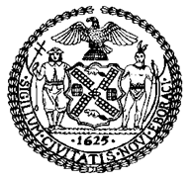

The Council of the City of New York

COMMITTEE REPORT OF THE HUMAN SERVICES
Jeffrey Baker, Legislative Director
Andrea Vazquez, Deputy Director, Human Services Division

COMMITTEE ON HEALTH
Hon. Mark Levine, Chair

COMMITTEE ON HOSPITALS
Hon. Carlina Rivera, Chair

September 30, 2021

Oversight – Vaccine Hesitancy and Equity in NYC

INT. NO. 2373: By Council Members Salamanca, Yeger, Brannan, Ampry-Samuel, Riley, Van Bramer, Lander, Rosenthal, Brooks-Powers, Powers, Koo, Dinowitz, Rivera, Rose, Adams, Koslowitz, D. Diaz, Dromm, Moya and Ayala

TITLE: A Local Law to amend the administrative code of the city of New York, in relation to amending death certificates for deaths caused by COVID-19

ADMINISTRATIVE CODE: Adds a new section 17-169.1

Introduction
On September 30, 2021, the Committee on Health, chaired by Council Member Mark Levine, and the Committee on Hospitals, chaired by Council Member Carlina Rivera, will hold a joint hearing on vaccine hesitancy and equity in New York City. The Committees will hear Introduction Number 2373 (Int. No. 2373), sponsored by Council Member Salamanca, in relation to amending death certificates for deaths caused by COVID-19. Among those invited to testify are representatives from the New York City Department of Health and Mental Hygiene (DOHMH) and other members of the Administration, advocates, and other interested parties.
Background
Vaccination Rates in New York City
On December 14, 2020, Nurse Sandra Lindsey became the first person in the United States to receive the COVID-19 vaccine in a non-clinical trial, when she received the vaccine at New York’s Long Island Jewish Medical Center. New York City began the first portion of Phase 1a of vaccine distribution that same day, which included high-risk hospital staff, affiliates, volunteers, and contract staff. Today, all individuals in New York City age 12 and over are eligible to receive a vaccine for COVID-19.
As of July 2021, three in ten adults were unvaccinated nationally and about 14 percent of adults say they will “definitely not” get a COVID-19 vaccine. As of September 27, 2021, 69.1% of New York City residents of all ages have received at least one dose of a vaccine, while 82% of adult New Yorkers have received at least one dose, and of those 65 and older, 82% have received at least one dose. The breakdown of those vaccinated by borough is as follows:
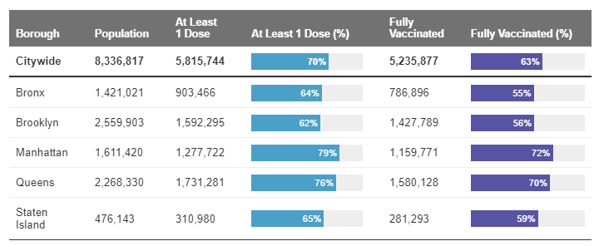
DOHMH, COVID-19 Data

DOHMH also collects vaccination data, disaggregated demographically, including by race/ethnicity, age, and sex, as follows:

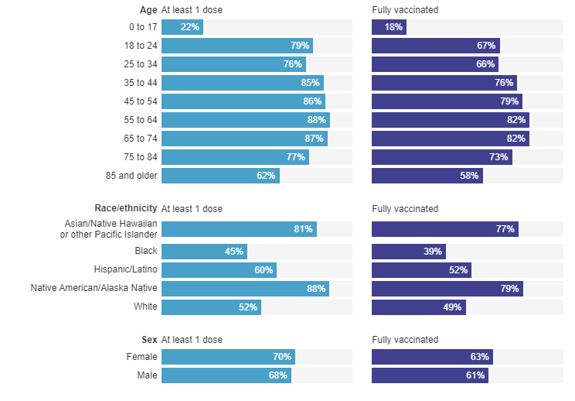
DOHMH, COVID-19 Data
This data is further reported and disaggregated by borough, age and NYC residency. DOHMH has qualified this data by explaining that when a person gets vaccinated, they self-report their race/ethnicity, sex, location and other demographic data, or the information can be collected from electronic health records. However, some vaccination records do not include race/ethnicity data, and while the CDC requires this data be reported, it has not always been a requirement and is inconsistently reported. Additionally, the number of people vaccinated in some demographic groups and ZIP codes may exceed the total estimated population of that group or area, which is more likely to occur with smaller groups. In such instances, DOHMH reports the group as 99% vaccinated. Finally, DOHMH population counts are from 2019 and do not reflect the most recent 2020 Census.
Vaccination rates in New York City can also be further broken out by professional sector. For example, more than a third of New York City’s municipal workforce is still holding out on getting a vaccine. According to data provided by the Mayor’s office, as of September 7, 2021, only 65 percent of city workers, or approximately 239,000 people, had received at least one dose of the vaccine. Dr. Denis Nash, an epidemiology professor at CUNY, stated that there seems to be a lot of vaccine hesitancy in the city worker population, and it appears that a large swath of city workers, from first responders to public housing employees, are willing to opt for weekly testing rather than getting vaccinated. The breakdown of vaccination rates by a list of 47 city agencies showed a wide range, from the highest level—92 percent of the Conflicts of Interest Board—to the lower 44 percent of the City’s Sanitation Department. One worrisome trend is the coverage among the city’s first responders, who tend to have frequent contact with the public: 57 percent of fire department employees have received one dose, while the rate for emergency management workers is 54 percent, and the rate for NYPD employees is 53 percent. Even amongst the city’s healthcare workers, only 77 percent of Department of Health and Mental Hygiene staffers and 77 percent of city hospital workers were vaccinated. The Department of Education, whose 143,000 employees are also required to be immunized, has a vaccination rate of 72 percent. A spokesman for the mayor’s office noted that the city’s data on municipal employee vaccinations does not include workers who were vaccinated outside the city, meaning that the numbers were a “conservative” estimate. On September 28, 2021, President and CEO Dr. Mitchell Katz of NYC Health + Hospitals (H+H), which runs 11 public hospitals across the five boroughs, stated that to date, more than 91 percent of NYC H+H workers are vaccinated.
Some unions have opposed the vax-or-test rule, many of them arguing that the Mayor should have consulted them first. Henry Garrido, president of the union DC37, stated that while they encourage everyone to get vaccinated and support measures to ensure their members’ health and wellbeing, weekly testing was “clearly subject to mandatory bargaining.” The United Federation of Teachers (UFT) and the Mayoral administration have also been in discussions after a complaint was filed with the Public Employment Relations Board saying the city refused to accommodate teachers who cannot be vaccinated because of medical or religious reasons. According to Michael Mulgrew, president of the union, “The city has backed off its initial position that teachers with medical and religious exemptions to the vaccine be removed from payroll. But there are still many details of how these exemptions will be applied—and how other teachers unwilling to take the vaccine will be treated—that are now being worked through.”
Vaccination Hesitancy and Equity in New York City
According to the World Health Organization (WHO), vaccination hesitancy refers to “delay in acceptance or refusal of vaccines despite availability of vaccine services,” is “complex and context specific varying across time, place and vaccines,” and is “influenced by factors such as complacency, convenience and confidence.” Vaccine hesitancy has existed since the advent of vaccines, and certainly since before the COVID-19 pandemic. In 2019, the WHO listed vaccine hesitancy among the top 10 threats to global health because it “threatens to reverse progress made in tackling vaccine-preventable diseases.” To combat hesitancy, the WHO suggests that “Health workers, especially those in communities, remain the most trusted advisor and influencer of vaccination decisions, and they must be supported to provide trusted, credible information on vaccines.” The causes and reasons for vaccine hesitancy are varied: The WHO has cited the degree of “trust in vaccines, healthcare systems, and policy makers (confidence), a perception of low risks from disease (complacency, which paradoxically arises because effective vaccines lead to low disease risk in the first place), and access challenges (convenience) as reasons for vaccine hesitancy.” According to a survey conducted by Carnegie Mellon University and the University of Maryland in a collaboration with Facebook: 70% of vaccine-hesitant adults are worried about potential side effects of COVID-19 vaccines. The Centers for Disease Control and Prevention (CDC) have identified other factors beyond safety, including a reliance on a “wait and see” approach, a lack of trust in the government, and concerns about the speed at which COVID-19 vaccines were developed.
Additionally, for many communities of color, immigrant communities, and religious communities, vaccine hesitancy has been attributed to a history of racist or discriminatory medical experimentation by the government, fostered by ongoing discrimination against people of color in the health care system and other barriers that limit access. Such health inequities exist in New York City – according to DOHMH:
Differences in health outcomes and vaccination coverage among racial and ethnic groups are due to long-term structural racism, not biological or personal traits. Structural racism — centuries of racist policies and discriminatory practices across institutions, including government agencies, and society — prevents communities of color from accessing vital resources (such as health care, housing and food) and opportunities (such as employment and education), and negatively affects overall health and well-being. The disproportionate impact of COVID-19 on New Yorkers of color highlights how these inequities negatively influence health outcomes.
Still, vaccine hesitancy cannot simply be drawn along racial or ethnic lines; the issue is also largely related to political beliefs, and people who are not vaccinated are not a monolith. According to the Kaiser Family Foundation (KFF), vaccine hesitation can be divided into those with a “wait and see” attitude, and those who will “definitely not” get vaccinated. Four in ten of those in the “wait and see” group are people of color while 50% are White adults, while those who say they will “definitely not” get a COVID-19 vaccine overwhelmingly are White adults (65% of the group). Political identification also plays a major role with more than half (58%) of the “definitely not” group identifying as Republican or Republican-leaning. In addition, religious identity also plays a role as White Evangelical Christians make up nearly twice the share of the “definitely not” group (32%) as the “wait and see” group. In New York City, there is also a discrepancy of vaccination rate between boroughs, with 79% of Manhattan residents and 76% of Queens residents having received at least one dose, while only 64% of Bronx, 62% of Brooklyn, and 65% of Staten Island residents have gotten at least one dose.
While this issue remains incredibly complicated and nuanced, any approach that seeks to scapegoat, vilify, or put down those that are unvaccinated seems destined to fail. DOHMH has implemented an “Equity Action Plan” to advance equitable policies and practices in the City’s COVID-19 response, utilizing focused messaging and increased engagement with community and health care partners in neighborhoods with a disproportionate burden of COVID-19 cases, hospitalizations, and deaths. The Equity Action Plan uses a “racial justice framework” and “population-specific strategies” to better reach community members. The plan has three parts:
- Engage with health care providers;
- Engage with community partners; and
- Communicate with the community.
The Committees look forward to learning more about this plan and other methods that the City is utilizing in addressing vaccine hesitancy and inequity.
Bill analysis
Int. No. 2373, in relation to amending death certificates for deaths caused by COVID-19
This bill would require the Department of Health and Mental Hygiene to waive the $40 fee for applicants requesting to amend a death certificate to list the cause of death as COVID-19 or health complications caused by COVID-19.
This bill would take effect immediately.

Int. No. 2373

By Council Members Salamanca, Yeger, Brannan, Ampry-Samuel, Riley, Van Bramer, Lander, Rosenthal, Brooks-Powers, Powers, Koo, Dinowitz, Rivera, Rose, Adams, Koslowitz, D. Diaz, Dromm, Moya and Ayala

A Local Law to amend the administrative code of the city of New York, in relation to amending death certificates for deaths caused by COVID-19

Be it enacted by the Council as follows:

Section 1. Chapter 1 of title 17 of the administrative code of the city of New York is amended by adding a new section 17-169.1 to read as follows:
§ 17-169.1 Amending death certificates; certain fees prohibited. a. Definitions. As used in this section, the term “COVID-19” means the disease caused by the severe acute respiratory syndrome coronavirus 2 (SARS-CoV-2).
b. Deaths caused by COVID-19. The department shall not charge a fee to an applicant applying to amend a death certificate where such amendment would change the cause of death to COVID-19 or health complications caused by COVID-19.
§ 2. This local law takes effect immediately.

JEF
LS #17943
7/21/2021

Today, there are three COVID-19 vaccines available in the United States: Pfizer-BioNTech, Moderna, & Johnson & Johnson / Janssen. For more information, see: https://www.cdc.gov/coronavirus/2019-ncov/vaccines/different-vaccines.html
See, e.g., “NYC Nurse Is Among The 1st To Get COVID-19 Vaccine In The U.S.,” NPR, Dec. 14, 2020, available at https://www.npr.org/2020/12/14/946253331/new-york-city-nurse-among-the-first-to-get-coronavirus-vaccine-in-the-u-s.
“Guidance for Facilities, Providers, and Local Health Departments Receiving COVID-19 Vaccine Weeks 1-5 New York State Vaccination Program Phase 1A Only,” NYS DOH, available at https://coronavirus.health.ny.gov/system/files/documents/2021/01/guidance_facilitiesreceivingcovid19vaccineweeks1-5.pdf.
New York City Department of Health and Mental Hygiene, “COVID-19: Vaccine.” Accessed at: https://www1.nyc.gov/site/doh/covid/covid-19-vaccine-eligibility.page
Id.
NYC DOHMH, COVID-19: Data, available at https://www1.nyc.gov/site/doh/covid/covid-19-data-vaccines.page.
Id.
Id.
Id.
Id.
Id.
Id.
Id.
Id.
Elizabeth Kim, Despite 'Vax-Or-Test' Order, One Third Of NYC Workforce Has Not Been Vaccinated, Gothamist, Sept. 9, 2021, https://gothamist.com/news/despite-vax-or-test-order-one-third-nyc-workforce-has-not-been-vaccinated.
Id.
Id.
Id.
Id.
Id.
Id.
Id.
Id.
More NY Health Workers Get Vaccinated, Others Lose Jobs or Pay as Hochul Deadline Hits, NBC New York, Sept. 28, 2021, https://www.nbcnewyork.com/news/coronavirus/more-ny-health-workers-get-vaccinated-as-hochul-deadline-looms/3295558/.
Elizabeth Kim, supra note 15.
Id.
Christina Veiga, NYC, teachers union continue negotiations over COVID vaccine mandate, Chalkbeat New York, Sept. 8, 2021, https://ny.chalkbeat.org/2021/9/8/22663061/nyc-teachers-union-negotiations-covid-vaccine-mandate.
Id.
Id.
“Vaccine Hesitancy: what it means and what we need to know in order to tackle it,” WHO, available at https://www.who.int/immunization/research/forums_and_initiatives/1_RButler_VH_Threat_Child_Health_gvirf16.pdf.
“Vaccine hesitancy: More than a pandemic,” Edward Chen, Harvard University, June 29, 2021 available at https://sitn.hms.harvard.edu/flash/2021/vaccine-hesitancy-more-than-a-pandemic/.
“Ten threats to global health in 2019,” WHO, available at https://www.who.int/news-room/spotlight/ten-threats-to-global-health-in-2019.
Id.
“Vaccine hesitancy: More than a pandemic,” Edward Chen, Harvard University, June 29, 2021 available at https://sitn.hms.harvard.edu/flash/2021/vaccine-hesitancy-more-than-a-pandemic/.
Id.
Id.
Id.
NYC DOHMH, COVID-19: Data, available at https://www1.nyc.gov/site/doh/covid/covid-19-data-vaccines.page.
“COVID-19 Vaccine Monitor,” KFF, available at https://www.kff.org/coronavirus-covid-19/dashboard/kff-covid-19-vaccine-monitor-dashboard/.
Id.
Id.
Id.
See, e.g., “America Is Getting Unvaccinated People All Wrong,” Ed Yong, The Atlantic, July 22, 2021, available at https://www.theatlantic.com/health/archive/2021/07/unvaccinated-different-anti-vax/619523/.
“Overview of the NYC Department of Health and Mental Hygiene’s COVID-19 Equity Action Plan,” DOHMH, available at https://www1.nyc.gov/assets/doh/downloads/pdf/imm/covid-19-equity-action-plan.pdf.
“Overview of the NYC Department of Health and Mental Hygiene’s COVID-19 Equity Action Plan,” DOHMH, available at https://www1.nyc.gov/assets/doh/downloads/pdf/imm/covid-19-equity-action-plan.pdf.
“Overview of the NYC Department of Health and Mental Hygiene’s COVID-19 Equity Action Plan,” DOHMH, available at https://www1.nyc.gov/assets/doh/downloads/pdf/imm/covid-19-equity-action-plan.pdf.

