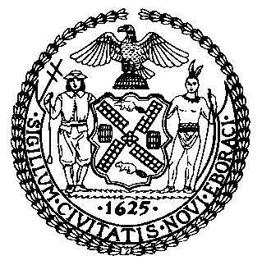 | The Council of the City of New York  Finance Division  Latonia Mckinney, Director  Fiscal Impact Statement  Proposed Intro. No: 2141-A  Committee: Mental Health, Disabilities and Addiction
Title: A Local Law amend the New York city charter and the administrative code of the city of New York, in relation to removing outdated clinical language, and to repeal paragraph 2 of subdivision a of section 555 of such charter in relation to a report on the establishment of the department of health and mental hygiene | Sponsors: Council Members Rivera, Kallos, Louis, Rosenthal and Chin
Summary of Legislation: In 2010, Congress passed Rosa’s Law, which changed references to “mental retardation” in specified federal laws to “intellectual disability,” in recognition of the fact that the term “mental retardation” is archaic, insensitive and stigmatizing, and clinically outdated. With respect to the City’s consolidated laws, the term “mental retardation” appears in 10 sections across the Charter and the Administrative Code. Proposed Intro. No. 2141-A bill would remove references to “mental retardation” and substitute the term “intellectual disability” or “intellectual and developmental disability,” as applicable, in such sections.

Effective Date: This local law would take effect immediately.

Fiscal Year In Which Full Fiscal Impact Anticipated: Fiscal 2023
Fiscal Impact Statement:

 | Effective FY22 | FY Succeeding Effective FY23 | Full Fiscal Impact FY23
Revenues | $0 | $0 | $0
Expenditures | $0 | $0 | $0
Net | $0 | $0 | $0

Impact on Revenues: It is anticipated that the proposed legislation would have no impact on revenues.

Impact on Expenditures: It is anticipated that there would be no impact on expenditures resulting from the enactment of Proposed Intro No. 2141-A as the designated agency would utilize existing resources to comply with the requirements of this legislation.

Source of Funds To Cover Estimated Costs: N/A
Source of Information: New York City Council Finance Division
Department of Health and Mental Hygiene
Estimate Prepared By: Lauren Hunt, Financial Analyst

Estimate Reviewed By: Nathan Toth, Deputy Director
Crilhien R. Francisco, Unit Head
Stephanie Ruiz, Assistant Counsel
Legislative History: This legislation was introduced to the full Council on October 29, 2020 and was referred to the Committee on Mental Health, Disabilities and Addiction (Committee). A hearing was held by the Committee, jointly with the Committee on Hospitals, on December 3, 2021, and the bill was laid over. The legislation was subsequently amended and the amended version, Proposed Intro. No. 2141-A, will be considered on December 8, 2021. Upon a successful vote by the Committee, Proposed Intro. No. 2141-A will be submitted to the full Council for a vote on December 09, 2021.
Date Prepared: December 2, 2021

