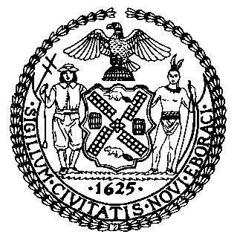 | The Council of the City of New York  Finance Division  Latonia Mckinney, Director  Fiscal Impact Statement  Proposed Intro. No: 2426-A  Committee: Committee on Education
Title: A Local Law in relation to requiring the Department of Education to report on school attendance, vaccination, testing consent, and quarantine data related to COVID-19, and providing for the repeal of such provision upon the expiration thereof | Sponsor(s): Council Members Treyger and Yeger
Summary of Legislation: Proposed Introduction 2426-A would require the Department of Education (DOE) to post a weekly report on its website regarding student attendance, COVID-19 student vaccination status, COVID-19 student testing consent forms, and student quarantine due to COVID-19 exposure, for students in grades pre-kindergarten through grade 12 for each public school, including District 75 schools. The report would disaggregate data by gender, race or ethnicity, individualized education program status, English language learner status, status as a student residing in shelter, and status as a student in temporary housing that is not a shelter.
Effective Date: This local law would take effect immediately and remain in effect until June 30, 2023.

Fiscal Year In Which Full Fiscal Impact Anticipated: Fiscal 2023
Fiscal Impact Statement:
 | Effective FY22 | FY Succeeding Effective FY23 | Full Fiscal Impact FY23
Revenues | $0 | $0 | $0
Expenditures | $0 | $0 | $0
Net | $0 | $0 | $0
Impact on Revenues: It is anticipated that there would be no impact on revenues resulting from the enactment of this legislation.
Impact on Expenditures: It is anticipated that there would be no impact on expenditures resulting from the enactment of this legislation as DOE already has existing resources sufficient to comply with the requirements of this legislation.
Source of Funds To Cover Estimated Costs: N/A
Source of Information: New York City Council Finance Division
Mayor's Office of City Legislative Affairs
Estimate Prepared by: Chelsea Baytemur, Legislative Financial Analyst
Estimate Reviewed by: Noah Brick, Assistant Counsel
Dohini Sompura, Unit Head
Regina Poreda Ryan, Deputy Director
Legislative History: This legislation was first considered by the Committee on Education (Committee) as Preconsidered Introduction 2426 and laid over on October 6, 2021. The legislation was introduced by the full Council on October 7, 2021 and referred to the Committee. The legislation was subsequently amended, and the amended version, Proposed Intro. No. 2426-A, will be considered by the Committee on November 10, 2021. On November 10, 2021, the Committee passed Proposed Introduction Number 2426-A and Proposed Introduction Number 2427-A by a vote of thirteen in the affirmative, zero in the negative, with zero abstentions.
Date Prepared: November 4, 2021

