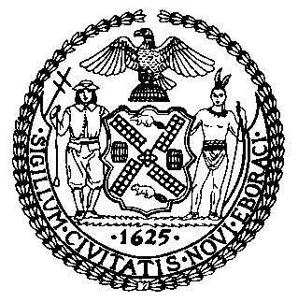 | The Council of the City of New York  Finance Division  Latonia McKinney, Director  Fiscal Impact Statement  Proposed Int. No.: 2330-A  Committee: Public Housing
Title: A Local Law to amend the administrative code of the city of New York, in relation to New York city housing authority complaints and requests for service | Sponsor(s): Council Members Cabrera, Ampry-Samuel, Yeger, Kallos, Louis, and Gjonaj

Summary of Legislation: This bill would require the City’s 311 Customer Service Center to track complaints or requests for service it receives from all members of the public, including residents of a New York City Housing Authority (NYCHA) development, related to NYCHA. This bill would also require 311 to refer such complaints to NYCHA, and to publish information relating to those complaints.

Effective Date: This legislation would take effect 120 days after becoming law.
.
Fiscal Year In Which Full Fiscal Impact Anticipated: Fiscal 2023
Fiscal Impact Statement:

 | Effective FY22 | FY Succeeding Effective FY23 | Full Fiscal Impact FY23
Revenues | $0 | $0 | $0
Expenditures | $0 | $0 | $0
Net | $0 | $0 | $0

Impact on Revenues: It is estimated that there would be no impact on revenues resulting from the enactment of this legislation.
Impact on Expenditures: It is estimated that there would be no impact on expenditures resulting from the enactment of this legislation because existing resources would be used to implement the provisions of this local law.
Source of Funds To Cover Estimated Costs: N/A
Source of Information: New York City Council Finance Division
Mayor’s Office of Legislative Affairs

Estimate Prepared by: Luke Zangerle, Legislative Financial Analyst

Estimate Reviewed by: Chima Obichere, Unit Head
Stephanie Ruiz, Assistant Counsel

Legislative History: This legislation was first considered by the Committee on Public Housing (Committee) as a preconsidered introduction on June 16, 2021, and the bill was laid over. On June 17, 2021, the legislation was introduced to the full Council as Int. No. 2330 and was referred to the Committee. The legislation was subsequently amended, and the amended version, Proposed Int. No. 2330-A, will be considered by the Committee on October 7, 2021. Following a successful Committee vote, the bill will be submitted to the full Council for a vote on October 7, 2021.
Date Prepared: October 5, 2021

