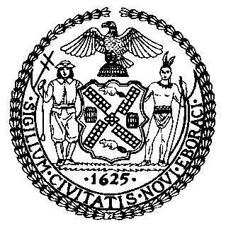 | The Council of the City of New York  Finance Division  Latonia Mckinney, Director  Fiscal Impact Statement  Proposed Intro. No: 668-A  Committee: Mental Health, Disabilities and Addiction
Title: A local law to amend the administrative code of the city of New York, in relation to overdose prevention and reversal training. | Sponsor(S): Council Members Torres and Holden
Summary of Legislation: The proposed legislation would require the Department of Health and Mental Hygiene (DOHMH) to provide opioid overdose prevention and reversal training to the public. DOHMH already provides such trainings, but this law would codify existing trainings and ensure they occur as long as necessary to combat the City’s opioid epidemic.

Effective Date: This local law would take effect on 120 days after becoming law.

Fiscal Year In Which Full Fiscal Impact Anticipated: Fiscal 2020
Fiscal Impact Statement:

 | Effective FY19 | FY Succeeding Effective FY20 | Full Fiscal Impact FY20
Revenues | $0 | $0 | $0
Expenditures | $0 | $0 | $0
Net | $0 | $0 | $0

Impact on Revenues: It is anticipated that this legislation would not affect revenues.

Impact on Expenditures: It is anticipated that there would be no impact on expenditures resulting from the enactment of Intro. 668-A because DOHMH would utilize existing resources to continue to provide opioid overdose prevention and reversal training to the public.

Source of Funds To Cover Estimated Costs: N/A
Source of Information: New York City Council Finance Division
Estimate Prepared By: Jeanette Merrill, Financial Analyst

Estimate Reviewed By: Nathan Toth, Deputy Director, NYC Council Finance Division
Crilhien R. Francisco, Unit Head, NYC Council Finance Division
Rebecca Chasan, Counsel, NYC Council Finance Division
Legislative History: This legislation was considered as a preconsidered introduction by the Committee on Mental Health, Disabilities and Addiction and the Committee on General Welfare at a joint hearing held on February 27, 2018. The legislation was introduced to the full Council on March 7, 2018 as Intro. 668 and referred to the Committee on Mental Health, Disabilities and Addiction. The legislation was subsequently amended and the amended version, Proposed Intro. 668-A, will be considered by the Committee on Mental Health, Disabilities and Addiction on June 5, 2018. Upon successful vote by the Committee on Mental Health, Disabilities and Addiction, Proposed Intro. No. 668-A will be submitted to the full Council for a vote on June 7, 2018.
Date Prepared: June 4, 2018

