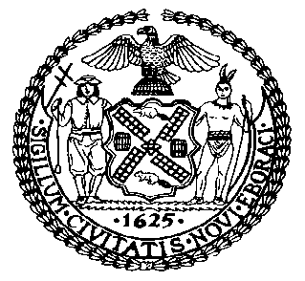 | The Council of the City of New York  Finance Division  Latonia McKinney, Director  Fiscal Impact Statement  Proposed Intro. No. 2171-A  Committee: Housing and Buildings
Title: A Local Law to amend the administrative code of the city of New York and the New York city building code, in relation to the date by which carbon monoxide detectors are required to be installed in commercial spaces | Sponsors: Council Member Cornegy
Summary of Legislation: This legislation would extend the deadline to install carbon monoxide detectors in commercial buildings that are equipped with fire alarm systems and fall within occupancy groups A-1, A-2, A-3, B or M from January 1, 2021 to July, 1 2021.

Effective Date: This local law would take effect immediately, and be deemed to have been in force and effect on and after January 1, 2021.
Fiscal Year In Which Full Fiscal Impact Anticipated: Fiscal 2022
Fiscal Impact Statement:

 | Effective FY21 | FY Succeeding Effective FY22 | Full Fiscal Impact FY22
Revenues | $0 | $0 | $0
Expenditures | $0 | $0 | $0
Net | $0 | $0 | $0

Impact on Revenues: It is estimated that there would be no impact on revenues resulting from the enactment of this legislation because full compliance with the requirements of the legislation is anticipated.
Impact on Expenditures: It is anticipated that there would be no impact on expenditures resulting from the enactment of this legislation because any required expenditure would be borne by private parties.
Source of Funds To Cover Estimated Costs: N/A

Source of Information: New York City Council Finance Division
Department of Buildings

Estimate Prepared by: Luke Zangerle, Financial Analyst

Estimated Reviewed by: Chima Obichere, Unit Head
Noah Brick, Assistant Counsel

Legislative History: This legislation was considered as a preconsidered item by the Committee on Housing and Buildings and the Committee on Fire and Emergency Management on December 2, 2020 and was laid over. The legislation was subsequently introduced to the full Council on December 10, 2020 as Intro. No. 2171 and was referred to the Committee on Housing and Buildings. The legislation was subsequently amended, and the amended version, Proposed Intro No. 2171-A, will be considered by the Committee on Housing and Buildings on December 15, 2020. Following a successful Committee vote, the bill will be submitted to the full Council for a vote on December 17, 2020.

Date Prepared: December 14, 2020

