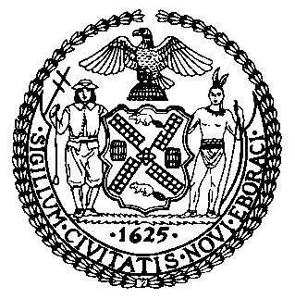 | The Council of the City of New York  Finance Division  Latonia McKinney, Director  Fiscal Impact Statement  Proposed Intro No. 1957-A  Committee: Consumer Affairs and Business Licensing
Title: A Local Law in relation to temporary space for outdoor dining | Sponsors: Council Members Reynoso, Gjonaj, Rivera, Cumbo, Powers, Van Bramer, Lander, Ayala, Richards, Salamanca, Kallos, the Speaker (Council Member Johnson), Constantinides, Holden, Vallone, Brannan, Dromm, Koslowitz, Moya and Levine
Summary of Legislation: This Local Law would require the City to establish an open restaurants program pursuant to which food service establishments could operate a temporary outdoor dining area. The food service establishment would be permitted to operate roadway seating or sidewalk seating after the completion of an online self-certification application, which shall be determined in a form and manner by the Department of Transportation (DOT). DOT, in consultation with the Department of Health and Mental Hygiene (DOHMH), would designate a sidewalk, roadway, or other open space including, but not limited to, a pedestrian plaza and or a public parking lot as an area which a food vendor may vend, provided that such food vendor adheres to guidelines from DOHMH. This local law would not relieve food service establishments from their obligation to adhere to all emergency executive orders, and to all local, state and federal requirements relating to health and safety. There would be no fee for participation in this program. The program would remain in effect until September 8, 2020 or until such later date as DOT shall determine, provided however that such program shall not remain in effect after December 31, 2020. DOT shall provide the Speaker of the Council notice five days prior to the termination of such program.
Effective Date: This local law would take effect immediately.
Fiscal Year in which Full Fiscal Impact Anticipated: Fiscal 2021
Fiscal Impact Statement:
 | Effective FY21 | FY Succeeding  Effective FY22 | Full Fiscal Impact FY22
Revenues (+) | $0 | $0 | $0
Expenditures (-) | $0 | $0 | $0
Net | $0 | $0 | $0

Impact on Revenues: It is estimated that there would be no impact on revenues resulting from the enactment of this legislation.

Impact on Expenditures: It is estimated that there would be no an impact on expenditures resulting from the enactment of this legislation because the relevant agencies would use existing resources to accomplish its requirements.

Source of Funds to Cover Estimated Costs: N/A

Sources of Information: New York City Council Finance Division
Mayor’s Office of Legislative Affairs
Office of Management and Budget
Department of Transportation

Estimate Prepared by: Sebastian Palacio Bacchi, Senior Financial Analyst

Estimate Reviewed by: Nathaniel Toth, Deputy Director
John Russell, Unit Head
Noah Brick, Assistant Counsel
Legislative History: This legislation was introduced to the Council as Intro. No. 1957 on May 28, 2020 and was referred to the Committee on Consumer Affairs and Business Licensing (Committee). The Committee heard the legislation on June 4, 2020, and the legislation was laid over. The legislation was subsequently amended, and the amended version, Proposed Int. 1957-A, will be considered by the Committee on Thursday, June 25, 2020. Upon a successful vote by the Committee, Proposed Int. 1957-A will be submitted to the full Council for a vote on June 25, 2020.
Date Prepared: June 18, 2020

