Staff: Committee on Public Housing
Audrey Son, Counsel
Jose Conde, Senior Policy Analyst
Ricky Chawla, Policy Analyst
Luke Zangerle, Financial Analyst

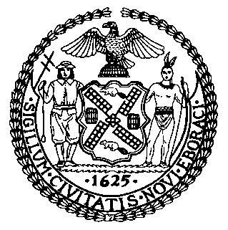

The New York City Council
Jeffrey Baker, Legislative Director

Committee Report of the Infrastructure Division
Terzah Nasser, Deputy Director, Infrastructure Division

Committee on Public Housing
Hon. Alicka Ampry-Samuel, Chair

October 7, 2021

Proposed Int. No. 2330-A: By Council Members Cabrera, Ampry-Samuel, Yeger, Kallos, Louis and Gjonaj
Title: A Local Law to amend the administrative code of the city of New York, in relation to New York city housing authority complaints and requests for service
Administrative Code: Adds a new section 23-307

Introduction
On October 7, 2021, the Committee on Public Housing, chaired by Council Member Alicka Ampry-Samuel, will hold a hearing on Proposed Int. No. 2330-A, in relation to New York city housing authority complaints and requests for service. The original bill was first heard on June 16, 2021. More information about this bill, along with the materials for that hearing, can be found at https://tinyurl.com/59sb7jp4.

Proposed Int. No. 2330-A
This bill would require the 311 customer service center to receive complaints or service requests related to the New York City Housing Authority in the same manner it routinely receives other complaints or service requests, and to refer those complaints or service requests to NYCHA. The 311 customer service center would also be required to annually publish all such complaints or service requests.
This legislation would take effect 120 days after becoming law.

Proposed Int. No. 2330-A

By Council Members Cabrera, Ampry-Samuel, Yeger, Kallos, Louis and Gjonaj

A LOCAL LAW

To amend the administrative code of the city of New York, in relation to New York city housing authority complaints and requests for service

Be it enacted by the Council as follows:

Section 1. Chapter 3 of title 23 of the administrative code of the city of New York is amended by adding a new section 307 to read as follows:
§ 23-307 NYCHA complaints and requests for service. a. The 311 customer service center shall allow the public, including residents of a New York city housing authority development, to contact the center to file complaints or requests for service relating to the New York city housing authority by phone, online and in any other manner that such center routinely accepts complaints or requests for service from the public. Such center shall refer to such authority complaints or requests for service relating to such authority.
b. The 311 customer service center shall publish annually, in a searchable and machine-readable format, all complaints or requests for service relating to such authority.
§ 2. This local law takes effect 120 days after it becomes law, except that the commissioner of information technology and telecommunications shall take all actions necessary for its implementation, including the promulgation of rules, prior to such effective date.
AS
LS #5640
9/29/21 9:48 PM

