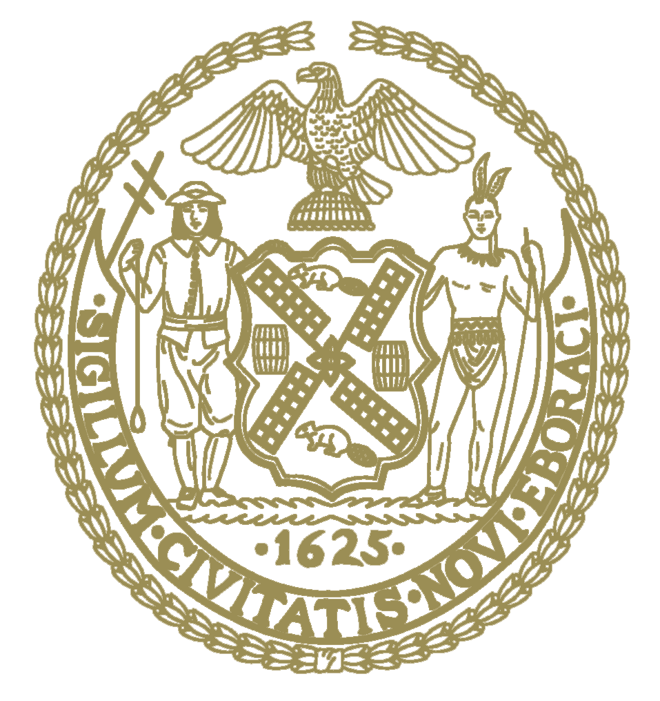

THE COUNCIL OF
THE CITY OF NEW YORK
CITY HALL
NEW YORK, NY 10007

June 15, 2022
Dear Fellow New Yorkers:

Pursuant to New York City Council’s remote attendance policy, Council Member Riley is authorized to participate remotely by the Speaker’s Office for all meetings of the Council held on June 15, due to a medically excused absence.
Sincerely,
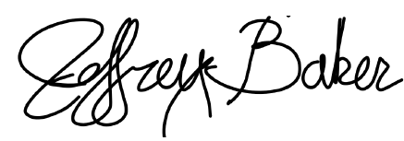
Jeffrey T. Baker
Deputy Chief of Staff for Legislation & Policy

