THE COUNCIL OF THE CITY OF NEW YORK
RESOLUTION NO. 1137

Resolution approving with modifications the decision of the City Planning Commission on Application No. N 190156 ZRM, for an amendment of the text of the Zoning Resolution (Preconsidered L.U. No. 544).

By Council Members Salamanca and Moya

WHEREAS, Catholic Health Care System, filed an application pursuant to Section 201 of the New York City Charter, for an amendment of the text of the Zoning Resolution of the City of New York, modifying APPENDIX F (Inclusionary Housing Designated Areas and Mandatory Inclusionary Housing Areas) for the purpose of establishing a Mandatory Inclusionary Housing area utilizing Option 2, which in conjunction with the related action would facilitate a mixed-use development that would include community facility and residential uses, Borough of Manhattan, Community District 11 (Application No. N 190156 ZRM), (the "Application");

WHEREAS, the City Planning Commission filed with the Council on September 13, 2019, its decision dated September 11, 2019 (the “Decision”), on the application, approving an amendment of the text of the Zoning Resolution of the City of New York, modifying APPENDIX F (Inclusionary Housing Designated Areas and Mandatory Inclusionary Housing Areas) for the purpose of establishing a Mandatory Inclusionary Housing permitting the use of Option 1 or Option 2;

WHEREAS, the Application is related to application C 190158 ZMM (Pre. L.U. No. 543), an amendment to the Zoning Map, Section No. 6b, by changing from an R7-2 District to an R8 District property bounded by East 106th Street, Madison Avenue, East 105th Street and a line 150 feet easterly of Fifth Avenue - Museum Mile, in the Borough of Manhattan, Community District 11;

WHEREAS, the Decision is subject to review and action by the Council pursuant to Section 197-d of the City Charter;

WHEREAS, upon due notice, the Council held a public hearing on the Decision and Application on September 18, 2019;

WHEREAS, the Council has considered the land use implications and other policy issues relating to the Decision and Application; and

WHEREAS, the Council has considered the relevant environmental issues, including the negative declaration issued April 8th, 2019 (CEQR No. 19DCP070M), which includes an (E) designation related to air quality, noise, and hazardous materials that would be established in connection with the proposed actions; and additionally the applicant entered into a Restrictive Declaration to ensure the implementation of best management practices relating to construction as Project Components Related to the Environment (E-531) (the “Negative Declaration”).

RESOLVED:
The Council finds that the action described herein will have no significant impact on the environment as set forth in the (E) Designation (E-531) and Negative Declaration.
Pursuant to Sections 197-d and 200 of the City Charter and on the basis of the Decision and Application, the environmental determination and consideration described in the report, N 190156 ZRM, incorporated by reference herein, and the record before the Council, the Council approves the Decision of the City Planning Commission with the following modifications:

Matter underlined is new, to be added;
Matter struck out is to be deleted;
Matter within # # is defined in Section 12-10;
Matter double struck out is old, deleted by the City Council;
Matter double-underlined is new, added by the City Council;
* * * indicates where unchanged text appears in the Zoning Resolution.

APPENDIX F

* * *
MANHATTAN

* * *

Manhattan Community District 11

* * *

Map 7 – [date of adoption]

[PROPOSED MAP]

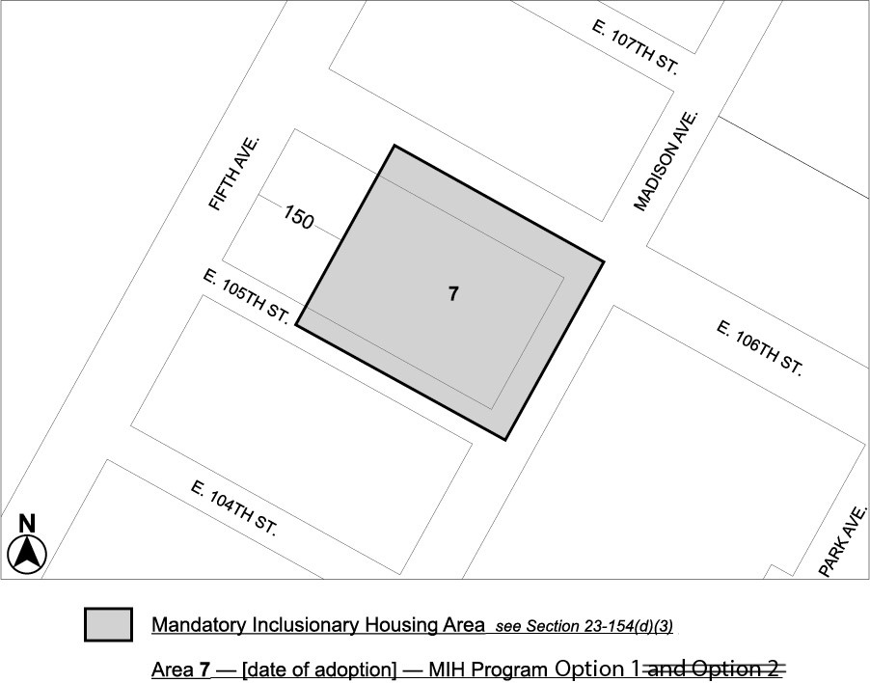

* * *

Adopted.

Office of the City Clerk, }
The City of New York, } ss.:

I hereby certify that the foregoing is a true copy of a Resolution passed by The Council of The City of New York on October 17, 2019, on file in this office.

.....……......................................... City Clerk, Clerk of The Council

