Health Committee Staff
Sara Liss, Senior Legislative Counsel
Harbani Ahuja, Legislative Counsel
Emily Balkan, Senior Legislative Policy Analyst
Lauren Hunt, Finance Analyst
Brook Frye, Data Analyst

Hospitals Committee Staff
Harbani Ahuja, Legislative Counsel
Emily Balkan, Senior Legislative Policy Analyst
John Cheng, Finance Analyst
Rachael Alexandroff, Data Analyst

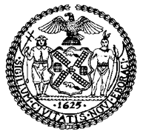

THE COUNCIL

COMMITTEE REPORT OF THE HUMAN SERVICES Division
Jeffrey Baker, Legislative Director
Andrea Vazquez, Deputy Director, Human Services

COMMITTEE ON HEALTH
Hon. Mark Levine, Chair

COMMITTEE ON HOSPITALS
Hon. Carlina Rivera, Chair

January 12, 2021

Oversight: COVID-19 Vaccine Distribution & Accessibility in NYC

- Introduction
On January 12, 2021, the Committee on Health, chaired by Council Member Mark Levine, and the Committee on Hospitals, chaired by Council Member Carlina Rivera, will hold an oversight hearing titled “COVID-19 Vaccine Distribution & Accessibility in NYC.” Among those invited to testify are representatives from the New York City Department of Health and Mental Hygiene (DOHMH), the New York City Health and Hospitals Corporation (H+H), medical service providers, advocates, and other interested parties.
- Background
  - COVID-19 Background
A novel coronavirus, called SARS-CoV-2, first emerged in late 2019 and spread rapidly around the world. As of January 11 2021, there have been over 90 million confirmed cases of COVID-19, the disease caused by SARS-CoV-2, and over 1.9 million deaths worldwide, including more than 22.2 million cases and more than 374,000 deaths in United States. New York State (NYS) and New York City (NYC) have been hit particularly hard by this pandemic. As of January 11 2021, there have been more than 1.1 million confirmed cases and more than 31,600 deaths in the State, including more than 424,000 cases, 25,500 confirmed deaths, and 4,841 probable deaths in New York City.
COVID-19 presents a wide range of symptoms, ranging from mild symptoms to severe illness. Symptoms include fever or chills, cough, shortness of breath, difficulty breathing, fatigue, muscle or body aches, headache, loss of taste or smell, sore throat, congestion, runny nose, nausea, vomiting, and diarrhea. Some people are at increased risk of developing severe COVID-19 symptoms and dying from the virus, including older adults and those with certain underlying medical conditions, such as cancer, chronic kidney disease, heart conditions, obesity, and type 2 diabetes. Other people who should take extra precautions include people who are racial and/or ethnic minorities, individuals with disabilities, those with developmental and behavioral disorders, individuals with drug use or substance use disorder, those who are pregnant or breastfeeding, individuals living in rural communities, and those experiencing homelessness. Recent studies have found that individuals with intellectual disabilities and developmental disorders are at particular risk, with a COVID-19 fatality rate three times as high as the rate amongst those without intellectual and developmental disabilities.
Generally, children are unlikely to experience serious symptoms, complications, or fatalities if they contract COVID-19, but they can still spread the virus to others, even if they are asymptomatic. Moreover, while most children with COVID-19 have mild symptoms or have no symptoms at all, some children can get severely ill from COVID-19, including infants and children with certain underlying conditions such as asthma, chronic lung disease, immunosuppression, and medical complexity.
  - COVID-19 Vaccine Development
Although vaccines typically take years of research and testing before they are administered to the public, researchers have worked to develop a SARS-CoV-2 vaccine in record time. The work on a COVID vaccine has been expedient for a few reasons. Health experts say the world cannot fully return to a more normal level of activity until a coronavirus vaccine is widely distributed, and it is likely that multiple vaccines will be needed in order to supply enough doses for universal vaccination. Before the virus had a name, and when there was only one reported death, a team of Chinese scientists uploaded its genetic sequence to a public site, inviting people from all over the world to begin working on a vaccine. Additionally, according to STAT Health, the virus itself is an easier target for potential vaccines than other pathogens, because it is similar to previously encountered viruses and because it causes an acute, and not a chronic, infection. It is also “a prime candidate for cutting-edge vaccine platforms new to scientists’ toolkits.”
While an effective vaccine would trigger a person’s immune system to make antibodies against the virus without causing disease, there are different techniques scientists are using to develop vaccines, some of which have not been approved previously for medical use. Older and more traditional strategies for developing vaccines, such as using a weakened or inactivated form of the virus, take a long time to develop. Inactive or live attenuated vaccines require growing viruses, and these procedures can take months to produce a batch of new vaccines. Common examples of such vaccines include conventional vaccines for influenza, chickenpox, and measles, mumps, and rubella.
Newer approaches only require scientists to know the virus’ genetic sequence, and are quicker to implement. In fact, a team from the National Institute of Allergy and Infectious Diseases (NIAID) and the biotech company Moderna had a COVID-19 vaccine candidate ready for a Phase 1 trial less than ten weeks after scientists in China published the SARS-CoV-2 genetic sequence. The Moderna/NIAID vaccine, and others, were built with messenger ribonucleic acid (mRNA). mRNA is a naturally occurring hereditary substance—specifically, a single-stranded RNA molecule that is complementary to one of the deoxyribonucleic acid (DNA) strands of a gene.
COVID-19 mRNA vaccines function by giving the human body “instructions” via mRNA for how to make the coronavirus’ spike protein, a harmless piece of the virus found on its surface. The vaccine shuttles the mRNA into cells, which utilize those instructions to create the protein that triggers the immune response to COVID-19. Other COVID-19 vaccines being developed are DNA based, but prior to this, no mRNA or DNA vaccine has ever been approved before. Other approaches have also been developed, such as viral vector vaccines and protein-based vaccines.
According to The New York Times’ COVID-19 vaccine tracker, there are various phases of vaccine testing, and researchers are currently testing 64 vaccines in clinical trials on humans and at least 85 preclinical vaccines are under active investigation in animals. Seven vaccines are currently approved for early or limited use, all of which are approved for use in Russia, China, or the U.A.E. Aside from these vaccines, there are currently developments and approvals in the United States that have occurred with three potential promising vaccines, two of which have received Emergency Use Authorization.
The Pfizer-BioNTech vaccine, which is an mRNA vaccine, reports having a 95 percent efficacy rate. It can be stored safely for up to five days in a standard refrigerator before being administered, but must be kept at minus 70 degrees Celsius for long-term storage. The vaccine costs $20 per dose, and Pfizer has announced that it can manufacture up to 50 million doses in 2020 and 1.3 billion in 2021. The second vaccine, developed by Moderna, has an efficacy rate of 94.1 percent, and costs $32-37. This vaccine can be stored for 30 days in a standard refrigerator or six months at minus 20 degrees Celsius, and Moderna has reported that it can manufacture 20 million doses in 2020 and up to 1 billion in 2021. The third vaccine was developed by Oxford-AstraZeneca, and is a viral vector vaccine, which was developed using a combination of a virus that causes the common cold in chimpanzees and coronavirus genetic material. According to initial reports, the vaccine is 62 percent and 90 percent effective, depending on dosage, with an actual average effective rate of 70.4 percent. Further studies are underway to better understand the vaccine’s effectiveness, as clarification is needed, given that the initially reported 90 percent effective rate for those who received a lower dosage resulted from a manufacturing discrepancy and was only performed on 2,741 participants. The vaccine can be stored up to six months in a refrigerator. Per AstraZeneca, they can manufacture a total annual capacity of 3 billion doses, costing $3-4 per dose. Additionally, concerns have been expressed about potential vaccines’ effectiveness across different populations, including those who are elderly, obese, ethnic and racial minorities, and others, as well as the length of time immunity from a vaccine may last.
Vaccine development has also been speedy because of funding and regulatory nimbleness. The Ebola crisis taught regulators and other stakeholders the importance of having regulatory flexibility and transparency, which allows faster and streamlined processes to develop life-saving vaccines and treatments. For example, the Food and Drug Administration (FDA) outlined that vaccines need to prevent infections or reduce the severity of COVID-19 in 50 percent of recipients to be approved, and some phases of clinical trials were collapsed, which saved time. By late November 2020, both Pfizer and Moderna applied for Emergency Use Authorization (EUA) from the FDA. EUA allows unapproved medical products or unapproved uses of approved medical products to be used in an emergency to diagnose, treat, or prevent serious or life-threatening diseases or conditions caused by Chemical, Biological, Radiological, and Nuclear (CBRN) threat agents when there are no adequate, approved, and available alternatives. The FDA granted EUA to the Pfizer vaccine on December 11, 2020, and to the Moderna vaccine on December 18, 2020, making them the first coronavirus vaccines to hit the market in the United States.
  - New York State and City Plans for Distribution
Both New York State and New York City proposed preliminary plans for the COVID-19 vaccine, to ensure the safe and efficient distribution and administration of the vaccine to New York residents. To ensure coordinated and efficient statewide distribution and administration, all localities and entities in New York State will be required to follow the state’s guidance and protocols for COVID-19 vaccination.
    - New York State Plan
The New York State Plan was created by analyzing New York’s health emergency response to the first influenza pandemic, lessons learned from the H1N1 vaccination effort, and emergency preparedness exercises with state and local health departments. To establish and build public trust around vaccine safety and effectiveness, Governor Cuomo appointed members to New York’s Independent Clinical Advisory Task Force, comprised of leading scientists, doctors, and health experts, whose role is to expeditiously review every COVID-19 vaccine authorized by the federal government, and will advise New York State on the vaccine’s safety and effectiveness in fighting the virus. To help guide the distribution and administration process, the Governor established a Vaccine and Implementation Task Force—comprised of experts in public health, immunizations, government operations, data, and other relevant fields—to advise the set up and operation of the State’s COVID-19 vaccination program.
New York State prioritized vaccination recipients based on science, clinical expertise, and federal guidelines, with critical populations identified and recommended by the Advisory Committee on Immunization Practices, and prioritization decisions taking into account the disparate impact of COVID-19 on communities of color, health disparities present in underrepresented and marginalized communities, and communities with historically poor health outcomes. One of New York’s prioritization strategies for vaccine distribution is designed to ensure early vaccination of the most vulnerable New Yorkers as well as essential frontline workers, with distribution potentially directed to people who reside or work within communities with the highest prevalence of COVID-19. The following chart highlights the vaccine prioritization categories:
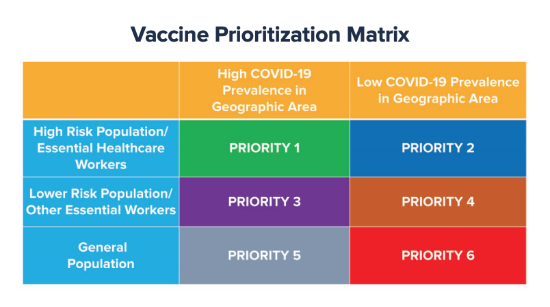
New York State Department of Health, New York State’s COVID-19 Vaccination Program, Oct. 2020

New York State’s plan also uses up-to-date data to determine which geographic areas of the state may derive a greater public health benefit from receiving vaccines early, such as areas with a higher historical burden of disease or areas with the highest prevalence of COVID-19. In addition, individual factors for hospitals and nursing homes are considered, including cases per facility in the prior 14 days, and the vulnerability index of the population served. New York will also consider whether the vaccine can be used effectively as a potential outbreak interruption strategy, and if so, what the criteria will be.
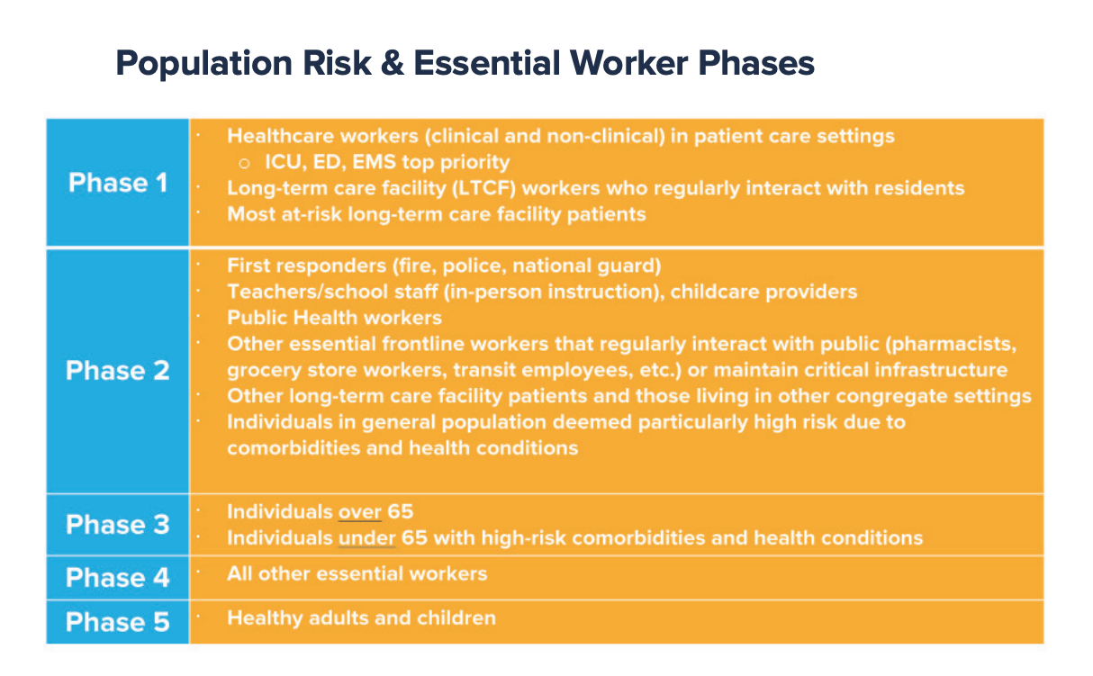
New York State Department of Health, New York State’s COVID-19 Vaccination Program, Oct. 2020

Based on these prioritization criteria, sub-populations have been identified to allow for additional micro-level prioritization based on vaccine availability and vaccination rates, and is carried out through phased vaccine distribution, as seen in the chart above. Entities receiving the vaccine are given a level of autonomy to determine the internal order of employee vaccination based on risk and within the boundaries of New York State and federal guidance. New York State is also working directly with Tribal Nations to ensure these communities’ vaccination needs are met. Taking all prioritization and allocation data into account, New York has prepared detailed allocation scenarios based on this data and variables for vaccine allotment amounts and vaccination rates within priority populations. For example, the chart below illustrates a hypothetical scenario for the allocation of 100,000 doses:
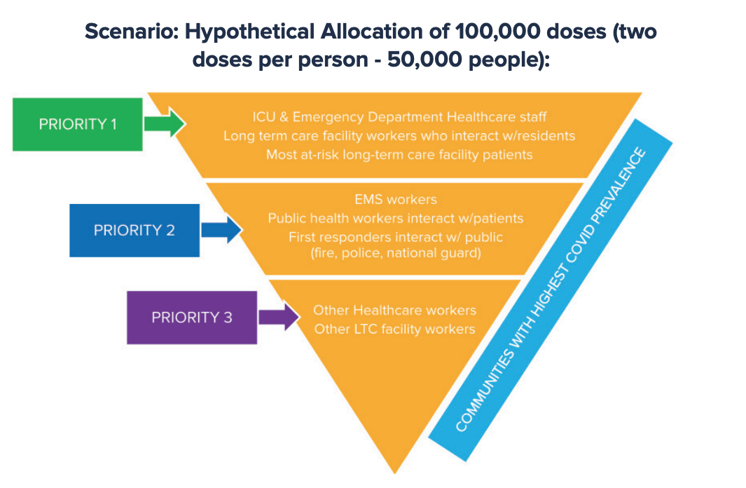
New York State Department of Health, New York State’s COVID-19 Vaccination Program, Oct. 2020

The State plan assumes a scenario of vaccines requiring a two-dose regimen, administered 21 to 28 days apart. This has been and will continue to be a complex logistical undertaking, and New York is undertaking this critical task through state agencies with operational and logistical expertise, including the Department of Health, Division of Homeland Security and Emergency Services, the Division of Military and Naval Affairs, New York National Guard, the Office of General Services, and the Department of Transportation, and other agencies who are coordinating all aspects of vaccine acquisition and distribution with private and community health care partners and local governments. Distribution planning requires strict adherence to handling and storage requirements of the vaccine to maintain stability and potency.
A critical component of managing vaccine distribution and delivery is vaccine storage and inventory management. In order to address the critical time restraints of distributing the vaccine, New York State is working with local jurisdictions to identify and operationalize appropriate regionally-based storage locations that comply with CDC and manufacturer recommendations for storage, including at temperatures as low as minus 80 degrees Celsius. To address limited specialized storage capacity, the State plan may utilize larger vaccination administration sites to also serve as regional storage locations, following the same format as the Strategic National Stockpile of Chempak supplies. To ensure that vaccines are transported in a manner consistent with recommendations and that maximizes vaccine stability and minimizes wastage, New York State may deploy vehicles equipped to transport vaccines that meet requisite cold-chain requirements. All inventory management is performed with advanced data technology platforms to ensure that each vaccine dosage is tracked from point of delivery to point of administration, and storage sites are integrated into the delivery process to sites designated for vaccine distribution. Possible regional cold storage locations across the state have been identified, with one located in New York City as of December 2020.
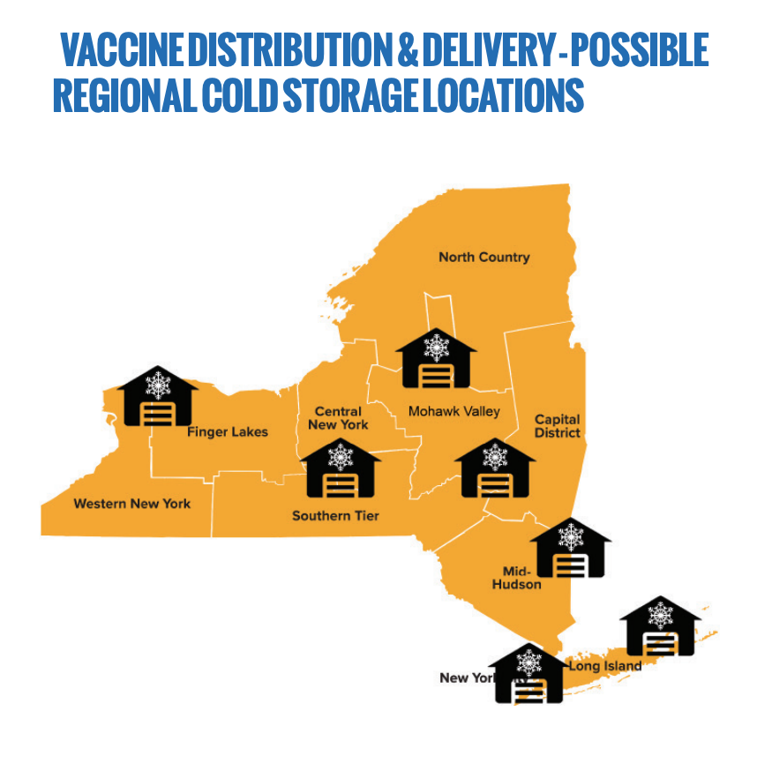
New York State Department of Health, New York State’s COVID-19 Vaccination Program, Oct. 2020

To administer the vaccine, New York State is and will rely on an established network of health care providers—including hospitals, LTCFs (nursing homes, adult care facilities (ACFs), assisted living), Federally Qualified Health Centers (FQHCs), Community Health Centers, Rural Health Clinics, private provider offices, local health departments, and other entities that will serve as Vaccination Administration Sites (VAS). In addition, the state will work with commercial and independent pharmacies, businesses, and other organizations, such as schools, colleges and universities, homeless shelters, correction facilities, and sites where target populations gather (i.e., senior centers, social service offices, food pantries, etc.), to enable on-site vaccination at these sites. New York State began enrolling providers as VASs in early September, and continues to identify additional vaccine administration locations. All potential providers, from individual clinicians to multi-facility health systems, are enrolling with the NYSDOH Vaccine Program to be a COVID-19 vaccinator by completing and submitting a COVID-19 Vaccination Provider Agreement and Provider Profile available through the Health Commerce System. These providers will be activated in the New York State Immunization Information System (NYSIIS) with COVID-19 vaccine ordering capability, and a comprehensive provider outreach, enrollment, and training effort is already underway. New York State will also issue detailed guidance regarding provider roles, patient messaging, process for scheduling patients for second doses, on-site vaccine storage and temperature monitoring, vaccine safety and efficacy, vaccine administration, vaccine ordering, vaccine reporting, best practices, and other helpful advisory topics.
Providing nearly 40 million vaccination doses will require the recruitment and training of additional personnel authorized to administer the vaccine; therefore, in addition to supporting efforts by existing providers to hire more personnel, the state will mobilize the existing public health workforce and train additional staff. Accordingly, in early 2021, the Governor signed an executive order to expand the eligible pool of trainees that can administer vaccinations at POD sites, provided that trainees receive and complete, or already have, a state-provided online or in-person training. Once vaccine availability increases and outpaces provider administration capacity, New York State will establish public clinics to serve targeted populations, plan for quick activation and mobilization of mass vaccination point of dispensing (POD) sites, and deploy mobile vaccination units, all in efforts to provide doses to thousands of New Yorkers each day. All VAS and health care providers that administer the vaccine will need storage capabilities, PPE, and integration into the state’s data and IT infrastructure.
To meet the new challenge of providing potentially two COVID-19 vaccine doses to all New Yorkers, the State will expand and strengthen NYSIIS to serve as a secure, centralized database that will be used to order COVID-19 vaccine, record and track inventory, track vaccine administration, and monitor priority groups. Currently, over 6,600 provider practices actively report to NYSIIS. Approximately 80 percent of data is received electronically from 100 different Electronic Health Record (EHR) vendors. Over 12,400 organizations (including pharmacies) and 36,000 individuals currently actively utilize NYSIIS to access vaccine information. NYSIIS will be used to capture a broad range of information, from provider profiles and inventory management, to documentation of patient demographics and tracking of doses administered. It will also allow for providers to generate second-dose reminder notices for their patient populations. New York State will launch and maintain an external public-facing dashboard to keep New Yorkers informed of vaccination progress and relevant updates, including doses administered by day, ZIP code, age group, etc. Furthermore, an online website has been made available for New Yorkers seeking information regarding vaccine eligibility and appointment scheduling that offers a vaccine eligibility screening tool and a vaccine administration site locator. In addition to online services, a call center and hotline have been made available for patients and providers to access live support to raise any issues regarding vaccine access and delivery.
Overall management of New York’s vaccination program will require a Vaccine Central Command Center (VC3) to oversee all aspects of vaccine delivery, administration, and other operational aspects of the program. The VC3 will operate within the existing New York State Incident Command structure and include representatives from a wide range of state agencies that will be charged with managing all aspects of the COVID-19 vaccine program. The State will also undertake a comprehensive review of all regulatory and statutory provisions that may require expansion or revision to support the goals of the vaccination efforts. Finally, the State will conduct post-vaccination monitoring through the Vaccine Adverse Event Reporting System (VAERS), which will give New Yorkers who receive the vaccine the opportunity to report any potential adverse effects, allowing New York State DOH and the State’s Clinical Advisory Task Force to conduct robust monitoring of the vaccine’s safety.
    - New York City Plan
New York City’s plan builds upon a well-established immunization infrastructure and draws on DOHMH’s pandemic influenza plan, as well as lessons learned from the H1N1 and annual flu vaccination plans. DOHMH has established a Vaccine Task Force (VTF) for New York City’s COVID-19 response, with the objective of developing a plan for equitable distribution of COVID-19 vaccines when they become available. The VTF includes staff from across DOHMH specializing in equity, provider communications, community partner engagement, people living congregate settings, development and dissemination of information to the public, health care system support and field operations, as well as vaccine distribution, allocation, and accountability. DOHMH is leveraging existing relationship with immunization providers as well as reaching out to potential providers for enrollment in the COVID-19 vaccination program, and the VTF will coordinate vaccine planning with these organizations and collaborate and work closely with New York State and other government agencies.
Similar to the State plan, the NYC COVID-19 Vaccination Plan looks to the National Academy of Science, Engineering, and Medicine framework and guidance from the Advisory Committee on Immunization Practices for planning of a phased rollout that adheres to national guidance and ensures local equity in allocation and access to New York City residents.
DOHMH plans to use available datasets, including administrative data, Community Health Survey and Citywide Immunization Registry (CIR) data to identify and estimate critical populations including but not limited to: the number of people aged 65 and older, people with underlying medical conditions, essential workers and first responders, as well as those living in congregate settings such as long-term facilities, shelters, and correctional facilities. Established in 1996, the CIR is currently used by nearly 2,700 immunization providers across New York City, and many of the facilities that are prioritized for initial vaccine distribution are already enrolled in and using the CIR. Providers will complete the CDC COVID-19 Vaccination Program Provider Agreement online through the CIR’s Online Registry, and will provide information about a facility’s vaccination administration capacity. All COVID-19 vaccine ordering will be submitted by providers through the CIR’s Online Registry. The Provider Agreement includes detailed information on a facility’s vaccine storage and handling capacity, and this information will allow DOHMH to identify which facilities can store the vaccine and the size of their storage capacity. Providers will be given vaccine storage and handling toolkits, and offered webinars and educational materials to ensure proper vaccine storage and prevent wastage.
According to the City plan, all COVID-19 vaccine doses administered are expected to be reported to the CIR, allowing DOHMH to track doses of vaccine administered and overall vaccine uptake within New York City. The CIR has a text message reminder system available for all providers enrolled in the CIR, so it will allow for second-dose reminder notifications. Furthermore, the CIR supports bidirectional exchange between the CIR and a provider’s electronic health record, allowing them to check a patient’s vaccine history, ensuring proper administration of a second vaccine dose. DOHMH will also provide guidance, assistance, and education materials to ensure safety monitoring, and similar to the State plan, all COVID-19 vaccine providers will be instructed on the requirements and process for reporting adverse events following vaccination to the VAERS.
The City plan states that DOHMH will have multiple levels of oversight for the COVID-19 vaccination program, tracking provider enrollments, number of vaccines ordered, number of vaccine doses shipped, vaccine doses reported to the CIR by age and neighborhood, first and second dose coverage by age, and compliance with reporting requirements. Vaccination sites will be made available for the public on DOHMH’s website using the NYC Health Map or by calling 311. DOHMH will also undertake a comprehensive COVID-19 vaccine marketing campaign, informed by community feedback. The City plan states that the VTF is actively engaging community members to understand vaccine hesitancy, especially as it relates to historic and persistent racial oppression, and the VTF is prepared to deliver on-the-ground messaging both from public health leaders and trusted community members, in multiple languages to increase uptake of the vaccine and combat misinformation.
  - COVID-19 Vaccine Rollout and Challenges to Date
On December 14, 2020, Nurse Sandra Lindsey became the first person in the United States to receive the COVID-19 vaccine in a non-clinical trial, when she received the vaccine at New York’s Long Island Jewish Medical Center. New York City began the first portion of Phase 1a of vaccine distribution that same day, which included high-risk hospital staff, affiliates, volunteers and contract staff, following the clinical risk assessment guidance, who received the vaccine through hospital employers. The following week, beginning December 21, 2020, this first group was expanded to include emergency medical services (EMS) personnel, medical examiners and coroners, funeral workers who have direct contact with infectious material and bodily fluids, health care or other high-risk direct care essential staff working in long-term care facilities (LTCF) and long-term, congregate settings, and persons living in LTCFs and in long-term congregate settings. Staff and residents of long-term care facilities received the vaccine through a federal Pharmacy Partnership for Long-Term Care Program, utilizing CVS, Walgreens, and Managed Health Care Associates for administration. In the following two weeks, beginning December 28, 2020, and continuing through January 10, 2021, the group was again expanded to the remaining categories of phase 1a, which include: agency staff and residents in congregate living situations run by the Office of People with Developmental Disabilities (OPWDD), the Office of Mental Health (OMH), and the Office of Addiction Services and Supports (OASAS), urgent care providers, any staff administering COVID-19 vaccinations, all outpatient/ambulatory front-line, high-risk health care workers of any age who provide direct in-person patient care, or other staff in a position in which they have direct contact with patients (i.e., intake staff), and all front-line, high-risk public health workers who have direct contact with patients, including those conducting COVID-19 tests, handling COVID-19 specimens and COVID-19 vaccinations. EMS staff receive vaccinations through hospitals, federal qualified health centers (FQHCs), urgent care centers (UCCs), and local health department points of distribution (PODs).
Unfortunately, much of phase 1a was marked by confusion, slow rollout, and a reluctance by many eligible to receive the vaccine, and as of January 7, 2021, New York had only administered 430,000 of the 900,000 vaccines it had received, while as of January 10, 2021, New York City had only administered just over 200,000 of the under 525,000 vaccines it has received. Some have blamed the slow rollout on confusion and inconsistency by hospitals over who falls into each category, by vaccine-skepticism or disinterest by eligible health care workers, and on too rigid an attachment to the various phases. Mayor Bill de Blasio urged Governor Cuomo to expand the categories of those that can receive the vaccine, and United States Surgeon General Jerome Adams urged states that they “not only can, but SHOULD aggressively expand vaccinations to other phases if current supply exceeds demand in phase 1a!”
On Friday, January 8, 2021, Governor Cuomo announced that phase 1b would commence in New York State on January 11, 2021, beginning with essential workers and New Yorkers over the age of 75. The Governor also announced that a new network of vaccine sites would be operationalized to supplement vaccine administration for individual falling under group 1a and eligible under the first phase of group 1b. The Governor further clarified that health care workers would remain prioritized, even as administration would be opened to those in 1b, and that the State is mandating that fairness and social equity be incorporated into the administration of vaccines to individuals in 1b. The Governor called upon large unions to organize vaccine administration to essential workers in their networkers, to allow other providers to administer vaccines to those in the 75+ age group.
Additionally, the Governor signed an executive order to expand the eligible pool of trainees that can administer vaccinations at POD sites, provided that trainees receive and complete, or already have, a state-provided online or in-person training. Those newly eligible include:
- Licensed practical nurses (LPNs)
- Pharmacists who are not certified to administer immunizations by SED
- Midwives who are not certified to administer immunizations by SED
- Dentists
- Dental hygienists*
- Podiatrists
- Emergency Medical Technicians
- Advanced Emergency Medical Technicians
- Students in eligible education programs (medicine, nursing, PA, pharmacy, dentistry, podiatry, and midwifery)

DOHMH provided further guidance after the Governor’s announcement, declaring that the next phase would include: people ages 75 and older, teachers and education workers, first responders, public safety workers, and public transit workers. The City estimates that the rest of phase 1b, which includes other frontline essential workers (to be determined by New York State) and other at-risk groups (to be determined by New York State), will begin in February 2021, and that phase 1c, which includes people ages 65-74, people with certain underlying health conditions (to be determined by New York State), and all other essential workers (to be determined by New York State), will begin in March/April 2021, and that phase 2, which includes all other people, will likely begin in summer 2021.
New York City aims to have one million New Yorkers vaccinated by the end of January 2021. The New York City Vaccine Command Center will help to manage, triage, and coordinate the largescale effort, and the City aims to double its weekly capacity for vaccination through a three-pronged plan:
- COVID-19 Vaccine Hubs will be launched across the city in January, where New Yorkers in neighborhoods will be able to access a vaccine;
- H+H COVID-19 testing sites will also serve as vaccination centers, in addition to continuing to provide ongoing COVID-19 testing; and
- The City will partner with local organizations to scale up their capacity to administer vaccines quicker.
The City currently has over 160 sites open and available – including H+H Gotham Health Facilities, Pop-up Vaccine Clinics hosted by DOHMH, NYC Vaccine Hubs, and other locations – with a plan to have 250 sites operational by the end of January. The City will also open five large-scale vaccination centers in the coming weeks, which will operate 24 hours a day, seven days a week, to move towards a cumulative capacity of up to 100,000 vaccine doses per week. The first two 24/7 mass vaccination sites will open on Sunday, January 10, at Bathgate in the Bronx and Brooklyn Army Terminal in Brooklyn. The City will open 12 additional vaccine hubs across the city beginning Friday, January 15th, which will be open from 9:00 AM – 7:00 PM, seven days a week. Finally, the City has established a vaccine webpage and site locator.
- Conclusion
The Committees aim to learn more about the City’s plan for vaccine distribution, including the plans for prioritizing the most vulnerable and frontline workers, logistical concerns surrounding vaccinating the general public, shipment, access and storage concerns, any support the City and State are seeking to receive from the Federal Government to increase capacity and speed up the distribution timeline, how the City will build public trust and educate the public, and any potential costs to the City or to New Yorkers in distributing the vaccine. The Committee also hopes to hear how the City’s vaccine distribution plan will be culturally sensitive in addressing skepticism and medical mistrust.

Axios, “The COVID-19 Tracker.” Accessed at: https://www.statnews.com/feature/coronavirus/covid-19-tracker/.
Worldometer, “COVID-19 Coronavirus Pandemic.” Accessed at: https://www.worldometers.info/coronavirus/.
NYS DOH COVID-19 Tracker, “Persons Tested Positive by County.” Accessed at: https://covid19tracker.health.ny.gov/views/NYS-COVID19-Tracker/NYSDOHCOVID-19Tracker-Map?%3Aembed=yes&%3Atoolbar=no&%3Atabs=n.
New York State Department of Health COVID-19 Tracker, “Fatalities.” Accessed at: https://covid19tracker.health.ny.gov/views/NYS-COVID19-Tracker/NYSDOHCOVID-19Tracker-Fatalities?%3Aembed=yes&%3Atoolbar=no&%3Atabs=n.
New York City Department of Health and Mental Hygiene, “COVID-19: Data.” Accessed at: https://www1.nyc.gov/site/doh/covid/covid-19-data.page.
Centers for Disease Control and Prevention, “Symptoms of Coronavirus,” May 13, 2020. Accessed at: https://www.cdc.gov/coronavirus/2019-ncov/symptoms-testing/symptoms.html.
Id.
Centers for Disease Control and Prevention, “People at Increased Risk and Other People Who Need to Take Extra Precautions,” September 11, 2020. Accessed at: https://www.cdc.gov/coronavirus/2019-ncov/need-extra-precautions/index.html.
Centers for Disease Control and Prevention, “People with Certain Medical Conditions,” October 6, 2020. Accessed at: https://www.cdc.gov/coronavirus/2019-ncov/need-extra-precautions/people-with-medical-conditions.html?CDC_AA_refVal=https%3A%2F%2Fwww.cdc.gov%2Fcoronavirus%2F2019-ncov%2Fneed-extra-precautions%2Fgroups-at-higher-risk.html.
Centers for Disease Control and Prevention, “People at Increased Risk and Other People Who Need to Take Extra Precautions,” September 11, 2020. Accessed at: https://www.cdc.gov/coronavirus/2019-ncov/need-extra-precautions/index.html.
“Developmental Disabilities Heighten Risk of Covid Death,” NY Times, Nov. 10, 2020, available at https://www.nytimes.com/2020/11/10/health/covid-developmental-disabilities.html.
Centers for Disease Control and Prevention, “COVID-19 in Children and Teens,” September 17, 2020. Accessed at: https://www.cdc.gov/coronavirus/2019-ncov/daily-life-coping/children/symptoms.html.
Id.
Jonathan Corum et. al., Coronavirus Vaccine Tracker, The New York Times, last updated November 23, 2020, available at https://www.nytimes.com/interactive/2020/science/coronavirus-vaccine-tracker.html
Ursula Perano, Key information about the effective COVID-19 vaccines, Axios, November 23, 2020, available at https://www.axios.com/covid-vaccines-coronavirus-moderna-pfizer-oxford-d9522a80-c1c5-4da2-b7d8-c6c90c28b4b3.html
Jonathan Corum et. al., Coronavirus Vaccine Tracker, The New York Times, last updated November 23, 2020, available at https://www.nytimes.com/interactive/2020/science/coronavirus-vaccine-tracker.html
Andrew Joseph, ‘A huge experiment’: How the world made so much progress on a Covid-19 vaccine so fast, STAT News, July 30, 2020, available at https://www.statnews.com/2020/07/30/a-huge-experiment-how-the-world-made-so-much-progress-on-a-covid-19-vaccine-so-fast/
Andrew Joseph, ‘A huge experiment’: How the world made so much progress on a Covid-19 vaccine so fast, STAT News, July 30, 2020, available at https://www.statnews.com/2020/07/30/a-huge-experiment-how-the-world-made-so-much-progress-on-a-covid-19-vaccine-so-fast/
Andrew Joseph, ‘A huge experiment’: How the world made so much progress on a Covid-19 vaccine so fast, STAT News, July 30, 2020, available at https://www.statnews.com/2020/07/30/a-huge-experiment-how-the-world-made-so-much-progress-on-a-covid-19-vaccine-so-fast/
Jonathan Corum, et. al., Different Approaches to a Coronavirus Vaccine, The New York Times, May 20, 2020, available at https://www.nytimes.com/interactive/2020/05/20/science/coronavirus-vaccine-development.html
Andrew Joseph, ‘A huge experiment’: How the world made so much progress on a Covid-19 vaccine so fast, STAT News, July 30, 2020, available at https://www.statnews.com/2020/07/30/a-huge-experiment-how-the-world-made-so-much-progress-on-a-covid-19-vaccine-so-fast/
Jonathan Corum, et. al., Different Approaches to a Coronavirus Vaccine, The New York Times, May 20, 2020, available at https://www.nytimes.com/interactive/2020/05/20/science/coronavirus-vaccine-development.html
Id.
Andrew Joseph, ‘A huge experiment’: How the world made so much progress on a Covid-19 vaccine so fast, STAT News, July 30, 2020, available at https://www.statnews.com/2020/07/30/a-huge-experiment-how-the-world-made-so-much-progress-on-a-covid-19-vaccine-so-fast/
Id.
Id.
“Messenger RNA,” NIH, available at https://www.genome.gov/genetics-glossary/messenger-rna.
See Id.; see also, Andrew Joseph, ‘A huge experiment’: How the world made so much progress on a Covid-19 vaccine so fast, STAT News, July 30, 2020, available at https://www.statnews.com/2020/07/30/a-huge-experiment-how-the-world-made-so-much-progress-on-a-covid-19-vaccine-so-fast/
Andrew Joseph, ‘A huge experiment’: How the world made so much progress on a Covid-19 vaccine so fast, STAT News, July 30, 2020, available at https://www.statnews.com/2020/07/30/a-huge-experiment-how-the-world-made-so-much-progress-on-a-covid-19-vaccine-so-fast/
Id.
Jonathan Corum, et. al., Different Approaches to a Coronavirus Vaccine, The New York Times, May 20, 2020, available at https://www.nytimes.com/interactive/2020/05/20/science/coronavirus-vaccine-development.html
Jonathan Corum et. al., Coronavirus Vaccine Tracker, The New York Times, last updated January 8, 2021, available at https://www.nytimes.com/interactive/2020/science/coronavirus-vaccine-tracker.html
Jonathan Corum et. al., Coronavirus Vaccine Tracker, The New York Times, last updated January 8, 2021, available at https://www.nytimes.com/interactive/2020/science/coronavirus-vaccine-tracker.html
Ursula Perano, Key information about the effective COVID-19 vaccines, Axios, November 23, 2020, available at https://www.axios.com/covid-vaccines-coronavirus-moderna-pfizer-oxford-d9522a80-c1c5-4da2-b7d8-c6c90c28b4b3.html; Emergency Use Authorization will be explained below.
Id.
Id.
Id.
Id.
Id.
Jonathan Corum et. al., Coronavirus Vaccine Tracker, The New York Times, last updated November 23, 2020, available at https://www.nytimes.com/interactive/2020/science/coronavirus-vaccine-tracker.html
Ursula Perano, Key information about the effective COVID-19 vaccines, Axios, November 23, 2020, available at https://www.axios.com/covid-vaccines-coronavirus-moderna-pfizer-oxford-d9522a80-c1c5-4da2-b7d8-c6c90c28b4b3.html
Id. It should also be noted that some scientists have taken issue with this method of “averaging” the efficacy from essentially two different trial groups, since these groups may not be directly comparable, as there is reason to think the 90 percent effective group may have all been younger than 55 years old. See Sarah Zhang, The Long Haul of Vaccine Results Is Just Beginning, The Atlantic, Dec. 1, 2020, https://www.theatlantic.com/health/archive/2020/12/vaccine-trials-can-still-surprise-us/617247/.
Helen Branswell & Adam Feuerstein, AstraZeneca Covid-19 vaccine is 70% effective on average, early data show, STAT News, Nov. 23, 2020, available at https://www.statnews.com/2020/11/23/astrazeneca-covid-19-vaccine-is-70-effective-on-average-early-data-show/ and Suzi Ring & James Paton, Astra Eyes Extra Global Vaccine Trial as Questions Mount, Bloomberg, November 26, 2020, available at https://www.bloomberg.com/news/articles/2020-11-26/astra-likely-to-run-fresh-global-covid-vaccine-trial-ceo-says?utm_source=newsletter&utm_medium=email&utm_campaign=newsletter_axiosvitals&stream=top
Ursula Perano, Key information about the effective COVID-19 vaccines, Axios, November 23, 2020, available at https://www.axios.com/covid-vaccines-coronavirus-moderna-pfizer-oxford-d9522a80-c1c5-4da2-b7d8-c6c90c28b4b3.html
Id.
Sarah Varney, America’s Obesity Epidemic Threatens Effectiveness of Any COVID Vaccine, Kaiser Health News, August 6, 2020, available at https://khn.org/news/americas-obesity-epidemic-threatens-effectiveness-of-any-covid-vaccine/; Arthur Allen, Five Important Questions About Pfizer’s COVID-19 Vaccine, Kaiser Health News, November 11, 2020, available at https://khn.org/news/pfizer-covid-19-vaccine-effectiveness-5-things-to-know/; & Adam Feuerstein, et. al., With strong data on two Covid-19 vaccines, we have more answers about the road ahead — and questions too, STAT News, November 16, 2020, available at https://www.statnews.com/2020/11/16/with-strong-data-on-two-covid-19-vaccines-we-have-more-answers-about-the-road-ahead-and-questions-too/
Arthur Allen, Five Important Questions About Pfizer’s COVID-19 Vaccine, Kaiser Health News, November 11, 2020, available at https://khn.org/news/pfizer-covid-19-vaccine-effectiveness-5-things-to-know/
Andrew Joseph, ‘A huge experiment’: How the world made so much progress on a Covid-19 vaccine so fast, STAT News, July 30, 2020, available at https://www.statnews.com/2020/07/30/a-huge-experiment-how-the-world-made-so-much-progress-on-a-covid-19-vaccine-so-fast/
Id.
Id.
“Moderna becomes second company to request emergency FDA authorization for COVID-19 vaccine candidate,” USA Today, Nov. 30, 2020, available at https://www.usatoday.com/story/news/health/2020/11/30/moderna-emergency-fda-authorization-covid-19-vaccine-pfizer/6376336002/
“Emergency Use Authorization,” FDA, available at https://www.fda.gov/emergency-preparedness-and-response/mcm-legal-regulatory-and-policy-framework/emergency-use-authorization#abouteuas.
Jonathan Corum et. al., Coronavirus Vaccine Tracker, The New York Times, last updated November 23, 2020, available at https://www.nytimes.com/interactive/2020/science/coronavirus-vaccine-tracker.html
New York State Department of Health, New York State’s COVID-19 Vaccination Program, Oct. 2020, https://www.governor.ny.gov/sites/governor.ny.gov/files/atoms/files/NYS_COVID_Vaccination_Program_Book_10.16.20_FINAL.pdf; New York City Department of Health & Mental Hygiene, Interim COVID-19 Vaccination Plan – Executive Summary, https://www.cdc.gov/vaccines/covid-19/downloads/new-york-city-jurisdiction-executive-summary.pdf.
Id.
Id.
Id.
Id.
Id.
Id.
Id.
Id.
Id.
Id.
Id.
Id.
Id.
Id.
Id.
Id.
Id.
Id.
Id.
Id.
Id.
Id.
Id.
Id.
Id.
Id.
Id.
“The New York State Immunization Information System (NYSIIS) is a confidential, secure, web-based system that collects and maintains demographic and immunization information in one consolidated record for persons of all ages in New York State (outside of New York City). NYSIIS was formally launched in 2008 and tested immediately in its infancy in support of the 2009 H1N1 vaccination effort. NYSIIS has been greatly enhanced and expanded over the last 10+ years and is widely used and accepted by all pediatric vaccination providers, all 58 local health departments and a more limited group of adult immunization providers.” Id.
Id.
Id.
Id.
“Vaccination Training,” DOH Website, available at https://covid19vaccine.health.ny.gov/vaccination-training; will be explained more below.
New York State Department of Health, New York State’s COVID-19 Vaccination Program, Oct. 2020, https://www.governor.ny.gov/sites/governor.ny.gov/files/atoms/files/NYS_COVID_Vaccination_Program_Book_10.16.20_FINAL.pdf; New York City Department of Health & Mental Hygiene, Interim COVID-19 Vaccination Plan – Executive Summary, https://www.cdc.gov/vaccines/covid-19/downloads/new-york-city-jurisdiction-executive-summary.pdf.
Id.
Id.
Id
Id.
Id.
Id.
Id.
Id.
“COVID-19 Vaccine: Get the Facts,” NY DOH, available at https://covid19vaccine.health.ny.gov/.
New York State Department of Health, New York State’s COVID-19 Vaccination Program, Oct. 2020, https://www.governor.ny.gov/sites/governor.ny.gov/files/atoms/files/NYS_COVID_Vaccination_Program_Book_10.16.20_FINAL.pdf; New York City Department of Health & Mental Hygiene, Interim COVID-19 Vaccination Plan – Executive Summary, https://www.cdc.gov/vaccines/covid-19/downloads/new-york-city-jurisdiction-executive-summary.pdf.
“COVID-19 Vaccine: Get the Facts,” NY DOH, available at https://covid19vaccine.health.ny.gov/; Hotline is 1-833-NYS-4-VAX (1-833-697-4829).
Id.
Id.
Id.
Id.
Id.
New York City Department of Health & Mental Hygiene, Interim COVID-19 Vaccination Plan – Executive Summary, https://www.cdc.gov/vaccines/covid-19/downloads/new-york-city-jurisdiction-executive-summary.pdf.
Id.
Id.
Id.
Id.
Id.
Id.
Id.
Id.
Id.
Id.
Id.
Id.
Id.
Id.
Id.
Id.
Id.
Id.
See, e.g., “NYC Nurse Is Among The 1st To Get COVID-19 Vaccine In The U.S.,” NPR, Dec. 14, 2020, available at https://www.npr.org/2020/12/14/946253331/new-york-city-nurse-among-the-first-to-get-coronavirus-vaccine-in-the-u-s.
“Guidance for Facilities, Providers, and Local Health Departments Receiving COVID-19 Vaccine Weeks 1-5 New York State Vaccination Program Phase 1A Only,” NYS DOH, available at https://coronavirus.health.ny.gov/system/files/documents/2021/01/guidance_facilitiesreceivingcovid19vaccineweeks1-5.pdf.
Id.
Id.; see also, “Understanding the Pharmacy Partnership for Long-Term Care Program,” CDC, available at https://www.cdc.gov/vaccines/covid-19/long-term-care/pharmacy-partnerships.html.
“Guidance for Facilities, Providers, and Local Health Departments Receiving COVID-19 Vaccine Weeks 1-5 New York State Vaccination Program Phase 1A Only,” NYS DOH, available at https://coronavirus.health.ny.gov/system/files/documents/2021/01/guidance_facilitiesreceivingcovid19vaccineweeks1-5.pdf.
Id.
See, e.g., “N.Y. Front-Line Workers to Lose Place in Line If Skip Shot,” Bloomberg News, Jan. 7, 2021, available at https://www.bloomberg.com/news/articles/2021-01-07/nyc-s-de-blasio-blames-state-for-thousands-of-unused-vaccines; see also, “COVID-19 Vaccine Tracker,” DOHMH, available at https://www1.nyc.gov/site/doh/covid/covid-19-data-vaccines.page.
See, e.g., “Which NYC Frontline Workers Will Get the Next Shot at the COVID-19 Vaccine?,” The City, Jan. 7, 2021, available at https://www.thecity.nyc/2021/1/7/22219780/which-nyc-frontline-workers-will-get-the-next-shot-at-the-covid-19-vaccine.
See Twitter of Surgeon General, January 7, 2021, available at https://twitter.com/Surgeon_General/status/1347218066602659843; see also, “N.Y. Front-Line Workers to Lose Place in Line If Skip Shot,” Bloomberg News, Jan. 7, 2021, available at https://www.bloomberg.com/news/articles/2021-01-07/nyc-s-de-blasio-blames-state-for-thousands-of-unused-vaccines; see also, “Which NYC Frontline Workers Will Get the Next Shot at the COVID-19 Vaccine?,” The City, Jan. 7, 2021, available at https://www.thecity.nyc/2021/1/7/22219780/which-nyc-frontline-workers-will-get-the-next-shot-at-the-covid-19-vaccine.
“Governor Cuomo Announces Expanded Vaccination Network To Accelerate Distribution of COVID-19 Vaccine,” Governor Press Release, Jan. 8, 2021, available at https://www.governor.ny.gov/news/governor-cuomo-announces-expanded-vaccination-network-accelerate-distribution-covid-19-vaccine.
Id.
Id.
Id.
“Vaccination Training,” DOH Website, available at https://covid19vaccine.health.ny.gov/vaccination-training.
“COVID-19: Vaccine Distribution in NYC,” DOHMH Website, available at https://www1.nyc.gov/site/doh/covid/covid-19-vaccine-eligibility.page.
Id.
“City Sets Ambitious Goal of 1 Million Doses Administered in January,” Mayor Press Release, Dec. 31, 2020, available at https://www1.nyc.gov/office-of-the-mayor/news/898-20/city-sets-ambitious-goal-1-million-doses-administered-january.
Id.
See, “City Aggressively Ramps Up Capacity for COVID-19 Vaccinations Citywide,” Mayor Press Release, Jan. 4, 20201, available at https://www1.nyc.gov/office-of-the-mayor/news/003-21/city-aggressively-ramps-up-capacity-covid-19-vaccinations-citywide; see also, “New York City Continues to Ramp Up Vaccination Capacity Citywide,” Mayor Press Release, Jan. 5, 2021, available at https://www1.nyc.gov/office-of-the-mayor/news/008-21/new-york-city-continues-ramp-up-vaccination-capacity-citywide; see also, “New York City Announces Additional Vaccine Hubs,” Mayor Press Release, Jan. 6, 2021, available at https://www1.nyc.gov/office-of-the-mayor/news/010-21/new-york-city-additional-vaccine-hubs.
Id.
Id.
Id.
https://www1.nyc.gov/site/doh/covid/covid-19-vaccines.page.
https://vaccinefinder.nyc.gov/

