THE COUNCIL OF THE CITY OF NEW YORK
RESOLUTION NO. 152

Resolution approving with modifications the decision of the City Planning Commission on Application No. N 220112 ZRK, for an amendment of the text of the Zoning Resolution (Preconsidered L.U. No. 33).

By Council Members Salamanca and Riley

WHEREAS, MHANY Management, Inc. and Cypress Hills Local Development Corporation, filed an application pursuant to Section 201 of the New York City Charter, for an amendment of the text of the Zoning Resolution of the City of New York, modifying Article XIII, Chapter 2 (Special Enhanced Commercial District), and modifying APPENDIX F for the purpose of establishing a Mandatory Inclusionary Housing Area, which in conjunction with the related action would facilitate the development of a new seven-story, 19,700-square-foot mixed-use building containing 27 affordable independent residences for senior dwelling units and approximately 2,750 square feet of community facility floor area located at 3285 Fulton Street in the East New York neighborhood of Brooklyn, Community District 5 (ULURP No. N 220112 ZRK) (the "Application");

WHEREAS the City Planning Commission filed with the Council on March 18, 2022 its decision dated March 16, 2022 (the "Decision") on the Application;

WHEREAS, the Application is related to application C 220111 ZMK (Pre. L.U. No. 32), a zoning map amendment to change an R5/C2-3 zoning district to a R7A/C2-4 and R5 zoning districts;

WHEREAS, the Decision is subject to review and action by the Council pursuant to Section 197-d of the City Charter;

WHEREAS, upon due notice, the Council held a public hearing on the Decision and Application on March 21, 2022;

WHEREAS, the Council has considered the land use implications and other policy issues relating to the Decision and Application; and

WHEREAS, the Council has considered the relevant environmental issues, including the Negative Declaration issued November 1st, 2021 (CEQR No. 21DCP198K), which includes an (E) designation to avoid the potential for significant adverse impacts related to hazardous materials, air quality and noise (E-654) (the “Negative Declaration”).

RESOLVED:

The Council finds that the action described herein will have no significant impact on the environment as set forth in the (E) Designation (E-654) and Negative Declaration.

Pursuant to Sections 197-d and 200 of the City Charter and on the basis of the Decision and Application, and based on the environmental determination and consideration described in the report, N 220112 ZRK, incorporated by reference herein, and the record before the Council, the Council approves the Decision of the City Planning Commission with the following modifications:

Matter underlined is new, to be added;
Matter struck out is to be deleted;
Matter within # # is defined in Section 12-10;
* * * indicates where unchanged text appears in the Zoning Resolution

ARTICLE XIII
SPECIAL PURPOSE DISTRICTS

Chapter 2
Special Enhanced Commercial District (EC)

* * *
132-10
GENERAL PROVISIONS

* * *
132-11
Special Enhanced Commercial Districts Specified

The #Special Enhanced Commercial District# is mapped in the following areas:

* * *

(f) #Special Enhanced Commercial District# 6

The #Special Enhanced Commercial District# 6 (EC-6) is established on April 20, 2016, on the following #designated commercial streets# as indicated on zoning map 17c:

(1) Fulton Street, in the Borough of Brooklyn, between Sheffield Avenue and Euclid Avenue Pine Street.

* * *

APPENDIX F

Inclusionary Housing Designated Areas and Mandatory Inclusionary Housing Areas

* * *

BROOKLYN

* * *

Brooklyn Community District 5

Map 1 [March 16th, 2022]

[PROPOSED MAP]

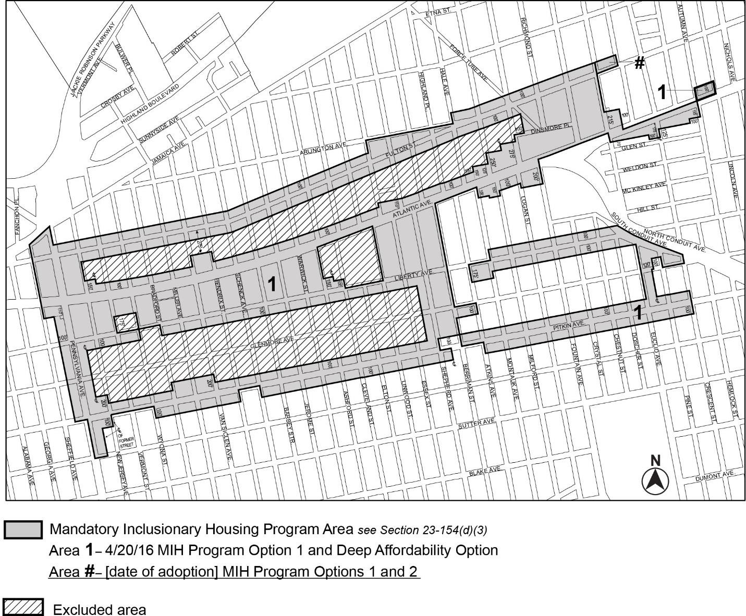

[*MODIFIED MAP*]

Portion of Community District 5, Brooklyn
* * *

Adopted.

Office of the City Clerk, }
The City of New York, } ss.:

I hereby certify that the foregoing is a true copy of a Resolution passed by The Council of The City of New York on ___________, 2022, on file in this office.

.....................................................
City Clerk, Clerk of The Council

