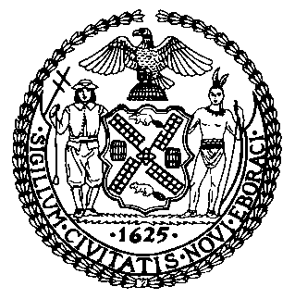 | The Council of the City of New York  Finance Division  Latonia Mckinney, Director  Fiscal Impact Statement  Proposed Int. No. 2034-A  Committee: Cultural Affairs, Libraries and International Intergroup Relations
Title: A Local Law to amend the administrative code of the city of New York, in relation to coordinating the use of open space for art and cultural programming | Sponsors: By Council Members Cumbo, Van Bramer, Kallos, Vallone, Chin, Richards and Cornegy
Summary of Legislation: Proposed Int. No. 2034-A would require the Mayor’s Office of Citywide Event Coordination and Management (CECM), in consultation with the Department of Cultural Affairs (DCLA), the Department of Parks and Recreation (Parks), the Department of Information, Technology and Telecommunications (DoITT) and any other relevant agency or office, to create a website that would provide information on open spaces, such as roadways, parks, or pedestrian plazas, designated by the City for art and cultural programming, facilitate the use of such space by art and cultural institutions and allow users to search for such open space on a map. The website would also allow users to search for information about outdoor programs offered by art and cultural institutions that are coordinated by CECM and provide information about other events either hosted by art and cultural institutions or outdoor events held on private property, to the extent such information is provided to CECM.
Effective Date: This local law would take effect 90 days after it becomes law.
Fiscal Year In Which Full Fiscal Impact Anticipated: Fiscal 2022
Fiscal Impact Statement:

 | Effective FY21 | FY Succeeding  Effective FY22 | Full Fiscal  Impact FY22
Revenues (+) | $0 | $0 | $0
Expenditures (-) | $0 | $0 | $0
Net | $0 | $0 | $0

Impact on Revenues: It is anticipated that there would be no impact on revenues resulting from the enactment of this legislation.
Impact on Expenditures: It is estimated that there would be no fiscal impact on expenditures resulting from the enactment of this legislation as the designated agencies would use existing resources to fulfill its requirements.
Source of Funds To Cover Estimated Costs: N/A
Source of Information: New York City Council Finance Division
Mayor’s Office of Legislative Affairs
Estimate Prepared by: Aliya Ali, Principal Financial Analyst

Estimate Reviewed by: Stephanie Ruiz, Assistant Counsel
Nathan Toth, Deputy Director
Crilhien Francisco, Unit Head
Legislative History: This legislation was introduced to the Council on August 27, 2020 as Int. No. 2034, and was referred to the Committee on Cultural Affairs, Libraries and International Intergroup Relations (Committee). A hearing was held by the Committee jointly with the Committee on Economic Development on September 24, 2020, and the legislation was laid over. The legislation was subsequently amended and the amended version, Proposed Int. No. 2034-A, will be voted on by the Committee at a hearing on December 10, 2020. Upon successful vote by the Committee, Proposed Int. No. 2034-A will be submitted to the full Council for a vote on December 10, 2020.
Date Prepared: November 12, 2020

