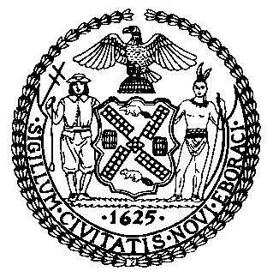 | The Council of the City of New York  Finance Division  Latonia Mckinney, Director  Fiscal Impact Statement  Proposed Intro. No 1075-A:  Committee: Sanitation and Solid Waste Management
Title: A Local Law in relation to an organic waste curbside collection pilot program | Sponsors: The Public Advocate (Ms. James), Council Members Holden and Kallos
Summary of Legislation: Proposed Int. No. 1075-A would mandate the Department of Sanitation (“DSNY”) to establish a pilot program for the curbside collection of organic waste from select buildings wholly occupied by one or more City agencies and institutional special use buildings, which are not-for-profits receiving DSNY collection service. Furthermore, DSNY would be required to conduct outreach and provide education to occupants of the buildings participating in the pilot program. Lastly, the legislation would mandate a report from DSNY that would include, but not be limited to, the amount of organic waste diverted from landfill and feedback from occupants of participating buildings. The pilot program would begin no later than July 1, 2019 and operate through at least until June 30, 2021, while the report would be due no later than October 31, 2021.

Effective Date: This local law would take effect immediately.

Fiscal Year in Which Full Fiscal Impact Anticipated: Fiscal 2020

Fiscal Impact Statement:
 | Effective FY19 | FY Succeeding Effective FY20 | Full Fiscal Impact FY20
Revenues | $0 | $0 | $0
Expenditures | $0 | $0 | $0
Net | $0 | $0 | $0

Impact on Revenues: It is anticipated that there would be no impact on revenues resulting from the enactment of this legislation.

Impact on Expenditures: It is anticipated that there would be no impact on expenses resulting from the enactment of this legislation because DSNY would utilize current budgeted headcount vacancies, to hire pilot program support personnel. Additionally, DSNY’s supply budget would be able to absorb the additional other than personnel services expenditures associated the pilot.
Source of Funds to Cover Estimated Costs: N/A

Source of Information: Mayor’s Office of City Legislative Affairs
New York City Council Finance Division

Estimate Prepared by: Jon Seltzer, Senior Financial Analyst, Finance Division

Estimate Reviewed by: Crilhien Francisco, Unit Head, Finance Division
Nathan Toth, Deputy Director, Finance Division
Rebecca Chasan, Senior Counsel, Finance Division
Stephanie Ruiz, Assistant Counsel, Finance Division
Legislative History: This legislation was introduced by the City Council as Proposed Introduction No. 1075 on August 8, 2018 and was referred to the Committee on Sanitation and Solid Waste Management (“Committee”). The legislation was subsequently amended and on December 18, 2018 a hearing was held on the amended version, Proposed Intro. 1075-A, and the bill was laid over. Proposed Intro. 1075-A will be voted on by the Committee at a hearing on December 19, 2018. Upon a successful vote by the Committee, the bill will be voted on by the full Council on December 20, 2018
Date Prepared: December 18, 2018

