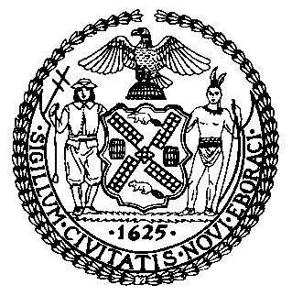 | The Council of the City of New York  Finance Division  Latonia McKinney, Director  Fiscal Impact Statement  Proposed Intro No. 1420-C  Committee: Governmental Operations
Title: A Local Law in relation to requiring a study and report on 311 complaints resulting in unconfirmed conditions | Sponsors: Council Members Matteo, Holden, Ayala, Yeger, Louis and Ulrich
Summary of Legislation: This bill would require an office or agency designated by the Mayor to collaborate with certain agencies to study the frequency of anonymous 311 complaints for the period beginning on January 1, 2016 and ending on December 31, 2020, and whether such complaints are more likely than other complaints to be unsubstantiated. Such study would also seek to identify patterns of unsubstantiated complaints against specific properties. A report on the findings of this study would be due to the Council on December 1, 2021. Such report would be required to include recommendations on the types of 311 complaints that agencies should allow to be made anonymously.
Effective Date: This local law would take effect immediately
Fiscal Year in which Full Fiscal Impact Anticipated: Fiscal 2022
Fiscal Impact Statement:
 | Effective FY21 | FY Succeeding  Effective FY22 | Full Fiscal Impact FY22
Revenues (-) | $0 | $0 | $0
Expenditures (+) | $0 | $0 | $0
Net | $0 | $0 | $0

Impact on Revenues: It is estimated that there would be no impact on revenues resulting from the enactment of this legislation.

Impact on Expenditures: It is estimated that there would be no impact on expenditures resulting from the enactment of this legislation because the relevant agencies would use existing resources to accomplish its requirements.

Source of Funds to Cover Estimated Costs: N/A

Sources of Information: New York City Council Finance Division
Mayor’s Office of Legislative Affairs
Office of Management and Budget

Estimate Prepared by: Sebastian Palacio Bacchi, Senior Financial Analyst

Estimate Reviewed by: Nathaniel Toth, Deputy Director
John Russell, Unit Head
Noah Brick, Assistant Counsel
Legislative History: This legislation was introduced to the Council as Intro. No. 1420 on February 13, 2019 and was referred to the Committee on Governmental Operations (Committee). The Committee heard the legislation at a joint hearing with the Committee on Technology on January 21, 2020, and the legislation was laid over. The legislation was subsequently amended twice, and the most recent version, Proposed Intro. 1420-C, will be considered by the Committee on January 28, 2021. Upon a successful vote by the Committee, Proposed Int. 1420-C will be submitted to the full Council for a vote on January 28, 2021.
Date Prepared: January 21, 2021

