THE COUNCIL OF THE CITY OF NEW YORK
RESOLUTION NO. 1597

Resolution approving the decision of the City Planning Commission on Application No. N 210104 ZRX, for an amendment of the text of the Zoning Resolution (Preconsidered L.U. No. 751).

By Council Members Salamanca and Moya

WHEREAS, WEBSTER 1099 REALTY LLC, filed an application pursuant to Section 201 of the New York City Charter, for an amendment of the text of the Zoning Resolution of the City of New York, modifying APPENDIX F for the purpose of establishing a Mandatory Inclusionary Housing area, which in conjunction with the related action would facilitate a mixed-used development consisting of one nine-story and one 11-story building, totaling 280,000-square-feet with residential and 30,000 square feet of ground-floor commercial uses at 1099 Webster Avenue in the East Concourse neighborhood of Bronx, Community District 4 (Application No. N 210104 ZRX) (the “Application”);

WHEREAS, the City Planning Commission filed with the Council on March 3, 2021, its decision dated March 3, 2021 (the “Decision”), on the Application;

WHEREAS, the Application is related to application C 210103 ZMX (Pre. L.U. No. 750), a zoning map amendment to rezone an M1-1, R7-1 and R7-1/C1-4 district to an R7X/C2-4 district;

WHEREAS, the Decision is subject to review and action by the Council pursuant to Section 197-d of the City Charter;

WHEREAS, upon due notice, the Council held a public hearing on the Decision and Application on March 4, 2021;

WHEREAS, the Council has considered the land use implications and other policy issues relating to the Decision and Application; and

WHEREAS, the Council has considered the relevant environmental issues, including the negative declaration issued October 19th, 2020 (CEQR No. 19DCP115X) which includes an (E) designation to avoid the potential for significant adverse impacts related to air quality and noise (E-576) (the “Negative Declaration”).

RESOLVED:

The Council finds that the action described herein will have no significant impact on the environment as set forth in the (E) Designation (E-576) and Negative Declaration.

Pursuant to Sections 197-d and 200 of the City Charter and on the basis of the Decision and Application, and based on the environmental determination and consideration described in the report, N 210104 ZRX, incorporated by reference herein, and the record before the Council, the Council approves the Decision of the City Planning Commission.

Matter underlined is new, to be added;
Matter struck out is to be deleted;
Matter within # # is defined in Section 12-10;
* * * indicates where unchanged text appears in the Zoning Resolution

* * *
APPENDIX F
Inclusionary Housing Designated Areas and Mandatory Inclusionary Housing Areas
* * *
BRONX
* * *
Bronx Community District 4

* * *
Map 3- March 3, 2021

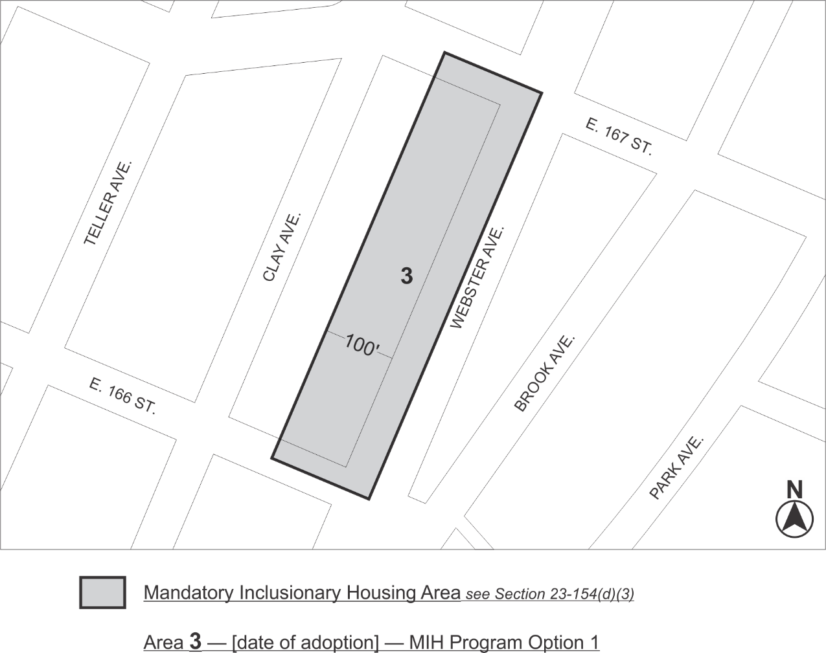

Portion of Community District 4, The Bronx

Adopted.

Office of the City Clerk, }
The City of New York, } ss.:

I hereby certify that the foregoing is a true copy of a Resolution passed by The Council of The City of New York on March 25, 2021, on file in this office.

.....................................................
City Clerk, Clerk of The Council

