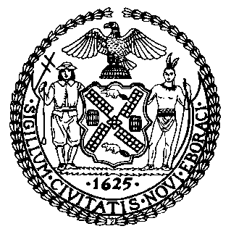 | The Council of the City of New York  Finance Division  Tanisha S. Edwards, Esq. Chief Financial Officer and Deputy Chief of Staff to the Speaker, New York City Council  Fiscal Impact Statement  Proposed Int. No. 106-A  Committee: Fire and Emergency Management
Title: A Local Law to amend the administrative code of the city of New York, in relation to the sale of electric space heaters. | Sponsors: Council Members Hanif, Public Advocate Jumaane Williams, Sanchez, Powers, Feliz, Riley, Yeger, Krishnan, Brannan, Williams, Won, Holden, Farías, Avilés, Ung, Abreu, Richardson Jordan, Gutiérrez, Hanks, De La Rosa, Schulman, Narcisse, Barron, Dinowitz, Nurse, Bottcher, Rivera, Joseph, Brewer, Velázquez, Ossé, Ayala, Cabán, and Ariola.
Summary of Legislation: Proposed Intro. No. 106-A would prohibit the sale of electric space heaters without certain safety features; specifically, requiring all such devices for sale to be equipped with a thermostat, an automatic function that disables the device upon tip-over or overheating, and be certified by a nationally recognized testing laboratory.
Effective Date: This local law would take effect 120 days after it becomes law.
Fiscal Year In Which Full Fiscal Impact Anticipated: Fiscal 2024
Fiscal Impact Statement:

 | Effective FY23 | FY Succeeding  Effective FY23 | Full Fiscal  Impact FY24
Revenues (+) | $0 | $0 | $0
Expenditures (-) | $0 | $0 | $0
Net | ($0) | ($0) | ($0)

Impact on Revenues: It is anticipated that there would be no impact on revenues resulting from the enactment of this legislation.
Impact on Expenditures: It is anticipated that the Department of Consumer and Worker Protection would use existing resources to comply with the enactment of this legislation.
Source of Funds To Cover Estimated Costs: N/A
Source of Information: New York City Council Finance Division
Mayor’s Office of City Legislative Affairs
Fire Department of New York
Office of Management and Budget
Estimate Prepared by: Jack Kern, Senior Financial Analyst

Estimate Reviewed by: Malcom Butehorn, Counsel
Eisha Wright, Deputy Director
Dohini Sompura, Assistant Director
John Russell, Unit Head

Legislative History: This legislation was introduced by the City Council on March 24, 2022 as Intro. 106 and referred to the Committee on Fire and Emergency Management. The legislation was heard at a joint hearing by the Committee on Fire and Emergency Management, the Committee on Housing and Buildings, and the Special Committee on Twin Parks Citywide Taskforce on Fire Prevention on April 6, 2022. The legislation was laid over and subsequently amended. The amended version, Proposed Intro. No. 106-A, will be voted on by the Committee on Fire and Emergency Management at a hearing on May 18, 2022. Upon successful vote by the Committee, Proposed Intro. No. 106-A will be submitted to the full Council for a vote on May 19, 2022.

Date Prepared: May 18, 2022

