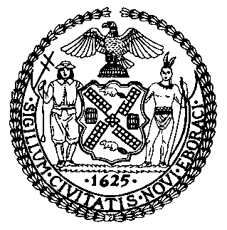 | The Council of the City of New York  Finance Division  Latonia McKinney, Director  Fiscal Impact Statement  Proposed Int. No: 2265-B  Committee: Housing and Buildings
Title: A Local Law to amend the administrative code of the city of New York, in relation to stove safety knobs | Sponsors: Council Members Cumbo, Chin, Kallos, Louis and Rivera
Summary of Legislation: Proposed Int. No. 2265-B would amend the Housing Maintenance Code by requiring owners of units in multiple dwellings to provide to tenants with either permanent stove safety knobs with integrated locking mechanisms or stove knob covers for each knob located on the front of each gas-powered stove at the tenant’s option. This bill would also require owners of such units to keep a record of outreach to tenants regarding the installation of permanent stove safety knobs with integrated locking mechanism or stove knob covers.

Effective Date: This local law would take effect 180 days after becoming law, provided that the requirement to provide an annual notice to each tenant of a unit regarding the owner's obligation to provide permanent stove safety knobs with integrated locking mechanisms or stove knob covers shall only apply after such date.

Fiscal Year In Which Full Fiscal Impact Anticipated: Fiscal 2023
Fiscal Impact Statement:
 | Effective FY22 | FY Succeeding Effective FY23 | Full Fiscal Impact FY23
Revenues | $0 | $0 | $0
Expenditures | $0 | $0 | $0
Net | $0 | $0 | $0
Impact on Revenues: It is estimated that there would be no impact on revenues resulting from the enactment of this legislation.

Impact on Expenditures: It is estimated that there would be no impact on expenditures resulting from the enactment of this legislation as the required costs would be borne by private parties.
Source of Funds to Cover Estimated Costs: N/A
Source of Information: New York City Council Finance Division
Mayor’s Office of Legislative Affairs
Estimate Prepared by: John Basile, Senior Financial Analyst

Estimate Reviewed by: Chima Obichere, Unit Head
Stephanie Ruiz, Assistant Counsel
Legislative History: This legislation was first introduced to the Council as Intro. No. 2265 on April 22, 2021 and referred to the Committee on Housing and Buildings (Committee). A hearing was held by the Committee on September 13, 2021 and the bill was laid over. The legislation was subsequently amended twice and the last amended version, Proposed Int. No. 2265-B, will be considered by the Committee on December 14, 2021. Upon a successful vote by the Committee, Proposed Int. No. 2265-B will be submitted to the full Council for a vote on December 15, 2021.
Date Prepared: December 13, 2021

