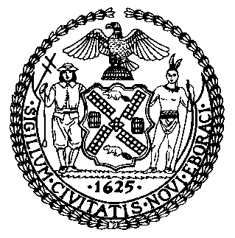 | The Council of the City of New York  Finance Division  Latonia Mckinney, Director  Fiscal Impact Statement  Proposed Intro. No: 176-A  Committee: Transportation
Title: A Local Law to amend the administrative code of the city of New York, in relation to creating an interagency task force on removing certain vehicles from public streets | Sponsors: Council Members Maisel, Holden, Chin, Adams, Kallos, Miller, and Ulrich
Summary of Legislation: Proposed Intro. No. 176-A would create an interagency task force to study the City’s existing system of removing from public streets vehicles that have been abandoned or parked without license plates or proper registration. The task force would collect information about the effectiveness of current practices and evaluate potential solutions to this problem in a final report, due no later than one year after the local law would take effect. The task force would consist of the Commissioner of Transportation, the Commissioner of Sanitation, and the Police Commissioner, or the respective designee of each such commissioner, and two additional members appointed by the Mayor. After submission of the required report, the task force would disband.

Effective Date: This local law would take effect immediately.

Fiscal Year In Which Full Fiscal Impact Anticipated: Fiscal 2022
Fiscal Impact Statement:
 | Effective FY21 | FY Succeeding Effective FY22 | Full Fiscal Impact FY22
Revenues | $0 | $0 | $0
Expenditures | $0 | $0 | $0
Net | $0 | $0 | $0
Impact on Revenues: It is estimated that there would be no impact on revenues resulting from the enactment of this legislation.

Impact on Expenditures: It is estimated that there would be no impact on expenditures because the agencies responsible for implementing the requirements of the legislation would use existing resources to comply with the provisions of the local law.
Source of Funds to Cover Estimated Costs: N/A
Source of Information: New York City Council Finance Division
Mayor’s Office of Legislative Affairs
Estimate Prepared by: John Basile, Senior Financial Analyst

Estimate Reviewed by: Nathaniel Toth, Deputy Director
Chima Obichere, Unit Head
Stephanie Ruiz, Assistant Counsel
Legislative History: This legislation was first introduced to the Council as Intro. No. 176 on January 31, 2018 and referred to the Committee on Transportation (Committee). A hearing was held by the Committee jointly with the Committee on Finance and the Committee on Governmental Operations on April 29, 2019 and the bill was laid over. The legislation was subsequently amended and the amended version, Proposed Intro. No. 176-A, will be considered by the Committee on May 26, 2021. Upon a successful vote by the Committee, Proposed Intro. No. 176-A will be submitted to the full Council for a vote on May 27, 2021.
Date Prepared: May 24, 2021

