THE COUNCIL OF THE CITY OF NEW YORK
RESOLUTION NO. 783

Resolution approving the decision of the City Planning Commission on Application No. N 180281 ZRQ, for an amendment of the text of the Zoning Resolution (L.U. No. 331).

By Council Members Salamanca and Moya

WHEREAS, the City Planning Commission filed with the Council on January 22, 2019 its decision dated January 9, 2019 (the "Decision"), on the application submitted by 241-15 Northern, LLC and North Shore Realty Group Corporation, Inc., pursuant to Section 201 of the New York City Charter, for an amendment of the text of the Zoning Resolution of the City of New York, modifying
Appendix F for the purpose of establishing a Mandatory Inclusionary Housing Area, which in conjunction with the related action would facilitate the development of an eight-story residential building and a five-story mixed-use building on two noncontiguous development sites located on and in the vicinity of the northwest corner of Douglaston Parkway and Northern Boulevard in the Douglaston neighborhood of Queens Community District 11, (Application No. N 180281 ZRQ), (the "Application");

WHEREAS, the Application is related to application C 060432 ZMQ (L.U. No. 332), a zoning map amendment to change an R1-2 district to R6A and R6A/C1-2 districts;

WHEREAS, the Decision is subject to review and action by the Council pursuant to Section 197-d(b)(1) of the City Charter;

WHEREAS, upon due notice, the Council held a public hearing on the Decision and Application on January 31, 2019;

WHEREAS, the Council has considered the land use implications and other policy issues relating to the Decision and Application; and

WHEREAS, the Council has considered the relevant environmental issues, including the negative declaration issued August 20, 2018 (CEQR No. 06DCP092Q), which includes an (E) designation to avoid the potential for significant adverse impacts related to air quality, noise, and hazardous material (E-494) (the “Negative Declaration”).

RESOLVED:

The Council finds that the action described herein will have no significant impact on the environment as set forth in the Negative Declaration.

Pursuant to Sections 197-d and 200 of the City Charter and on the basis of the Decision and Application, and based on the environmental determination and consideration described in the report, N 180281 ZRQ, incorporated by reference herein, and the record before the Council, the Council approves the Decision of the City Planning Commission.

Matter underlined is new, to be added;
Matter struck out is to be deleted;
Matter within # # is defined in Section 12-10;
*** indicates where unchanged text appears in the Zoning Resolution.

* * *

APPENDIX F
Inclusionary Housing Designated Areas and Mandatory Inclusionary Housing Areas

* * *
QUEENS

* * *

Queens Community District 11

* * *

Map 4 – [date of adoption]

[PROPOSED MAP]

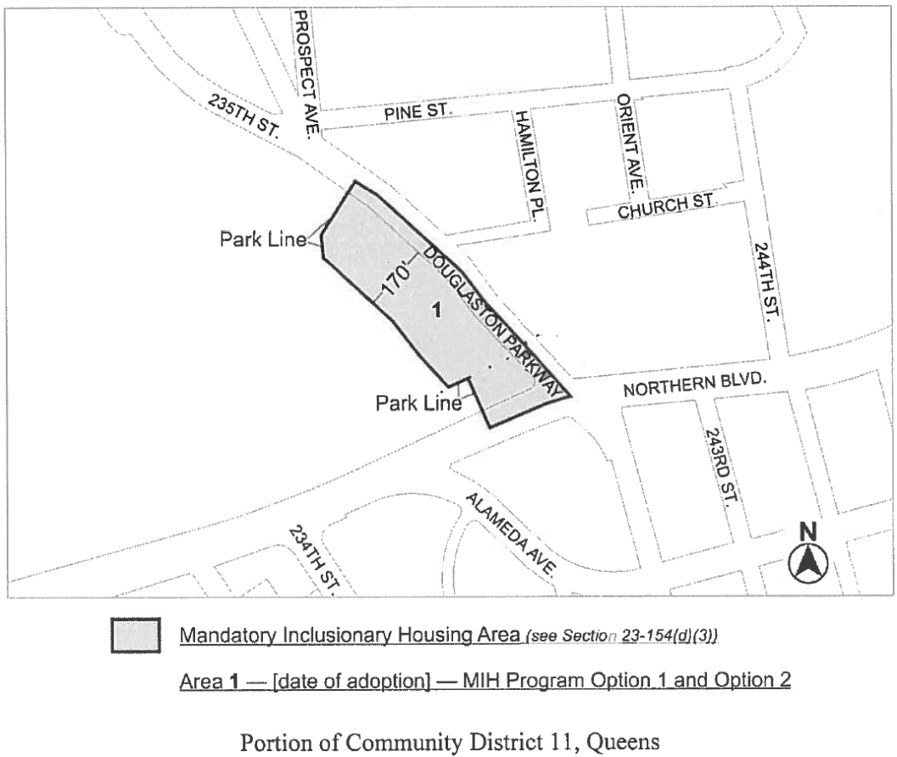

* * *

Adopted.

Office of the City Clerk, }
The City of New York, } ss.:

I hereby certify that the foregoing is a true copy of a Resolution passed by The Council of The City of New York on March 13, 2019, on file in this office.

.....……......................................... City Clerk, Clerk of The Council

