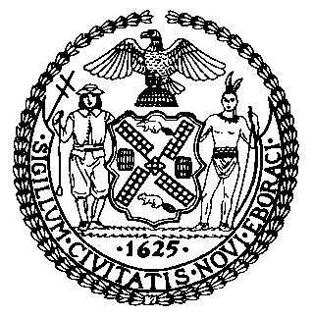 | The Council of the City of New York  Finance Division  Latonia Mckinney, Director  Fiscal Impact Statement  Proposed Intro. No: 1167-A  Committee: Health
Title: A local law to amend the administrative code of the city of New York, in relation to the repair of damaged water tanks | Sponsors: Council Member Salamanca, Kallos, Rosenthal and Constantinides
Summary of Legislation: Proposed Intro. 1167-A would require building owners to repair damage to water tanks or its supporting structures, and imposes a civil penalty for failure to do so

Effective Date: This local law would take effect on the same date as a local law amending the administrative code of the city of New York, relating to qualifications for persons conducting inspections and maintenance on drinking water tanks, as proposed in introduction number 1157-A for the year 2018, takes effect, except that the commissioner may take such actions as are necessary for the implementation of this local law, including the promulgation of rules, before such date.

Fiscal Year In Which Full Fiscal Impact Anticipated: Fiscal 2021
Fiscal Impact Statement:

 | Effective FY20 | FY Succeeding Effective FY21 | Full Fiscal Impact FY21
Revenues | $0 | $0 | $0
Expenditures | $0 | $0 | $0
Net | $0 | $0 | $0

Impact on Revenues: It is anticipated that the proposed legislation would not affect revenues.

Impact on Expenditures: It is anticipated that there would be no impact on expenditures resulting from the enactment of Proposed Intro. 1167-A because the relevant City agencies would utilize existing resources to fulfill the legislation.

Source of Funds To Cover Estimated Costs: N/A
Source of Information: New York City Council Finance Division
Department of Health and Mental Hygiene
Estimate Prepared By: Lauren Hunt, Financial Analyst

Estimate Reviewed By: Nathan Toth, Deputy Director, NYC Council Finance Division
Crilhien R. Francisco, Unit Head, NYC Council Finance Division
Noah Brick, Assistant Counsel, NYC Council Finance Division
Legislative History: This legislation was introduced to the full Council on October 17, 2018 and was referred to the Committee on Health (the Committee). A hearing was held by the Committee on October 30, 2018 and the bill was laid over. The legislation was subsequently amended and the amended version, Proposed Intro. 1167-A, will be voted on by the Committee at a hearing on April 8, 2019. Upon a successful vote by the Committee, Proposed Intro. No. 1167-A will be submitted to the full Council for a vote on April 9, 2019.
Date Prepared: April 2, 2019

