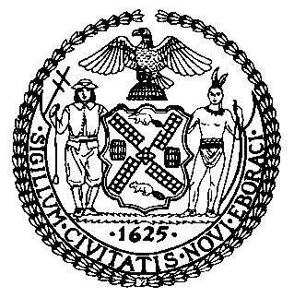 | The Council of the City of New York  Finance Division  Latonia McKinney, Director  Fiscal Impact Statement  Intro. No. 2136  Committee: Finance
title: A Local Law to amend the administrative code of the city of New York, in relation to authorizing an increase in the amount to be expended annually in two business improvement districts | Sponsors: Council Members Dromm and Louis (by request of the Mayor)

Summary of Legislation: Business Improvement Districts (BIDs) raise funding, primarily through special assessments, to provide services independent of those already provided by the City. Special assessments are additional charges billed to property owners within a BID that are collected as part of the City’s property tax collection system. This legislation would authorize the Bryant Park BID to increase the amount it expends annually from $1,600,000 to $2,500,000 and would authorize the Flatbush-Nostrand Junction BID to increase the amount it expends annually from $200,000 to $350,000, in both cases retroactive to July 1, 2020.

Effective Date: This local law would take effect immediately and be retroactive to and deemed to have been in effect as of July 1, 2020.

Fiscal Year in Which Full Fiscal Impact Anticipated: Fiscal Year 2021

Fiscal Impact Statement:

 | Effective FY21 | FY Succeeding  Effective FY22 | Full Fiscal  Impact FY21
Revenues (+) | $0 | $0 | $0
Expenditures (-) | $0 | $0 | $0
Net | $0 | $0 | $0

Impact on Revenues And Expenditures: There would be no net impact on revenues or expenditures resulting from the enactment of this legislation. The BID assessments are charges separate from the City’s property tax levy and do not contribute to the General Fund. The assessments are levied on the businesses located in the impacted BIDs. The authorized expenditures for Fiscal 2021 will increase from the Fiscal 2020 amounts.

Source of Funds to Cover Estimated Costs: BID special assessments

Source of Information: New York City Council Finance Division
Mayor’s Office of City Legislative Affairs

Estimate Prepared by: Luke Zangerle, Finance Analyst, Finance Division

Estimate Reviewed by: Chima Obichere, Unit Head
Noah Brick, Assistant Counsel

Legislative History: Intro. No. 2136 was introduced to the full Council on October 29, 2020 and referred to the Committee on Finance (Committee). The Committee will consider and vote on the legislation on November 19, 2020. Upon a successful vote by the Committee, the legislation will be submitted to the full Council for a vote on November 19, 2020.

Date Prepared: November 13, 2020

