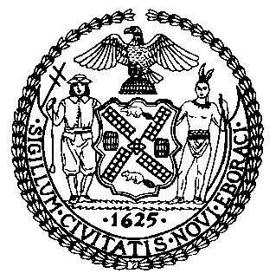 | The Council of the City of New York  Finance Division  Latonia Mckinney, Director  Fiscal Impact Statement  Proposed Intro. No: 425-A  Committee: Environmental Protection
Title: A Local Law to amend the administrative code of the city of New York, in relation to requiring the city to prepare a plan to prevent confirmed sewer backups | Sponsor: By Council Members Constantinides and Yeger
Summary of Legislation: Proposed Intro. 425-A would require the Department of Environmental Protection (DEP or the Department) to prepare and submit a plan to the Mayor and the Speaker of the Council by no later than December 31, 2019, on how to prevent sewer backups, to reduce sewer backups and to target recurring backups. Furthermore, this bill would require DEP to review the tree root control strategies of other municipalities and, following the review, consider recommending tree root control strategies for private property owners in the plan.

Effective Date: This local law would take effect immediately.

Fiscal Year in Which Full Fiscal Impact Anticipated: Fiscal 2020

Fiscal Impact Statement:

 | Effective FY19 | FY Succeeding Effective FY20 | Full Fiscal Impact FY20
Revenues | $0 | $0 | $0
Expenditures | $0 | $0 | $0
Net | $0 | $0 | $0

Impact on Revenues: It is anticipated that there would be no impact on revenues resulting from the enactment of this legislation.

Impact on Expenditures: It is anticipated that there would be no impact on expenses resulting from the enactment of this legislation because the Department would use existing resources to implement the requirements of this legislation.
Source of Funds to Cover Estimated Costs: N/A

Source of Information: New York City Council Finance Division
Mayor’s Office of Legislative Affairs

Estimate Prepared by: Jonathan Seltzer, Senior Financial Analyst, Finance Division

Estimate Reviewed by: Crilhien Francisco, Unit Head, Finance Division
Nathan Toth, Deputy Director, Finance Division
Stephanie Ruiz, Assistant Counsel, Finance Division
Legislative History: This legislation was introduced by the City Council as Intro.425 on February 14, 2018 and was referred to the Committee on Environmental Protection. A hearing was held by the Committee on Environmental Protection on June 25, 2018, and the bill was laid over. The legislation was subsequently amended and the amended version, Proposed Intro. 425-A, will be voted on by the Committee on Environmental Protection at a hearing on February 25, 2019. Upon successful vote by the Committee, Proposed Intro. 425-A will be submitted to the Council for a vote on February 28, 2019.
Date Prepared: February 22, 2019

