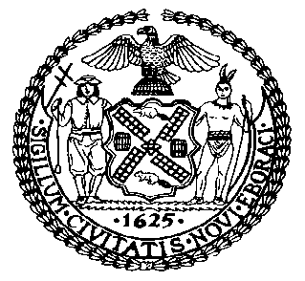 | The Council of the City of New York  Finance Division  Latonia McKinney, Director  Fiscal Impact Statement  Intro. No: 1158  Committee: Housing and Buildings
Title: A Local Law to amend the administrative code of the city of New York, in relation to holding information sessions and posting information online to provide guidance to building owners regarding maintenance and inspections of cooling towers | Sponsors: Council Members Levine, Kallos, Yeger, Diaz, Koo and Gibson
Summary of Legislation: Intro. No. 1158 would require the Department of Health and Mental Hygiene (DOHMH), in consultation with the Department of Buildings (DOB), to hold information sessions at least twice annually for building owners regarding the maintenance, cleaning, and inspections of cooling towers, and to post such information publically online.

Effective Date: This legislation would take effect 90 days after it becomes law.
Fiscal Year In Which Full Fiscal Impact Anticipated: Fiscal 2021
Fiscal Impact Statement:

 | Effective FY20 | FY Succeeding Effective FY21 | Full Fiscal Impact FY21
Revenues | $0 | $0 | $0
Expenditures | $0 | $0 | $0
Net | $0 | $0 | $0

Impact on Revenues: It is estimated that there would be no impact on revenues resulting from the enactment of this legislation.
Impact on Expenditures: It is estimated that there would be no impact on expenditures resulting from the enactment of this legislation because existing resources would be used by DOHMH and DOB to implement its provisions.
Source of Funds To Cover Estimated Costs: N/A.

Source of Information: New York City Council Finance Division

Estimate Prepared by: Sarah Gastelum, Principal Financial Analyst

Estimated Reviewed by: Noah Brick, Assistant Counsel
Chima Obichere, Unit Head

Legislative History: This legislation was introduced to the full Council on October 17, 2018, as Intro. No. 1158 and was referred to the Committee on Housing and Buildings. A joint hearing was held by the Committee on Housing and Buildings and the Committee on Health on October 23, 2018 and the legislation was laid over. The Housing and Buildings Committee will vote on Intro. No. 1158 on March 25, 2019. Following a successful vote by the Housing and Buildings Committee, the bill would be submitted to the full Council for a vote on March 28, 2019.

Date Prepared: March 21, 2019

