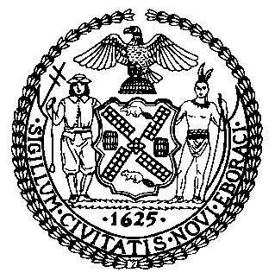 | The Council of the City of New York  Finance Division  Latonia McKinney, Director  Fiscal Impact Statement  Proposed Int. No. 1396-A  Committee: Civil Service and Labor
Title: A Local Law to amend the administrative code of the City of New York, in relation to fast food employee layoffs. | Sponsors: Adams, Lander, Moya, Ayala, Cabrera, Brannan, Eugene, Levine, Menchaca, Rosenthal, Kallos, Reynoso, Van Bramer, Salamanca, Chin, Cohen, Rivera, Treyger, Levin, Ampry-Samuel, Cumbo, Torres, Koslowitz, Rodriguez, Constantinides, Gibson, Powers, Vallone, Rose, Louis and Cornegy

Summary of Legislation: This legislation would provide that a fast food employer may discharge an employee for a bona fide economic reason, but must do so in reverse order of seniority in the establishment in question. The bill additionally provides for arbitration of discharge disputes between fast food employers and employees.

Effective Date: The local law would take effect at the same time and in the same manner as Int. 1415-A.

Fiscal Year In Which Full Fiscal Impact Anticipated: Fiscal 2022
Fiscal Impact Statement:

 | Effective  FY21 | FY Succeeding  Effective FY22 | Full Fiscal Impact  FY22
Revenues | $0 | $0 | $0
Expenditures | $0 | $0 | $0
Net | $0 | $0 | $0

Impact on Revenues: It is anticipated that there would be no impact on revenues resulting from this legislation.
Impact on Expenditures: It is estimated that there would be no impact on expenditures resulting from the enactment of this legislation, as it is anticipated that existing resources would be utilized to fulfill its requirements, including the provision of interpreters when required for arbitrations, which would be subject to reimbursement by employers whenever employees prevail.
Source of Funds To Cover Estimated Costs: N/A
Source of Information: New York City Council Finance Division
Estimate Prepared by: John Cheng, Financial Analyst
Estimate Reviewed by: John Russell, Unit Head
Noah Brick, Assistant Counsel
Legislative History: This legislation was introduced to the Council on February 13, 2019, and was referred to the Committee on Civil Service and Labor (Committee). A hearing was held by the Committee on February 13, 2020, and the legislation was laid over. The legislation was subsequently amended, and the amended version, Proposed Int. No. 1396-A, will be considered by the Committee on December 15, 2020. Upon successful vote by the Committee, the Proposed Int. No. 1396-A will be submitted to the full Council for a vote on December 17, 2020.
DATE PREPARED: December 15, 2020

