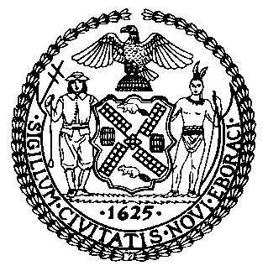 | The Council of the City of New York  Finance Division  Latonia Mckinney, Director  Fiscal Impact Statement  Proposed Intro. No: 713-A  Committee: Youth Services
Title: A Local Law to amend the administrative code of the city of New York, in relation to runaway and homeless youth information posting and reporting requirements. | Sponsors: Council Members Van Bramer, Rose, Chin, Kallos and Lander
Summary of Legislation: Proposed Intro. 713-A would require prominent signage within runaway and homeless youth (RHY) services funded by the Department of Youth and Community Development (DYCD) indicating where to call 24 hours a day with questions, comments or complaints regarding RHY services. The signage would include where to find rules governing RHY service and participant conduct and phone numbers to access mental health resources 24 hours a day. DYCD would annually report the number of RHY questions, comments and complaints received and their general nature, such as facility conditions, lack of resources, failure to provide information required by law and treatment by RHY staff or service participants. DYCD would also indicate the status of its responses to and any RHY service changes made as a result of reported calls.

Effective Date: This local law would take effect 180 days after it becomes law.

Fiscal Year in Which Full Fiscal Impact Anticipated: Fiscal 2020
Fiscal Impact Statement:
 | Effective FY19 | FY Succeeding Effective FY20 | Full Fiscal Impact FY20
Revenues | $0 | $0 | $0
Expenditures | $0 | $0 | $0
Net | $0 | $0 | $0

Impact on Revenues: It is anticipated that there would be no impact on revenues as a result of this legislation.

Impact on Expenditures: It is anticipated that there would be no impact on expenditures as a result of this legislation because existing resources would be used to implement the legislation.

Source of Funds To Cover Estimated Costs: N/A

Source of Information: Department of Youth and Community Development

Estimate Prepared by: Michele Peregrin, Financial Analyst
Estimate Reviewed by: Regina Poreda Ryan, Deputy Director
Eisha Wright, Unit Head
Rebecca Chasan, Counsel
Legislative History: This legislation was introduced to the Council on March 7, 2018 as Intro. No. 713 and referred to the Committee on Youth Services. A hearing was held by the Committee on Youth Services on April 26, 2018 and the bill was laid over. The legislation was subsequently amended and the amended version, Proposed Intro. No. 713-A, will be voted on by the Committee on Youth Services at a hearing on September 26, 2018. Upon successful vote by the Committee, Proposed Intro. No. 713-A will be submitted to the full Council for a vote on September 26, 2018.
Date Prepared: September 24, 2018

