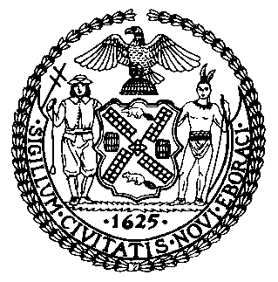 | The Council of the City of New York  Finance Division  Latonia Mckinney, Director  Fiscal Impact Statement  Proposed Intro. No: 1724-A  Committee: Transportation
Title: A Local Law to amend the administrative code of the city of New York, in relation to creating a demonstration program to use photographic evidence to impose liability on vehicle owners for passing a stopped school bus and providing for the repeal of such provision upon the expiration thereof | Sponsors: Kallos, Rodriguez, Treyger, Holden, Ayala, Rivera, Brannan, Cornegy, Powers, Rosenthal, Van Bramer, Gennaro and Dinowitz
Summary of Legislation: Proposed Intro. No. 2417-A would create a demonstration program to monitor vehicle operators, using images from stationary cameras or cameras affixed to the sides of school buses, for failure to stop for a school bus displaying a red visual signal. Under this program, liability and penalties would be imposed on the owners of such vehicles.
Effective Date: This local law would take effect 90 days after it becomes a law and expire and be deemed repealed on December 1, 2024.
Fiscal Year In Which Full Fiscal Impact Anticipated: Fiscal 2023
Fiscal Impact Statement:
 | Effective FY22 | FY Succeeding Effective FY23 | Full Fiscal Impact FY23
Revenues | $0 | $0 | $0
Expenditures | $0 | $0 | $0
Net | $0 | $0 | $0
Impact on Revenues: It is estimated that there would be no impact on revenues resulting from the enactment of this legislation as full compliant with the provisions of this legislation is anticipated.
Impact on Expenditures: It is anticipated that there would be no impact on expenditures resulting from the enactment of this legislation. In the event that the City would bear the cost for the required camera it is likely that there would be additional capital costs associated with the implementation of this local law. However, that amount of capital cost is undetermined at this time.
Source of Funds to Cover Estimated Costs: N/A

Source of Information: New York City Council Finance Division
Estimate Prepared by: John Basile, Senior Financial Analyst

Estimate Reviewed by: Nathan Toth, Deputy Director
Chima Obichere, Unit Head
Stephanie Ruiz, Assistant Counsel
Legislative History: This legislation was first introduced to the full Council as Intro. No. 1724 on September 25, 2019 and the bill was referred to the Committee on Transportation (Committee). A hearing was held by the Committee on December 16, 2019 and the bill was laid over. The legislation has been amended and the amended version, Proposed Intro. No. 1724-A, will be considered by the Committee on December 8, 2021. Upon a successful vote by the Committee, Proposed Intro. No. 1724-A will be submitted to the full Council for a vote on December 9, 2021.
Date Prepared: December 8, 2021

