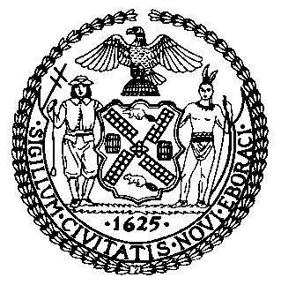 | The Council of the City of New York  Finance Division  Latonia McKinney, Director  Fiscal Impact Statement  Proposed Preconsidered Intro No. 2127-A  Committee: Consumer Affairs and Business Licensing
Title: A Local Law in relation to space heaters, the establishment of a permanent outdoor dining program, and to amend local law number 77 for the year 2020, in relation to the expiration of the outdoor dining program | Sponsors: Council Members Reynoso, Powers, Levine, Rodriguez, Rivera, Kallos, Van Bramer, Chin, Gjonaj and Louis
Summary of Legislation: This bill would extend the expiration of the City’s current outdoor dining program until September 30, 2021 and require that such temporary program would be replaced by a permanent program to allow for the use of roadway seating as outdoor dining areas. In addition, the bill would allow for the use of portable electric and propane heaters in outdoor dining areas, subject to guidelines issued by the Fire Department.
Effective Date: This local law would take effect immediately, except that section one of this local law would expire and be deemed repealed on May 1, 2021.
Fiscal Year in which Full Fiscal Impact Anticipated: Fiscal 2022
Fiscal Impact Statement:
 | Effective FY21 | FY Succeeding  Effective FY22 | Full Fiscal Impact FY22
Revenues (+) | $0 | $0 | $0
Expenditures (-) | $0 | $0 | $0
Net | $0 | $0 | $0

Impact on Revenues: It is estimated that there would be no impact on revenues resulting from the enactment of this legislation.

Impact on Expenditures: It is estimated that there would be no an impact on expenditures resulting from the enactment of this legislation because the relevant agencies would use existing resources to accomplish its requirements.

Source of Funds to Cover Estimated Costs: N/A

Sources of Information: New York City Council Finance Division
Mayor’s Office of Legislative Affairs
Office of Management and Budget
Department of Transportation

Estimate Prepared by: Sebastian Palacio Bacchi, Senior Financial Analyst

Estimate Reviewed by: Nathaniel Toth, Deputy Director
John Russell, Unit Head
Noah Brick, Assistant Counsel
Legislative History: This legislation was heard as a preconsidered introduction by the Committee on Consumer Affairs and Business Licensing together with the Committee on Transportation on September 30, 2020, and was laid over. The legislation was amended, and the amended version, Proposed Preconsidered Intro. No. -A, will be considered by the Committee on Consumer Affairs and Business Licensing on October 13, 2020. The legislation will be introduced to the full Council on October 15, 2020. Upon a successful vote by the Committee, Proposed Preconsidered Int. No. -A will be submitted to the full Council for a vote on October 15, 2020.
Date Prepared: October 5, 2020

