THE COUNCIL OF THE CITY OF NEW YORK
RESOLUTION NO. 144

Resolution approving with modifications the decision of the City Planning Commission on Application No. N 210387 ZRK, for an amendment of the text of the Zoning Resolution (L.U. No. 21).

By Council Members Salamanca and Riley

WHEREAS, EMP Capital Group, filed an application pursuant to Section 201 of the New York City Charter, for an amendment of the text of the Zoning Resolution of the City of New York, modifying Article III Chapter 5 for the purpose of amending street wall location regulations and modifying APPENDIX F for the purpose of establishing a Mandatory Inclusionary Housing area, which in conjunction with the related actions would facilitate the construction of a 17-story mixed use development containing 210 dwelling units, 52 to 63 of which would be permanently affordable, along with commercial and community facility space, at 1034-1042 Atlantic Avenue in the Crown Heights neighborhood of Brooklyn, Community District 8 (ULURP No. N 210387 ZRK) (the “Application”);

WHEREAS, the City Planning Commission filed with the Council on February 23, 2022, its decision dated February 16, 2022 (the “Decision”), on the Application;

WHEREAS, the Application is related to applications C 210386 ZMK (L.U. No. 20), a zoning map amendment to change an M1-1 zoning district to C6-3A and R7A/C2-4 zoning districts; and C 210379 ZSK (L.U. No. 22), a special permit pursuant to Zoning Resolution (ZR) Section 74-533 to reduce residential off-street parking to facilitate affordable housing;

WHEREAS, the Decision is subject to review and action by the Council pursuant to Section 197-d of the City Charter;

WHEREAS, upon due notice, the Council held a public hearing on the Decision and Application on March 8, 2022;

WHEREAS, the Council has considered the land use implications and other policy issues relating to the Decision and Application; and

WHEREAS, the Council has considered the relevant environmental issues, including the Negative Declaration issued September 20th, 2021 (CEQR No. 21DCP170K), which includes an (E) designation to avoid the potential for significant adverse impacts related to hazardous materials, air quality, and noise impacts (E-637) (the “Negative Declaration”).

RESOLVED:

The Council finds that the action described herein will have no significant impact on the environment as set forth in the (E) Designation (E-637) and Negative Declaration.
Pursuant to Sections 197-d and 200 of the City Charter and on the basis of the Decision and Application, and based on the environmental determination and consideration described in the report, N 210387 ZRK, incorporated by reference herein, and the record before the Council, the Council approves the Decision of the City Planning Commission with the following modifications:
Matter underlined is new, to be added;
Matter struck out is to be deleted;
Matter within # # is defined in Section 12-10;
* * * indicates where unchanged text appears in the Zoning Resolution
Matter double struck out is old, deleted by the City Council;
Matter double-underlined is new, added by the City Council

ARTICLE III
COMMERCIAL DISTRICT REGULATIONS

* * *

Chapter 5
Bulk Regulations for Mixed Buildings in Commercial Districts

* * *

35-60
MODIFICATION OF HEIGHT AND SETBACK REGULATIONS

* * *

35-66
Special Height and Setback Provisions for Certain Areas

* * *

35-662
Special height and setback provisions in C6-2A and C6-3X certain Districts districts along Atlantic Avenue within Community District 8, Borough of Brooklyn

In C6-2A, C6-3A and C6-3X Districts in Community District 8, in the Borough of Brooklyn, for a #zoning lot# with frontage along Atlantic Avenue, the #street wall# provisions of paragraph (a) of Section 35-651 shall apply along the Atlantic Avenue #street# frontage, and shall also apply along #street# frontages intersecting Atlantic Avenue, within 50 feet of the intersection.

* * *

APPENDIX F
Inclusionary Housing Designated Areas and Mandatory Inclusionary Housing Areas

* * *

BROOKLYN

* * *

Brooklyn Community District 8

* * *

Map 3 – [date of adoption]
[EXISTING MAP]

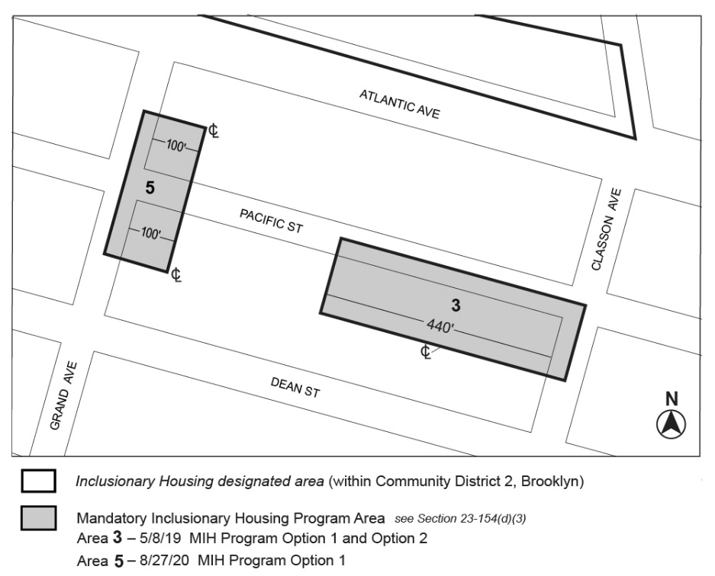

[PROPOSED MAP]
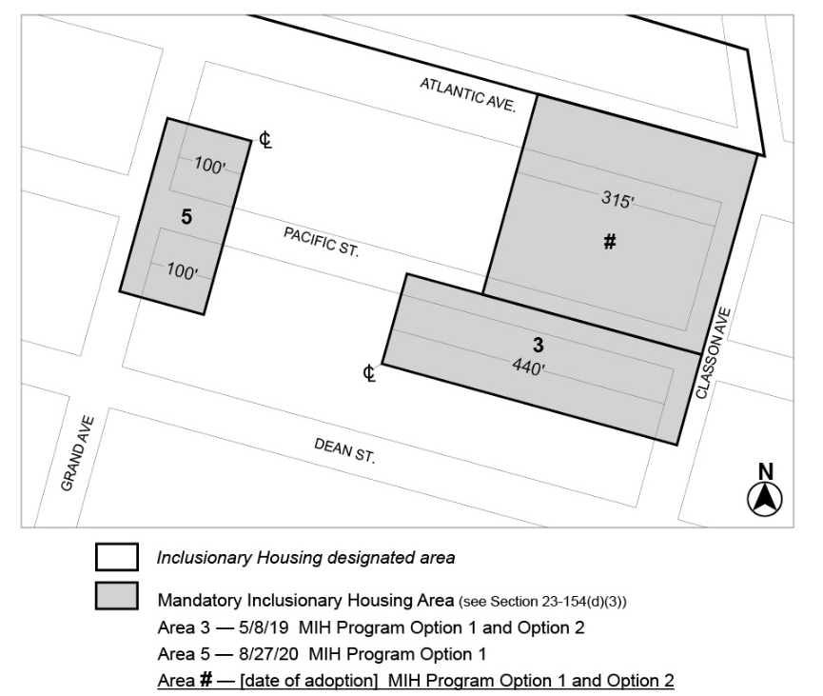

[Modified Map]
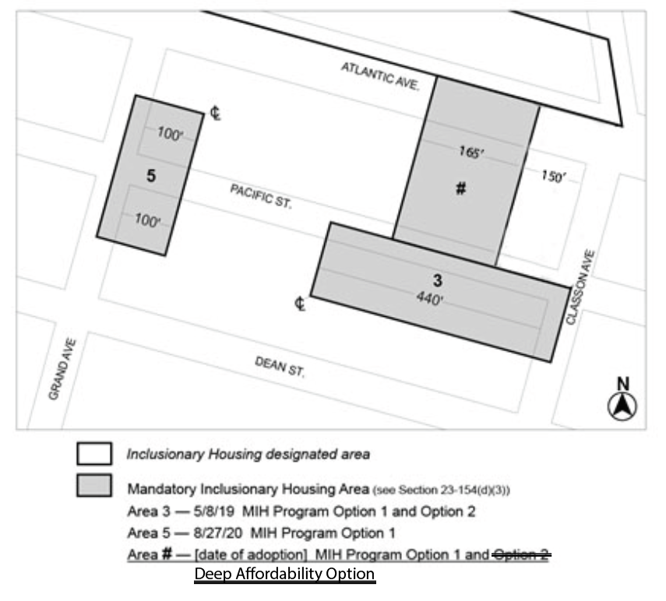
Portion of Community District 8, Brooklyn

* * *

Adopted.

Office of the City Clerk, }
The City of New York, } ss.:

I hereby certify that the foregoing is a true copy of a Resolution passed by The Council of The City of New York on __________, 2022, on file in this office.

.....................................................
City Clerk, Clerk of The Council

