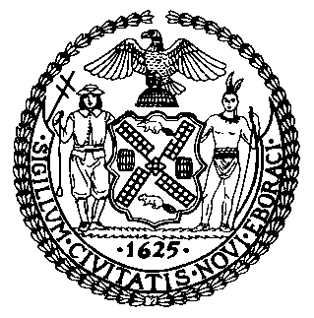 | The Council of the City of New York  Finance Division  Latonia McKinney, Director  Fiscal Impact Statement  Proposed Intro. No: 2443-A  Committee/Subcommittee: Land Use and Zoning and Franchises
Title: A Local Law to amend the administrative code of the city of New York, in relation to increasing penalties related to using joint living work quarters for artists contrary to zoning | Sponsors: Council Member Chin
Summary of Legislation: Proposed Intro. No. 2443-A would increase the penalties for using Joint Living Work Quarters for Artists (JLWQA) contrary to the requirements of the zoning resolution, including, if applicable, that the unit be occupied by an artist certified by the New York City Department of Cultural Affairs (DCP). In addition, this bill would also require new purchasers of JLWQA’s to file with the City Register and authorize the City to record JLWQA status against properties at the City Register.

Effective Date: This local law would take effect 180 days after it becomes law

Fiscal Year In Which Full Fiscal Impact Anticipated: Fiscal 2023
Fiscal Impact Statement:
 | Effective FY22 | FY Succeeding Effective FY23 | Full Fiscal Impact FY23
Revenues | $0 | $0 | $0
Expenditures | $0 | $0 | $0
Net | $0 | $0 | $0
Impact on Revenues: While the administering agency is authorized to impose civil penalties on violators of provisions of the legislation, this estimate assumes full compliant with the provisions of this legislation.

Impact on Expenditures: It is estimated that there would be no impact on expenditures resulting from the enactment of this legislation because the responsible agency will use existing resources to comply with this law.
Source of Funds to Cover Estimated Costs: N/A
Source of Information: New York City Council Finance Division

Estimate Prepared by: Chima Obichere, Unit Head

Estimate Reviewed by: Nathan Toth, Deputy Director
Stephanie Ruiz, Assistant Counsel
Legislative History: The Subcommittee on Zoning and Franchises (Subcommittee) held a hearing on this legislation as a Pre-considered Introduction on November 9, 2021. Following the hearing, this legislation was subsequently introduced to the full Council as Intro. No. 2443 on November 10, 2021 and referred to the Subcommittee and the Committee on Land Use (Committee). The legislation was subsequently amended and the amended version, Proposed Intro. No. 2443-A, will be considered by the Subcommittee and the Committee on December 9, 2021. Upon a successful vote by the Subcommittee and the Committee, Proposed Intro. No. 2443-A will be submitted to the full Council for a vote on December 9, 2021.
Date Prepared: December 9, 2021

