Committee on Oversight and Investigations
Stephanie Jones, Counsel
Noah Meixler, Legislative Policy Analyst
Jack Kern, Financial Analyst

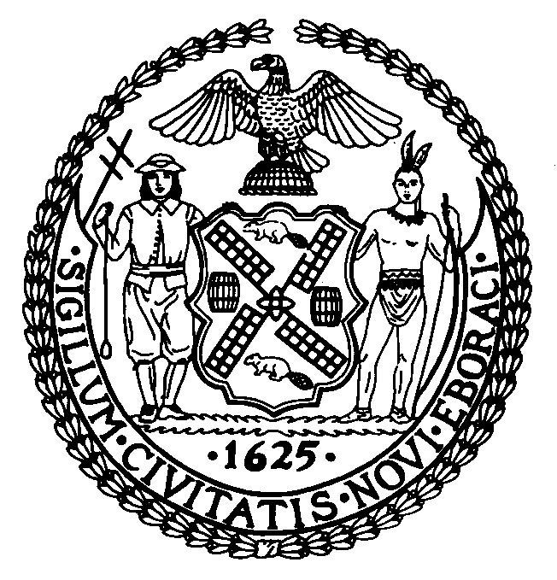

THE COUNCIL OF THE CITY OF NEW YORK

COMMITTEE REPORT OF the GOVERNMENTAL AFFAIRS Division

Jeffrey Baker, Legislative Director
Rachel Cordero, Deputy Director, Governmental Affairs

COMMITTEE ON OVERSIGHT AND INVESTIGATIONS
Hon. Ritchie Torres, Chair

February 24, 2020

Oversight: DOI Background Investigations Backlog

- INTRODUCTION
On February 24, 2020, the Committee on Oversight and Investigations, chaired by Council Member Ritchie Torres, will hold a hearing on DOI’s background investigations backlog. Those invited to testify include representatives from the Department of Investigations (“DOI”), good government groups, think tanks and non-profit organizations.
- BACKGROUND
- Background Investigation Unit
DOI is mandated to conduct background investigations of City employees pursuant to an Executive Order originally issued by Mayor Koch in 1978. DOI’s background investigations include an examination of whether the prospective employee has appropriate qualifications for the job, and whether the employee is free from “actual or potential conflicts of interest and is one in whom the public trust can be placed.” DOI’s Background Investigation Unit (“BIU”) conducts investigations of employees in managerial positions or earning an annual salary over $100,000, employees directly involved in City contracts, and employees working on the City’s computer programs or other sensitive positions. The Mayor or an agency head may also direct DOI to conduct a background investigation of a potential or current City employee if such an investigation is deemed to be in the public’s interest.
DOI and the Department of Health and Mental Hygiene (“DOHMH”) also play a role in background checks for individuals who work at child care, home care, and family care facilities. While DOHMH screens employees in these fields for criminal convictions, a history of child abuse, and other employment-related screening, DOI fingerprints all prospective hires.
- City Agency Involvement
While the BIU is the primary investigatory body for prospective employees at City agencies, some City agencies conduct their own background checks on employees as well. If the BIU fails to complete a background investigation prior to an employee’s start date, City agencies have discretion in deciding if new employees can begin their jobs while their investigation is ongoing. According to DOI spokeswoman Diane Struzzi, “It would not be feasible to conduct and complete all background investigations prior to commencement of employment for all employees subject to a background investigation. Ultimately, the decision about whether to wait for the outcome of a background investigation before allowing an employee to begin working is made by the hiring agency, not by DOI."
DOI also relies on City agencies to submit the names of their new employees to the BIU for the purposes of a background investigation. According to Diane Struzzi, “DOI guidelines allow City agencies up to 30 days from appointment, promotion, or transfer to forward a completed background package to DOI.” Because DOI relies on City agencies to submit employees’ names to BIU, DOI performs audits of all City employees to ensure agencies are submitting relevant cases.
- Concerns and Consequences
A large backlog of City employee background checks has developed at the BIU. During the Committee on Oversight and Investigations’ preliminary budget hearing in March of 2019, DOI Commissioner Margaret Garnett explained that in fiscal year 2018, the BIU received an average of 236 new investigations per month while closing an average of 193 investigations. The BIU’s inability to close more cases than it receives led the backlog to reach over 5,600 cases as of July 1, 2019. During the Committee’s preliminary budget hearing, Commissioner Garnett explained, “Bluntly, DOI’s mandated mission to screen all sensitive and high-level city employees is not being met, nor can it be met with the current staffing. It also means that the majority of those job candidates have already begun employment with the City of New York and are awaiting the results of their background investigation, sometimes for years, a vulnerability that causes me great concern.”
City employees working in agencies without completed background investigations poses a potential risk, as bad actors could gain access to sensitive information. According to the U.S. Government Accountability Office, high-quality security checks are “necessary to minimize the risks of unauthorized disclosures of classified information and to help ensure that information about individuals with criminal histories or other questionable behavior is identified and assessed.” The extensive backlog at DOI has led to questions about whether employees with troubling histories have been permitted to work for the City. The Department of Education’s deputy chief of staff to schools, David Hay, was arrested this past December for using a computer to facilitate a child sex crime and for possession of child pornography. Although DOE had conducted two background investigations of David Hay that looked at any potential criminal history, a more comprehensive background check by DOI had not been completed since his initial hiring in 2016.
According to the Mayor’s Management Report, DOI aims to achieve an average of 180 days to complete a background investigation from the date they receive a case. The Committee is interested in learning about DOI’s method for conducting investigations, and if their current procedure is both comprehensive and efficient. At the federal level, the National Background Investigations Bureau has sought to decrease the federal background investigations backlog by decreasing the amount of personnel hours necessary to complete an investigation, such as using automated record checks. The Committee is interested in learning about the steps DOI has taken to similarly optimize their investigations system while retaining the same level of scrutiny.
The Committee is also interested in learning about whether the group of employees the BIU investigates is overly broad. In DOI’s follow-up questions to the Committee’s 2020 preliminary budget hearing, Commissioner Garnett acknowledged, “some subset” of the employees that BIU investigates “could be eliminated without creating undue risk to the City.”
- Progress
While the background investigation backlog poses a threat to City residents by enabling potentially dangerous individuals to work at high levels of the City government, DOI has restructured the BIU to resolve the backlog. In Fiscal Year 2019, DOI created a new team within the BIU specifically dedicated to clearing its backlog of older cases. Another team at BIU is tasked with closing all new background investigations within six months of receipt to ensure no new cases are added to the backlog. The Committee is interested in learning about DOI’s progress, and when DOI expects to fully resolve the backlog.
II. CONCLUSION
The Committee is interested in receiving an update from DOI on how effective its restructuring of the BIU has been at decreasing the backlog. The Committee seeks to learn how the backlog began, and the potential dangers posed by City employees working for agencies without completed background checks. The Committee is also interested in hearing from good government groups about more efficient systems to conduct background investigations, and whether the total number of employees the BIU investigates should be more limited.

Executive Order No. 16, Mayor of the City of New York (July 26, 1976), available at: https://www1.nyc.gov/assets/records/pdf/executive_orders/1978EO016.PDF
Id.
Background Investigation Unit, City of New York Department of Investigations, https://www1.nyc.gov/site/doi/offices/background-investigations-unit.page
Executive Order No. 16, Mayor of the City of New York (July 26, 1976), available at: https://www1.nyc.gov/assets/records/pdf/executive_orders/1978EO016.PDF
The agencies help fulfill requirements put in place by Local Law 60 of 1984, as set forth in Administrative Code § 21-119. See also Fingerprint Unit, City of New York Department of Investigations, https://www1.nyc.gov/site/doi/offices/fingerprint-unit.page
Id.
Sophia Chang, Why the Department of Investigation has a ‘Dangerous’ Backlog on Background Checks for Top City Jobs, Gothamist, (Jan 7, 2020), https://gothamist.com/news/why-department-investigation-has-dangerous-backlog-background-checks-top-city-jobs
Id.
Id.
Sophia Chang, Why the Department of Investigation has a ‘Dangerous’ Backlog on Background Checks for Top City Jobs, Gothamist, (Jan 7, 2020), https://gothamist.com/news/why-department-investigation-has-dangerous-backlog-background-checks-top-city-jobs
Transcript of the Minutes of the Committee on Oversight and Investigations, (March 26, 2019) https://legistar.council.nyc.gov/LegislationDetail.aspx?ID=3861941&GUID=A11615C0-8CBE-4E8B-A980-7508A3421779&Options=&Search=
Department of Investigation, Fiscal 2020 Preliminary Mayor’s Management Report https://www1.nyc.gov/assets/operations/downloads/pdf/pmmr2020/doi.pdf.
Transcript of the Minutes of the Committee on Oversight and Investigations, (March 26, 2019) https://legistar.council.nyc.gov/LegislationDetail.aspx?ID=3861941&GUID=A11615C0-8CBE-4E8B-A980-7508A3421779&Options=&Search=
Government-wide Personnel Security Clearance Process, Government Accountability Office, https://www.gao.gov/highrisk/government-wide-personnel-security-clearance-process
Selim Algar and Ebony Bowden, DOE official David Hay booked hotel with hot tub for sex with teen boy: feds, New York Post, (Jan 3, 2020) https://nypost.com/2020/01/03/doe-official-david-hay-booked-hotel-with-hot-tub-for-sex-with-teen-boy-feds/
Id.
Department of Investigation, Fiscal 2020 Preliminary Mayor’s Management Report https://www1.nyc.gov/assets/operations/downloads/pdf/pmmr2020/doi.pdf.
Government-wide Personnel Security Clearance Process, Government Accountability Office, https://www.gao.gov/highrisk/government-wide-personnel-security-clearance-process
Margaret Garnett, Re: Follow-up Questions to City Council’s Fiscal 2020 Preliminary Budget Hearing, (May 3, 2019)
Department of Investigation, Fiscal 2020 Preliminary Mayor’s Management Report https://www1.nyc.gov/assets/operations/downloads/pdf/pmmr2020/doi.pdf.
Id.

