Staff: Committee on Housing & Buildings
Austen Brandford, Senior Counsel
Audrey Son, Counsel
Genan Zilkha, Counsel
Jose Conde, Senior Policy Analyst
Charles Kim, Policy Analyst
Sarah Gastelum, Principal Financial Analyst
Luke Zangerle, Financial Analyst

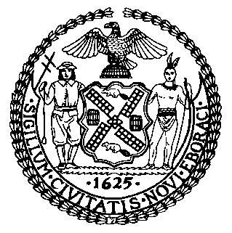

The New York City Council
Jeffrey Baker, Legislative Director

Committee Report of the Infrastructure Division
Terzah Nasser, Deputy Director, Infrastructure Division

Committee on Housing and Buildings
Hon. Robert E. Cornegy, Jr., Chair

September 16, 2020

Proposed Int. No. 1853 -A: By Council Members Cornegy, Kallos, Vallone, Rosenthal, Brannan, Ayala, Louis and Chin
Title: A Local Law in relation to requiring the department of buildings to report on the safety and feasibility of authorizing building exterior wall examinations by unmanned aircraft systems

Introduction
On September 16, 2020, the Committee on Housing and Buildings, chaired by Council Member Robert Cornegy, Jr., will hold a hearing on Proposed Int. No. 1853-A, in relation to requiring the department of buildings (“DOB”) to report on the safety and feasibility of authorizing building exterior wall examinations by unmanned aircraft systems (i.e. “drones”). This bill was first heard on January 27, 2020. More information about this bill, along with the materials for that hearing, can be found at https://on.nyc.gov/3hCBykh.

Proposed Int. No. 1853-A
Proposed Int. No. 1853-A would require DOB to conduct a study of the safety and feasibility of allowing drones to conduct building façade inspections. A report of the study’s findings would be due on October 31, 2021.
This legislation would take effect immediately.

Proposed Int. No. 1853-A

By Council Members Cornegy, Kallos, Vallone, Rosenthal, Brannan, Ayala, Louis and Chin

A Local Law in relation to requiring the department of buildings to report on the safety and feasibility of authorizing building exterior wall examinations by unmanned aircraft systems

Be it enacted by the Council as follows:

Section 1. The department of buildings shall conduct a study of the safety and feasibility of authorizing the use of unmanned aircraft systems, in conjunction with physical examinations and close-up inspections, for critical examinations of a building’s exterior walls, required by section 28-302.2 of the administrative code of the city of New York. The department shall consider, but not be limited to, the following subjects:
a. Whether authorizing such examinations to be conducted with the use of unmanned aircraft systems would: (i) be prohibited by any provision of law, rules and regulations, policies or directives of the federal aviation administration; (ii) conflict with any rules, regulations or policies of any New York state or city agencies; (iii) provide any increase in pedestrian safety over that afforded by current building examination practices; (iv) reduce the use of sidewalk sheds and scaffolding citywide; and (v) provide any economic benefits through cost savings or job creation; and
b. Whether there are any other obstacles or concerns related to authorizing such examinations to be conducted through the use of unmanned aircraft systems, including but not limited to safety and privacy issues such as surveillance, data security and data retention.
§ 2. The department shall issue a report of the study’s findings to the mayor and the speaker of the council upon completion of such study, which shall be no later than October 31, 2021.
§ 3. This local law takes effect immediately.
APB
LS 13172
9/8/20 1:25 pm

