Sanitation Committee Staff
Nicole Abene, Senior Counsel
Nadia Johnson, Senior Policy Analyst
Ricky Chawla, Policy Analyst
Jonathan Seltzer, Senior Finance Analyst

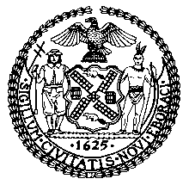

The New York City Council
Jeffrey Baker, Legislative Director

Briefing Paper and Committee Report of the Infrastructure Division
Terzah Nasser, Deputy Director

Committee on Sanitation & Solid Waste Management
Hon. Antonio Reynoso, Chair

April 21, 2021

Oversight – Getting to Zero Waste

INT. NO. 844: By Council Members Kallos and Van Bramer

TITLE: A Local Law to amend the administrative code of the city of New York, in relation to establishing a goal of zero waste for New York city by 2030

ADMINISTRATIVE CODE: Amends section 16-143

INT. NO. 2103: By Council Members Rosenthal, Brannan, Reynoso, Kallos, Louis and Chin

TITLE: A Local Law to amend the administrative code of the city of New York, in relation to requiring certain retail food stores to post notices on the food donation web portal concerning the availability of excess food, and arranging for the transportation and retrieval of such food

ADMINISTRATIVE CODE: Amends section 16-497

INT. NO. 2250: By Council Members Reynoso, Lander, Van Bramer and Yeger

TITLE: A Local Law to amend the administrative code of the city of New York in relation to the goal of zero waste to landfill

ADMINISTRATIVE CODE: Amended by adding a new section 16-316.5

- Introduction
On April 21, 2021, the Committee on Sanitation and Solid Waste Management, chaired by Council Member Antonio Reynoso, will hold a hearing entitled “Oversight – Getting to Zero Waste.” The Committee will also hear Int. No. 844, in relation to establishing a goal of zero waste for New York city by 2030; Int. No. 2103, in relation to requiring certain retail food stores to post notices on the food donation web portal concerning the availability of excess food, and arranging for the transportation and retrieval of such food; and Int. No. 2250, in relation to the goal of zero waste to landfill. The Committee expects to hear testimony from representatives of the New York City Department of Sanitation (“DSNY”), recycling and organics practitioners, food retailers, sustainability experts, and interested members of the public.
- Background
Local Law 19 of 1989 codified goals for the diversion from landfill of department-managed solid waste, and curbside and containerized waste. By July 1, 2020, the goal was to recycle 33% of department-managed solid waste and 25% of curbside and containerized waste. The City fell far short of those goals in 2020, with an actual diversion rate of 21.6% of department-managed solid waste and 18.5% of curbside and containerized rates.
New York City is now part of a growing movement by cities across the world with goals to achieve Zero Waste. In 2015, the City committed to send Zero Waste to landfill by 2030, as part of the city’s OneNYC: The Plan for a Strong and Just City. To measure progress towards the “Zero Waste” goal, the City committed to track waste reduction and waste diversion from landfills, and to set a target of reducing the amount of waste disposed by 90% by 2030 from a 2005 baseline. Eight initiatives were developed to reach Zero Waste: (1) Expand the organics program; (2) Enhance the city’s curbside recycling program; (3) Reduce the use of plastic bags and other non-compostable waste; (4) Give every New Yorker the opportunity to recycle and reduce waste; (5) Make all schools zero waste schools; (6) Expand opportunities to reuse and recycle textiles and electronic waste; (7) Develop an equitable blueprint for a Save-As-You-Throw program to reduce waste; and (8) Reduce commercial waste by 90 percent by 2030.
The City provides citywide curbside collection service for refuse and metal, glass, plastic (MGP) and paper recyclables. The City also provided curbside organics collection for several community board districts, but expansion was paused in 2019 and the program was completely halted in 2020. There are other materials that end up in residential refuse streams that could be diverted from landfill, but are not consistently part of DSNY’s curbside collection program. These materials include electronic waste (“e-waste”), textiles, and harmful household products. To reduce single use plastic and paper bag use, New York State law bans plastic bags for certain retail establishments and Local Law 100 of 2019 requires a 5-cent fee on paper bags, with some exemptions including plastic bags used for garments, prescriptions and bulk food items. Customers using the Supplemental Nutrition Assistance Program or the Special Supplemental Nutrition Program for Women, Infants, and Children are exempt from the 5-cent fee on paper bags. This hearing will focus on these efforts and the impact they have had thus far in helping the City achieve the Zero Waste goals.
- 2017 Waste Characterization Study
Every four years, as required by Local Law 40 of 2010, DSNY completes a waste characterization study. The study documents the composition and volume of materials that New York City residents discard as refuse, and assesses how much of this material could have been diverted from landfill. The study helps to assess the progress made towards the City’s goal of sending zero waste to landfills by 2030. In March 2018, DSNY released the “2017 NYC Residential, School, and NYCHA Waste Characterization Study” (the “2017 Study”). The 2017 Study was conducted from the Spring to Fall of 2017 by Mid-Atlantic Solid Waste Consultants, which assessed 810 samples, sorted under 70 main and 172 sub-categories. The previous waste characterization study was conducted in 2013.
The 2017 Study characterizes the materials in the waste stream into four main categories of materials. First, “recyclables” includes clean paper and cardboard, MGP and cartons. Second, “organics” includes food scraps, food-soiled paper, and yard waste. Third, “other divertable materials” [sic] includes textiles, plastic shopping bags, harmful household products, and e-waste. Finally, an “other” category includes materials “for which there are no or very limited options for beneficial use at this time.” These materials include “small scale building material scrap (construction and demolition debris), furniture and household wood products, treated wood and lumber, carpeting, various plastic film, flexible and foam products, multi-material items, disposable diapers, and animal by-products.”
On a per household basis, the average New York City household discarded 2,280 pounds of “aggregate discards” (or overall waste) per year in 2005, 2,000 pounds in 2013, and 1,990 pounds in 2017. The cause of this steady decline is attributed in part to a reduction in refuse and an increase in paper and MGP recycling. Also during this period, there was an increase in the waste stream of non-bottle rigid plastic waste, food scraps, food soiled paper, harmful household products, and textiles.
Figures 1, 2, and 3 below show the 2017 composition of aggregate discards for residences, schools, and NYCHA communities. For each of these three sectors, a considerable amount of waste was suitable for either organics or recycling collection, but was instead discarded as refuse. For residential, 68% of the waste collected could have been diverted from landfill, as 34% was suitable for organics collection and another 34% for recycling collection. For schools, 86% of the waste was either organics (51%) or recyclables (35%). For NYCHA, 55% of the waste was either organics (32%) or recyclables (33%). Additionally, under the “other divertable materials” category (textiles, plastic shopping bags, harmful household products, and e-waste), another 9% of refuse could have been diverted from landfill from residences, 2% from schools, and 12% from NYCHA.
Figure 1: Composition of Residential Curbside Aggregate Discards, 2017
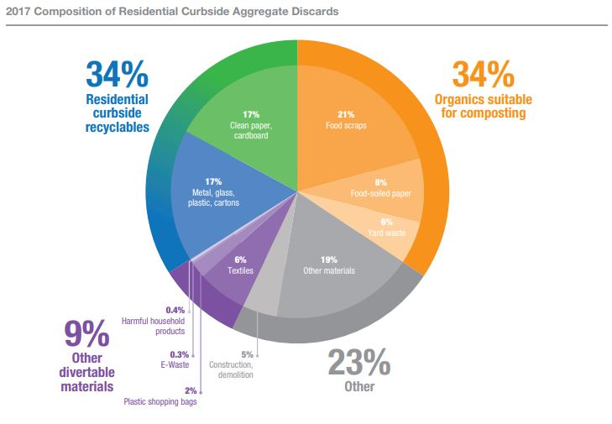
Source: New York City Department of Sanitation, "2017 NYC Residential, School, and NYCHA Waste Characterization Study," (March 2018)

Figure 1 shows that for residential curbside collected waste, 34% were curbside recyclable materials, 34% were organics suitable for composting, and 9% were other divertable materials, including textiles, e-waste-harmful household products, and plastic shopping bags. The remaining 23% were other materials, 5% of which was construction and demolition material.

Figure 2: Composition of Schools Aggregate Discards, 2017

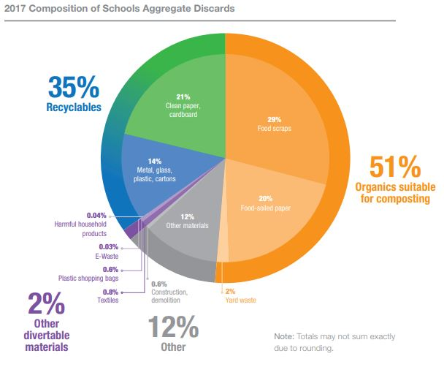

Source: New York City Department of Sanitation, "2017 NYC Residential, School, and NYCHA Waste Characterization Study," (March 2018)

Figure 2 shows that for school curbside collected waste, 35% were curbside recyclable materials, 51% were organics suitable for composting, and 2% were other divertable materials, including textiles, e-waste-harmful household products, and plastic shopping bags. The remaining 12% were other materials, 0.8% of which was construction and demolition material.

Figure 3: Composition of NYCHA Refuse, 2017
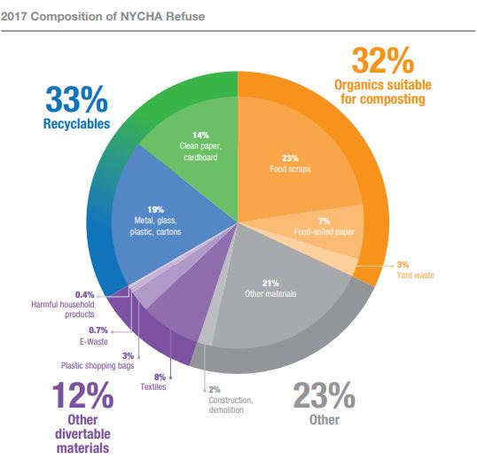
Source: New York City Department of Sanitation, "2017 NYC Residential, School, and NYCHA Waste Characterization Study," (March 2018)

Figure 3 shows that for NYCHA curbside collected waste, 33% were curbside recyclable materials, 32% were organics suitable for composting, and 12% were other divertable materials, including textiles, e-waste-harmful household products, and plastic shopping bags. The remaining 23% were other materials, 2% of which was construction and demolition material.

- Non-Curbside City Programs
Organics
As the 2017 Study shows, organics is the biggest area of opportunity for the city to divert waste from landfill. Thus, a robust, citywide organics program is an imperative tool for reaching the Zero Waste goals. The City has implemented both curbside and non-curbside city programs to divert organics from landfill. In October 2013, the New York City Council passed Local Law 77 of 2013 (“LL77”), which required the DSNY Commissioner to establish a voluntary residential organic waste curbside collection pilot program and a school organic waste collection pilot program. In 2015, the OneNYC plan committed the City to implement a residential organics program that would serve all New Yorkers by the end of 2018, and in 2019 the OneNYC 2050 plan committed the City to establishing mandatory organics recycling citywide. However, neither commitment has been met.
In May 2018, DSNY announced during a City Council Executive Budget Hearing that the City was temporarily halting the program’s expansion. At the time, DSNY continued to service areas already receiving curbside organics collection, despite low participation rates." In communities that were receiving organics collection service, only 10.6% of the organic waste produced was being sorted into the organics bins. The remaining 89% of organic waste was still being discarded as refuse waste and then sent to landfills. In addition to halting citywide expansion, some communities that were receiving twice a week curbside collection were reduced to once a week as of July 30, 2018.
The program’s participation rates did not make it cost effective. In order to fill trucks, either participation rates needed to increase or longer truck routes would be needed, which would conflict with hours in collective bargaining agreements. More drivers or overtime pay would have increased the budget of a program that had low participation rates.
On March 12, 2020, Mayor Bill de Blasio issued a state of emergency in response to the COVID-19 pandemic. Since then, some City resources were diverted to aid the relief efforts and Fiscal Year 2021 (FY2021) budget gaps, and priorities have shifted substantially. The residences serviced by the pilot curbside organics collection program had their collection temporarily halted on May 4, 2020, with no plans to resume service until at least June 30, 2022.
Food scrap drop-off sites were also temporarily suspended due to COVID-19 related budgetary constraints. After a FY2021 partial restoration of funding for the program, by the end of 2020, there were 18 food scrap drop-off locations that were reinstated: two in the Bronx, five in Brooklyn, ten in Manhattan, and one in Queens. Prior to its March 2020 suspension, the drop-off program featured 68 locations where individuals could bring food waste for composting during specific hours of operation, with 13 locations in the Bronx, 13 in Brooklyn, 30 in Manhattan, 10 in Queens, and 2 in Staten Island. In 2019, the program was able to divert over 3.2 million tons of organic material from the waste stream into beneficial reuses, a significant increase compared to previous years.

Other Materials
In 2016, DSNY created the donateNYC portal, which facilitates the donation of unwanted materials that can be reused by assisting residents in locating partnering donation sites. In 2017, partner sites diverted more than 98,230,000 pounds of materials from landfills (see Figure 4. It is unclear how much of this material was diverted through the use of or support from donateNYC, or was from everyday operations of each partner.
Figure 4: 2017 donateNYC Partner Impact, Reusable Items Diverted from Landfill
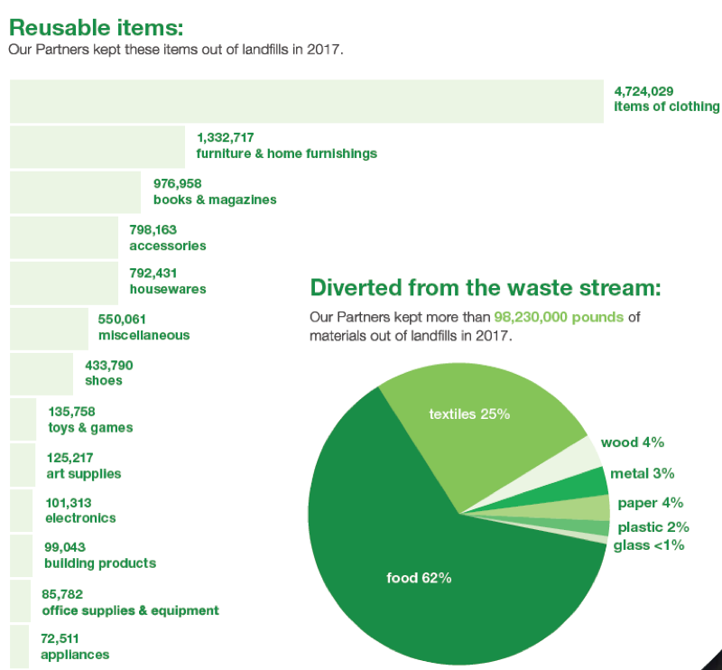

Figure 4 shows that donateNYC partners diverted more than 98,230,000 pounds of material from landfills in 2017. Of this, 62% was food, 25% was textiles, 4% was paper, 4% was wood, 3% wa metal, 2% was plastic, and less than 1% was glass. Excluding food items, the highest number of diverted materials from landfill by donateNYC partners were 4,724,029 items of clothing, 1,332,717 furniture and home furnishing items, 976,958 books and magazines.

In accordance with Local Law 176 of 2017, DSNY added the donateNYC Food Portal to donateNYC in 2018. The Food Portal matches registered food businesses and nonprofit organizations and is a tool to reduce food waste and support organizations that can use or redistribute the food in their communities. It is unclear how many businesses and organizations participate in the program and how much food has been distributed through connections made in the Food Portal.
Regarding textiles, the refashionNYC program is operated by DSNY in partnership with Housing Works, and offers in-building collection for apartment buildings with 10 or more units. The program allows New Yorkers to donate clothing or other fabric material in participating apartment buildings, businesses, schools, and non-profits, and is then regularly collected. As of 2015, refashionNYC served more than 100,000 households in 553 apartment buildings and complexes. It is unclear how many apartment buildings and other institutions currently participate. As of October 2019, refashionNYC diverted some 9,878 tons from landfill since the 2011 program launch. DSNY also provides residents information of clothing and textile drop-off locations, textile reuse and swap events, and businesses and organizations that provide mail back programs.
The City also created ecycleNYC, to help facilitate the diversion of electronic waste (“e-waste”) from landfill. Although it contributes less than one percent of the total waste stream, electronic waste contains many toxic materials, including mercury, cadmium, lead, and other heavy metals. Recycling electronic waste not only keeps these toxins from polluting the air, soil, and water, it also reduces energy and water use associated with manufacturing new materials. In January 2015, a New York State law banning the disposal of electronic waste took effect, barring the City from collecting these materials as refuse. Disposing of e-waste improperly can lead to a $100 fine.
DSNY’s ecycleNYC, program allows apartment buildings with ten or more units to sign up for collection with DSNY. Currently, buildings already part of the ecycleNYC program can make pick-up appointments with DSNY, while buildings interested in enrolling can submit applications. DSNY also launched a pilot program that provided curbside collection of e-waste for disposal in certain neighborhoods. This pilot first launched in Staten Island, and expanded to areas of Brooklyn, Queens, and the Bronx in 2017, 2018 and 2019. Due to the COVID 19 pandemic, the e-waste curbside collection is currently suspended.
DSNY also hosts Solvents, Automotive, Flammables, and Electronics (SAFE) disposal events, held in each borough to give residents an opportunity to drop off electronics and other household hazardous waste, including chemicals and prescription drugs. DSNY normally holds two SAFE disposal events per borough each year, in the spring and fall, but due to the COVID 19 pandemic, these events have been suspended and DSNY expects to resume them in Fall 2021. In October 2019, DSNY reported that its SAFE disposal events collected 450 tons of hazardous items such as paint, automotive products and unwanted medications in the past year.
- Legislation
Int. No. 844 would require DSNY to establish a goal of zero waste for New York City by 2030. If DSNY determines that the goal is not feasible, they would have to report on the findings and make recommendations. This local law would take effect immediately.
Int. No. 2103 would require certain stores that sell food for off-premises consumption, such as grocery stores, to post notices on the food donation web portal regarding excess food they have available for donation, at least once per month. The bill would also require stores to arrange for the retrieval of the food that they are donating, and to arrange for the transportation of such food if requested by the recipient. The bill would also exempt stores that would normally be subject to the requirements of this law if they have agreements in place for the donation of food on at least a monthly basis. The legislation would also require the Department of Sanitation or other City entity designated by the Mayor, to submit to the Mayor and the Speaker of the Council an annual report detailing the results of a yearly review of available food on the web portal and whether that available food is expected to meet the demands of city residents in the coming year. This local law would take effect 120 days after it becomes law, except that the commissioner of sanitation or another agency or office designated by the mayor shall take such measures as are necessary for the implementation of this local law, including the promulgation of rules, before such date.
Int. No. 2250 would require the Department of Sanitation to report on the City’s progress toward sending zero waste to landfill. The bill would require a plan toward sending zero waste to landfill by 2030 be completed and submitted to the Mayor and the Speaker by July 1, 2021. The legislation would also require a report on progress towards the zero waste goal be completed and submitted to the Mayor and the Speaker by July 1, 2022 and annually thereafter. This local law would take effect immediately.
- Conclusion
Zero waste is an ambitious and important goal, requiring a focus on both increased waste diversion from landfills and decreased waste generation from city residents and businesses. At this hearing, the Committee seeks to hear testimony on the City’s progress to reaching its goal of Zero Waste by 2030, benchmarks and metrics it is using to maintain and track progress, and challenges that persist. The Committee also seeks input, assessments, ideas and suggestions from interested members of the public on how the City can achieve its zero waste goals. The Committee also seeks input and comments on Int. No. 844, Int. No. 2103, and Int. No. 2250.
Int. No. 844

By Council Members Kallos and Van Bramer

A Local Law to amend the administrative code of the city of New York, in relation to establishing a goal of zero waste for New York city by 2030

Be it enacted by the Council as follows:

Section 1. Chapter 1 of title 16 of the administrative code of the city of New York is amended by adding a new section 16-143 to read as follows:
§ 16-143 Zero waste goal. a. Diversion of citywide-generated waste. The department shall establish a goal of diverting citywide-generated waste by one hundred percent by calendar year 2030.
b. If the department determines that such citywide-generated waste diversion goal is not feasible despite the best efforts of city government, the department shall report such findings and make recommendations with respect to policies, programs and actions that may be undertaken to achieve such diversion within 180 days of such determination.
§ 2. This local law takes effect immediately.

LS# 2322/Int. No. 1573/2017
JCH/NKA
12/27/2017
LS 249

Int. No. 2103

By Council Members Rosenthal, Brannan, Reynoso, Kallos, Louis and Chin

A Local Law to amend the administrative code of the city of New York, in relation to requiring certain retail food stores to post notices on the food donation web portal concerning the availability of excess food, and arranging for the transportation and retrieval of such food

Be it enacted by the Council as follows:

Section 1. Section 16-497 of Chapter 4-G of title 16 of the administrative code of the city of New York, as added by local law number 176 for the year 2017, is amended to read as follows:
§ 16-497 Food donation web portal. a. Definitions. For the purposes of this chapter, the following terms have the following meanings:
Excess food. The term “excess food” means food that (i) meets all quality and labeling standards imposed by federal, state, and local laws and regulations even though the food may not be readily marketable due to appearance, age, freshness, grade, size, surplus, or other conditions; (ii) is not required to meet the needs of a retail food store; and (iii) would otherwise be discarded.
Retail food store. The term “retail food store” means any establishment in the city where food and food products offered to the consumer are intended for off-premises consumption, but excludes convenience stores, pharmacies, greenmarkets or farmers' markets and food service establishments.
b. Within eighteen months after the effective date of the local law that added this section, the department or another agency or office designated by the mayor, shall, in conjunction with the department of information technology and telecommunications, create or modify and maintain a web portal that will allow prospective food donors and recipients, including but not limited to restaurants, grocery stores, produce markets, dining facilities and food rescue organizations, to post [notifications] notices concerning the availability of food, including food that would otherwise go to waste, and to arrange for the transportation or retrieval of such food. Such portal shall, at a minimum, allow (i) a prospective food donor to describe the type and amount of food available, including any information necessary to keep the food safe for human consumption, such as refrigeration requirements, as well as other information necessary to facilitate its donation, (ii) a prospective food recipient to specify the type and amount of food donations it will accept and the areas of the city from which it will accept donations and to receive prompt notification concerning the availability of food satisfying such specifications, and (iii) a prospective food donor and a prospective food recipient to communicate directly through a messaging system within such portal.
c. Each retail food store that has a floor area of at least fifteen thousand square feet, or that is part of a chain of three or more retail food stores that have a combined floor area of at least fifteen thousand square feet and that operate under common ownership and control, with excess food available, shall, at least once a month:
1. Post a notice on such portal offering such excess food for donation;
2. Arrange for the retrieval of such excess food by its recipient; and
3. If requested by the recipient, with reasonable effort arrange for the transportation of such excess food.
d. Retail food stores that would otherwise be subject to the requirements of subdivision c of this section shall be exempt from such requirements if they have, and are in compliance with, written agreements with not-for-profit organizations for the donation of food at least once per month.
e. The commissioner shall enforce the requirements of subdivision c of this section. A retail food store that would otherwise be subject to the requirements of subdivision c of this section that fails to comply with such subdivision shall be subject to a penalty of no more than $10,000 for each month during which such retail food store failed to post a required notice. The commissioner shall investigate any retail food store that has not posted notices offering excess food for at least six months out of the previous 12 months.
f. No later than December 1 of each year, the commissioner or another agency or office designated by the mayor, shall conduct a review of all notices concerning available, excess food posted to the food web portal within the past year; shall assess, in its discretion, to what extent such notices would meet the estimated demand for food from city residents likely to suffer from hunger in the next year; and shall submit a report detailing the results of such review and assessment to the mayor and the speaker of the council.
g. The commissioner or another agency or office designated by the mayor shall promulgate rules to implement the requirements of this section.
§ 2. This local law takes effect 120 days after it becomes law, except that the commissioner of sanitation or another agency or office designated by the mayor shall take such measures as are necessary for the implementation of this local law, including the promulgation of rules, before such date.

SJ
LS #3174, 6107, 9977, 14116
9/2/2020
Int. No. 2250

By Council Members Reynoso, Lander, Van Bramer and Yeger

A Local Law to amend the administrative code of the city of New York in relation to the goal of zero waste to landfill

Be it enacted by the Council as follows:
Section 1. Subchapter 3 of chapter 3 of title 16 of the administrative code of the city of New York is amended by adding a new section 16-316.5 to read as follows:
§ 16-316.5 Zero Waste plan and reporting. On or before July 1, 2021, the commissioner shall submit to the mayor and speaker of the council a plan to send zero waste to landfill by 2030. On or before July 1, 2022, and annually thereafter, the commissioner shall submit to the mayor and speaker of the council a report on the city’s progress toward the goal of sending zero waste to landfill pursuant to this section. The plan and each report shall include, but need not be limited to:
a. A timeline to send zero waste to landfill, including annual targets for waste diversion, disaggregated by waste stream;
b. Diversion rates for recyclable material collected curbside by the department, disaggregated by material and by community district;
c. Diversion rates for recyclable materials that are not collected curbside, disaggregated by material;
d. The department’s plan to increase diversion, which shall include, but not be limited to strategies to increase diversion for each material, strategies to increase compliance with existing law and a description of all education and outreach programs available to the public and strategies to increase or update such education and outreach programs;
e. A plan for separate initiatives to increase diversion in residential buildings with various numbers of units, and buildings owned or operated by the New York city housing authority;
f. A plan for separate initiatives to increase diversion in commercial establishments;
g. A list and description of materials that are not easily diverted from landfill and strategies for eliminating such materials from the waste stream;
h. An analysis of the economic market for recyclable materials, disaggregated by material;
i. An analysis of current processing capacity for recyclable materials, disaggregated by material;
j. An analysis of current availability of capacity at landfills utilized by the city;
k. A plan to increase diversion of materials disposed of in public litter baskets; and
l. A plan to increase the reuse of materials that would otherwise be disposed of.
§ 2. This local law takes effect immediately.

LS 9641
CM/NKA
7/20/2020

New York City, N.Y., Code § 16-305 Recycling of department-managed solid waste
DSNY Collections FY20 https://dsny.cityofnewyork.us/wp-content/uploads/2020/09/about_dsny-non-dsny-collections-FY2020.pdf
C40 Cities, “Advancing Towards Zero Waste Declaration,” available at https://www.c40.org/other/zero-waste-declaration (last visited Feb. 27, 2019). (Signatories: San Francisco, Auckland, Boston, Copenhagen, Dubai, London, Los Angeles, Melbourne, Milan, Montreal, New York City, Paris, Philadelphia, Portland, Rotterdam, Stockholm, Sydney, Tel Aviv, Tokyo, Toronto, Vancouver, Washington D.C, Catalonia, Navarra, Newburyport, San Jose, Santa Monica, Wales).
One New York: The Plan for a Strong and Just City (April 2015) at 176, available at http://www.nyc.gov/html/onenyc/downloads/pdf/publications/OneNYC.pdf
Id.
Id. at 176-87
See DSNY Commissioner Garcia comments at City Council Hearing “Oversight - Update on the City’s Organics Collection Program” (September 20, 2018), https://legistar.council.nyc.gov/LegislationDetail.aspx?ID=3601372&GUID=0805DDD0-F966-4D6B-96B3-548A5270673B&Options=&Search= ; and City of New York, “Citywide Savings Program” https://www1.nyc.gov/assets/omb/downloads/pdf/csp11-20.pdf at 19.
New York City Department of Sanitation, "2017 NYC Residential, School, and NYCHA Waste Characterization Study," (March 2018) http://dsny.wpengine.com/wp-content/uploads/2018/04/2017-Waste-Characterization-Study.pdf
According to New York State Law, Article 27, Title 28, Section 27-2801, "Exempt bag" means a bag: (a) used solely to contain or wrap uncooked meat, fish, or poultry; (b) bags used by a customer solely to package bulk items such as fruits, vegetables, grains, or candy; (c) bags used solely to contain food sliced or prepared to order; (d) bags used solely to contain a newspaper for delivery to a subscriber; (e) bags sold in bulk to a consumer at the point of sale; (f) trash bags; (g) food storage bags; (h) garment bags; (i) bags prepackaged for sale to a customer; (j) plastic carryout bags provided by a restaurant, tavern or similar food service establishment, as defined in the state sanitary code, to carryout or deliver food; or (k) bags provided by a pharmacy to carry prescription drugs.
New York State Legislature. Plastic Bag Waste Reduction Law. Article 27, Title 28. https://www.nysenate.gov/legislation/laws/ENV/A27T28; and New York City Council. Local Law 100 of 2019 https://legistar.council.nyc.gov/LegislationDetail.aspx?ID=3917691&GUID=CEACB88C-E6E9-4CB4-A7EF-0772C7972008&Options=&Search=
Id.
New York City Department of Sanitation, "2017 NYC Residential, School, and NYCHA Waste Characterization Study," (March 2018) http://dsny.wpengine.com/wp-content/uploads/2018/04/2017-Waste-Characterization-Study.pdf
New York City Department of Sanitation, "2017 NYC Residential, School, and NYCHA Waste Characterization Study," (March 2018) at 4-5 and 8-9, http://dsny.wpengine.com/wp-content/uploads/2018/04/2017-Waste-Characterization-Study.pdf
Id. at 12
Id.
Id.
Id.
Id.
Id.
Id.
Id. at 14
Id. at 11
Id. at 40
Id. at 47
Id. at 11, 40, and 47
New York City Local Law 77 of 2013, available at http://legistar.council.nyc.gov/LegislationDetail.aspx?ID=1450676&GUID=7743FA15-9A38-4854-8877-31C725522D90
One New York: The Plan for a Strong and Just City (April 2015) at 176, http://www.nyc.gov/html/onenyc/downloads/pdf/publications/OneNYC.pdf; OneNYC 2050 (April 2019) at 19, http://1w3f31pzvdm485dou3dppkcq.wpengine.netdna-cdn.com/wp-content/uploads/2020/01/OneNYC-2050-Full-Report-1.3.pdf.
DSNY Commissioner Kathryn Garcia, Testimony at Hearing on the FY 2019 Executive Budget (May 17, 2018), available in Hearing Testimony at http://legistar.council.nyc.gov/LegislationDetail.aspx?ID=3490250&GUID=5D437490-C1D4-42AF-9DF0-F845A74EB167&Options=&Search=
Id.
Farnoush Amiri, "NYC Pauses Expansion Of Ambitious Residential Composting Program" Gothamist (June 1, 2018), http://gothamist.com/2018/06/01/nyc_composting_sanitation.php
Id.
Pamela Wong, "Dept. Of Sanitation Will Reduce Organics Pickup In CB6 Neighborhoods" Bklyner (June 15, 2018), https://bklyner.com/dept-of-sanitation-will-reduce-organics-pickup-in-cb6-neighborhoods/
Danielle Muoio, "De Blasio's lofty organics goal stalled by lack of funding, participation" Politico (September 4, 2018), https://www.politico.com/states/new-york/albany/story/2018/09/03/de-blasios-lofty-organics-goal-stalled-by-lack-of-funding-participation-591124
Id.
City of New York Office of the Mayor, Executive Order 98 of 2020, (March 12, 2020), https://www1.nyc.gov/assets/home/downloads/pdf/executive-orders/2020/eeo-98.pdf.
City of New York, “Citywide Savings Program” https://www1.nyc.gov/assets/omb/downloads/pdf/csp11-20.pdf at 19
Id.
Id.
Id.
New York City Department of Sanitation, "donateNYC" https://www1.nyc.gov/assets/donate/about/donatenyc.shtml (last accessed on April 17, 2021)
New York City Department of Sanitation, "2017-18 donateNYC Partnership Report" https://www1.nyc.gov/assets/donate/docs/2018%20Annual%20Report-single-page-view-FINAL-reduced.pdf
Id. at 5
Local Law 176 of 2017, https://legistar.council.nyc.gov/LegislationDetail.aspx?ID=2984602&GUID=5268FF91-55DD-4407-BF0A-53B7E330EF3E&Options=&Search=
New York City Department of Sanitation. “DonateNYC: Donate Food for businesses and nonprofits.” https://www1.nyc.gov/assets/donate/site/DonateFood/About (last accessed April 12, 2021).
See New York City Department of Sanitation, "2019 Annual Report" https://dsny.cityofnewyork.us/wp-content/uploads/2019/10/2019_Annual_Report_Final-1.pdf at 12.
"OneNYC: The Plan for a Strong and Just City" at 184, https://onenyc.cityofnewyork.us/wp-content/uploads/2018/04/OneNYC-1.pdf
New York City Department of Sanitation “Donate Goods” https://www1.nyc.gov/assets/dsny/site/services/donate-goods (last accessed on April 14, 2021)
"OneNYC: The Plan for a Strong and Just City" at 184, https://onenyc.cityofnewyork.us/wp-content/uploads/2018/04/OneNYC-1.pdf
New York City Department of Sanitation, "2019 Annual Report" https://dsny.cityofnewyork.us/wp-content/uploads/2019/10/2019_Annual_Report_Final-1.pdf
New York City Department of Sanitation “Donate Goods” https://www1.nyc.gov/assets/dsny/site/services/donate-goods (last accessed on April 14, 2021)
"OneNYC: The Plan for a Strong and Just City" at 184, https://onenyc.cityofnewyork.us/wp-content/uploads/2018/04/OneNYC-1.pdf
Id.
Id.
New York City Department of Sanitation “Guidelines for Electronics Disposal” https://www1.nyc.gov/assets/dsny/site/services/electronics/overview-electronics-guidelines (last accessed on April 14, 2021)
New York City Department of Sanitation “Overview of ecycleNYC” https://www1.nyc.gov/assets/dsny/site/services/electronics/overview-electronics-ecycle (last accessed on April 14, 2021)
Id.
OneNYC Progress Report 2018 at 67, https://onenyc.cityofnewyork.us/wp-content/uploads/2018/05/OneNYC_Progress_2018.pdf; New York City Department of Sanitation, "2019 Annual Report" at 16 https://dsny.cityofnewyork.us/wp-content/uploads/2019/10/2019_Annual_Report_Final-1.pdf.
New York City Council, Department of Sanitation Fiscal 2021 Executive Budget Fact Sheet, (May 2020), available at https://legistar.council.nyc.gov/LegislationDetail.aspx?ID=4429900&GUID=99F493D9-E2E7-4EE1-AD34-5D7CC6334204&Options=&Search=
"OneNYC: The Plan for a Strong and Just City" at 184, https://onenyc.cityofnewyork.us/wp-content/uploads/2018/04/OneNYC-1.pdf
Id.
New York City Department of Sanitation, "2019 Annual Report" at 16 https://dsny.cityofnewyork.us/wp-content/uploads/2019/10/2019_Annual_Report_Final-1.pdf.

