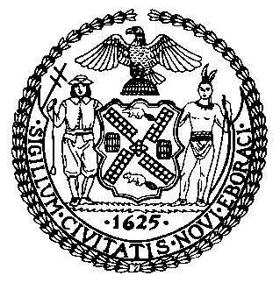 | The Council of the City of New York  Finance Division  Latonia McKinney, Director  Fiscal Impact Statement  Proposed Int. No. 1624-A  Committee: Contracts
Title: A Local Law to amend the administrative code of the city of New York, in relation to tracking certifications of minority and women owned business enterprises and emerging business enterprises | Sponsors: Council Members Kallos, Ampry-Samuel and Grodenchik
Summary of Legislation: This bill would require the Mayor’s Office of Contract Services and the Department of Small Business Services to expand the data in the quarterly Minority- and Women- Owned Business Enterprise (“M/WBE”) report to include the change in the number of certified M/WBE firms and certified Emerging Business Enterprise (“EBE”) firms in each industry classification since the most recent M/WBE disparity study and the percentage increase for such firms since the previous quarter.

Effective Date: This local law would take effect 120 days after it becomes law.
Fiscal Year in which Full Fiscal Impact Anticipated: Fiscal 2023
Fiscal Impact Statement:
 | Effective FY22 | FY Succeeding  Effective FY23 | Full Fiscal Impact FY23
Revenues (+) | $0 | $0 | $0
Expenditures (-) | $0 | $0 | $0
Net | $0 | $0 | $0

Impact on Revenues: It is estimated that there would be no impact on revenues resulting from the enactment of this legislation.

Impact on Expenditures: It is estimated that there would be no impact on expenditures resulting from the enactment of this legislation because the relevant agencies would use existing resources to accomplish its requirements.

Source of Funds to Cover Estimated Costs: N/A

Sources of Information: New York City Council Finance Division
Mayor’s Office of Legislative Affairs

Estimate Prepared by: John Russell, Unit Head

Estimate Reviewed by: Nathaniel Toth, Deputy Director
Stephanie Ruiz, Assistant Counsel
Legislative History: This legislation was considered by the Committee on Contracts (Committee) as a Preconsidered Introduction on June 20, 2019 and the legislation was laid over. The legislation was later introduced to the Council as Int. No. 1624 on June 26, 2019 and was referred to the Committee. The legislation was subsequently amended, and the amended legislation, Proposed Int. No. 1624-A, will be considered by the Committee on December 8, 2021. Upon a successful vote by the Committee, Proposed Int. No. 1624-A will be submitted to the full council for a vote on December 9, 2021.

Date Prepared: December 3, 2021

