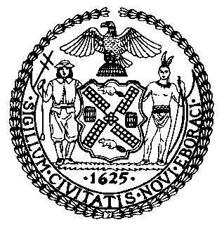 | The Council of the City of New York  Finance Division  Latonia Mckinney, Director  Fiscal Impact Statement  Proposed Intro. No: 1298-A  Committee: Committee on Education
Title: A Local Law to amend the administrative code of the city of New York, in relation to requiring the Department of Education to report on physical education curricula in New York city schools | Sponsor(s): Council Members Treyger, Kallos, King, Cornegy, Eugene, Gibson, Reynoso, Levine, Richards and Rose
Summary of Legislation: This bill would amend Local Law 102 of 2015 that requires the New York City Department of Education to report on physical education curricula in New York City schools, including average physical education class size, a description of the department’s physical education scope and sequence, including the topics covered by such physical education scope and sequence. The proposed bill would additionally require reporting on professional development received by certified physical education instructors.

Effective Date: Immediately
Fiscal Year In Which Full Fiscal Impact Anticipated: Fiscal 2020
Fiscal Impact Statement:

 | Effective FY19 | FY Succeeding Effective FY20 | Full Fiscal Impact FY20
Revenues | $0 | $0 | $0
Expenditures | $0 | $0 | $0
Net | $0 | $0 | $0

Impact on Revenues: It is anticipated that there would be no impact on revenues resulting from the enactment of this legislation.
Impact on Expenditures: It is anticipated that there would be no impact on expenditures resulting from the enactment of this legislation as DOE already has the resources in place to provide this data.
Source of Funds To Cover Estimated Costs: N/A
Source of Information: New York City Council Finance Division, New York City Department of
Education
Estimate Prepared by: Chelsea Baytemur, Legislative Financial Analyst
Estimate Reviewed by: Dohini Sompura, Unit Head
Regina Poreda Ryan, Deputy Director

Legislative History: This legislation was introduced to the Council as Intro. No.1298 on December 11, 2018 and referred to the Committee on Education. A hearing was held by the Committee on Education on December 3, 2018 and the legislation was laid over. The legislation was subsequently amended and the amended legislation, Proposed Intro. No. 1298-A, will be considered by the Committee on Education on May 28, 2019. Upon a successful vote by the Committee, Proposed Intro. No. 1298-A will be submitted to the full Council for a vote on May 29, 2019.

Date Prepared: May 23, 2019

