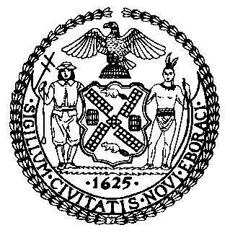 | The Council of the City of New York  Finance Division  Latonia McKinney, Director  Fiscal Impact Statement  Proposed Intro. No. 1115-A  Committee: Governmental Operations
Title: A Local Law to amend the New York city charter, in relation to agencies assisting eligible parolees with voter registration. | Sponsors: Council Members Cabrera, Kallos, Miller
Summary of Legislation: Proposed Intro. 1115-A would require the Voter Assistance Advisory Committee to develop and distribute guidance for agencies covered by the existing Agency Based Voter Registration Law on the voting rights of formerly incarcerated persons. It would also require such agencies, as part of their required assistance in completing voter registration forms, to, upon request by a parolee applicant, and when practically feasible, check if such applicant has had their voting rights restored.

Effective Date: This local law would take effect six months after it becomes law.
Fiscal Year in which Full Fiscal Impact Anticipated: Fiscal 2020
Fiscal Impact Statement:
 | Effective FY19 | FY Succeeding  Effective FY20 | Full Fiscal Impact FY20
Revenues (+) | $0 | $0 | $0
Expenditures (-) | $0 | $0 | $0
Net | $0 | $0 | $0

Impact on Revenues: It is anticipated that there would be no impact on revenues resulting from the enactment of this legislation.

Impact on Expenditures: It is estimated that there would be no impact on expenditures resulting from the enactment of this legislation. It is estimated that the Voter Assistance Advisory Committee and agencies covered by the Agency Based Voter Registration Law would be able to use existing resources to comply with the requirements of this legislation.

Source of Funds to Cover Estimated Costs: N/A

Sources of Information: New York City Council Finance Division

Estimate Prepared by: Zachary Harris, Legislative Financial Analyst

Estimate reviewed by: John Russell, Unit Head
Noah Brick, Assistant Counsel

Legislative History: This legislation was introduced to the Council as Intro. No. 1115 on September 26, 2018 and referred to the Committee on Governmental Operations. A joint hearing was held by the Committee on Governmental Operations and the Committee on Criminal Justice on October 3, 2018 and the legislation was laid over. The legislation was subsequently amended and the amended legislation, Proposed Intro. No. 1115-A, will be considered by the Committee on Governmental Operations on November 27, 2018. Upon a successful vote by the Committee, Proposed Intro. No. 1115-A will be submitted to the full Council for a vote on November 28, 2018.

Date Prepared: November 21, 2018

