THE COUNCIL OF THE CITY OF NEW YORK
RESOLUTION NO. 1830

Resolution approving with modifications the decision of the City Planning Commission on Application No. N 210482 ZRK, for an amendment of the text of the Zoning Resolution (L.U. No. 891).

By Council Members Salamanca and Moya

WHEREAS, Maspeth Manager, LLC and the NYC Department of Housing Preservation and Development, filed an application pursuant to Section 201 of the New York City Charter, for an amendment of the Zoning Resolution of the City of New York, modifying APPENDIX F for the purpose of establishing a Mandatory Inclusionary Housing area, which in conjunction with the related actions would facilitate the redevelopment of the former Greenpoint Hospital campus into a mixed-use development with two new buildings and the enlargement of two existing buildings containing 556 units of affordable housing, senior housing, replacement of a 200-bed homeless shelter, community facility uses, and light retail on the site located in the East Williamsburg neighborhood of Brooklyn, Community District 1 (Application No. N 210482 ZRK) (the “Application”);

WHEREAS, the City Planning Commission filed with the Council on October 8, 2021, its decision dated October 6, 2021 (the “Decision”), on the Application;

WHEREAS, the Application is related to application C 210480 ZMK (L.U. No. 889), a zoning map amendment to rezone the project area from an R6 district to R7-2 and R7-2/C2-4 zoning district; C 210481 ZSK (L.U. No. 890), a special permit to establish a Large-Scale General Development (LSGD) pursuant to ZR Section 74-74 and 74-743(a)(2); C 210483 HAK (L.U. No. 892), an Urban Development Action Area (UDAA) designation, Urban Development Action Area Project (UDAAP) approval, and disposition of City-owned property; and C 210484 PPK (L.U. No. 893), a disposition approval to change use restriction from a health care facility to a general community facility use;

WHEREAS, the Decision is subject to review and action by the Council pursuant to Section 197-d of the City Charter;

WHEREAS, upon due notice, the Council held a public hearing on the Decision and Application on October 13, 2021;

WHEREAS, the Council has considered the land use implications and other policy issues relating to the Decision and Application; and

WHEREAS, the Council has considered the relevant environmental issues, including the Negative Declaration issued June 18th, 2021 (CEQR No. 20HPD007K) (the “Negative Declaration”).

RESOLVED:

The Council finds that the action described herein will have no significant impact on the environment as set forth in the Negative Declaration.

Pursuant to Sections 197-d and 200 of the City Charter and on the basis of the Decision and Application, and based on the environmental determination and consideration described in the report, N 210482 ZRK, incorporated by reference herein, and the record before the Council, the Council approves the Decision of the City Planning Commission with the following modifications:

Matter underlined is new, to be added;
Matter struck out is to be deleted;
Matter double struck out is old, deleted by the City Council;
Matter double-underlined is new, added by the City Council
Matter within # # is defined in Section 12-10;
* * * indicates where unchanged text appears in the Zoning Resolution

* * *

APPENDIX F
Inclusionary Housing Designated Areas and Mandatory Inclusionary Housing Areas

* * *

BROOKLYN

* * *

Brooklyn Community District 1

* * *

[EXISTING MAP]

Map 2 – (3/23/11)

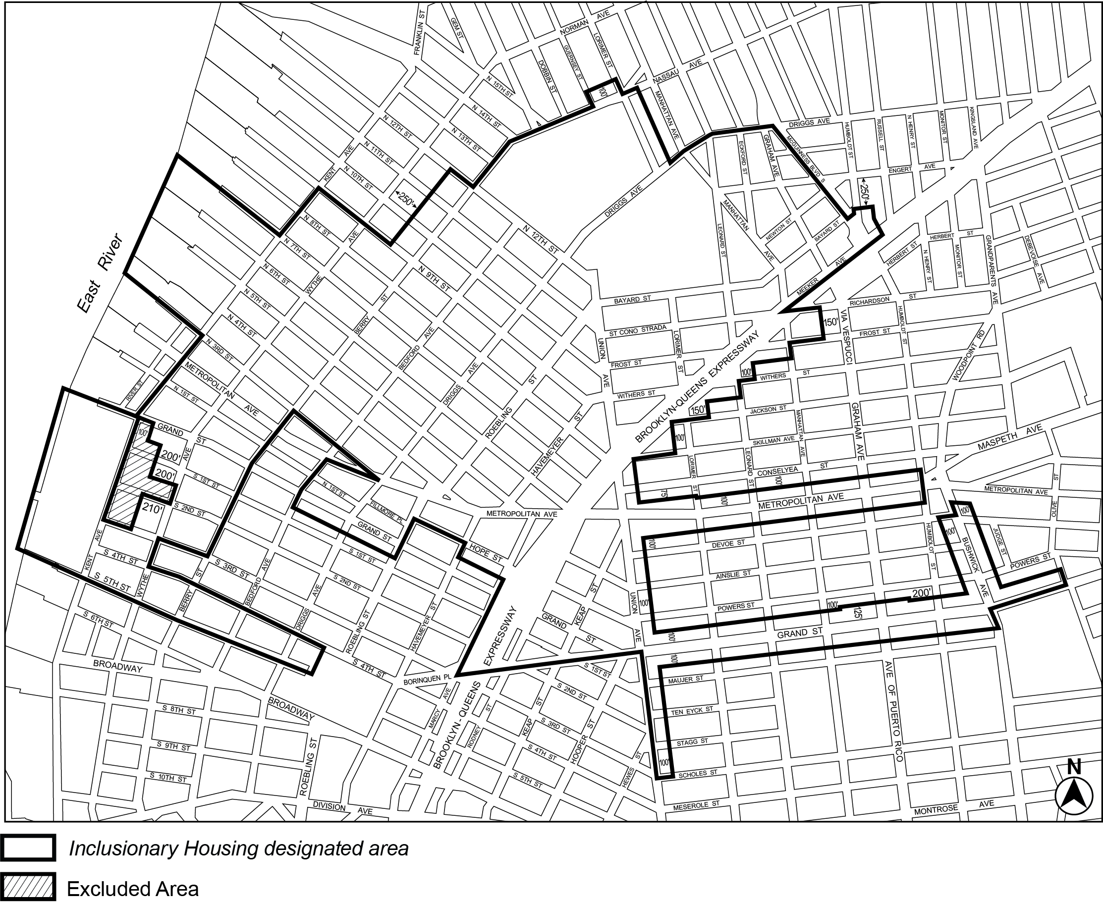

[PROPOSED MAP]

Map 2 – (date of adoption)

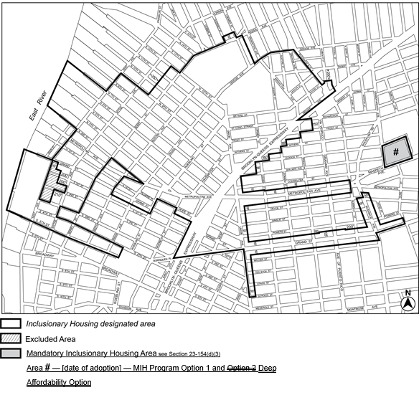

Portion of Community District 1, Brooklyn

* * *

Adopted.

Office of the City Clerk, }
The City of New York, } ss.:

I hereby certify that the foregoing is a true copy of a Resolution passed by The Council of The City of New York on __________, 2021, on file in this office.

.....................................................
City Clerk, Clerk of The Council

