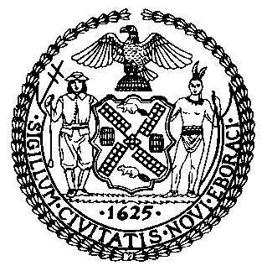 | The Council of the City of New York  Finance Division  Latonia McKinney, Director  Fiscal Impact Statement  Proposed Intro. No. 1083-A  Committee: Sanitation and Solid Waste Management
Title: A Local Law to amend the administrative code of the city of New York, in relation to fines for unreported employees | Sponsors: Council Members Salamanca, Kallos, Lancman and Lander
Summary of Legislation: Proposed Intro. No. 1083-A would require the Business Integrity Commission (BIC) to fine companies that have unreported employees a minimum of $1,000 and a maximum of $10,000 for each individual working for the company who is not reported.

Effective Date: This local law would take effect immediately.
Fiscal Year in which Full Fiscal Impact Anticipated: Fiscal 2021
Fiscal Impact Statement:
 | Effective FY20 | FY Succeeding  Effective FY21 | Full Fiscal Impact FY21
Revenues (+) | $0 | $0 | $0
Expenditures (-) | $0 | $0 | $0
Net | $0 | $0 | $0

Impact on Revenues: It is estimated that this legislation would have no impact on revenues because full compliance with the legislation is anticipated.

Impact on Expenditures: It is estimated that there would be no impact on expenditures resulting from the enactment of Proposed Intro. No. 1083-A as BIC would utilize existing resources to implement the requirements of this bill.

Source of Funds to Cover Estimated Costs: N/A

Sources of Information: New York City Business Integrity Commission
New York City Council Finance Division

Estimate Prepared by: Jonathan Seltzer, Senior Financial Analyst

Estimate reviewed by: Crilhien Francisco, Unit Head
Noah Brick, Assistant Counsel
Nathan Toth, Deputy Director
Legislative History: This legislation was introduced to the Council as Intro. No. 1083 on August 8, 2018 and referred to the Committee on Sanitation and Solid Waste Management (Committee). The Committee heard the legislation on June 27, 2019 and it was laid over. The legislation was subsequently amended and the amended version, Proposed Intro. No. 1083-A, will be considered by the Committee at a hearing on October 29, 2019. Upon a successful vote by the Committee, Proposed Intro. No. 1083-A will be submitted to the full Council for a vote on October 30, 2019.
Date Prepared: October 24, 2019

