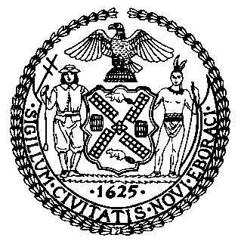 | The Council of the City of New York  Finance Division  Latonia Mckinney, Director  Fiscal Impact Statement  Proposed Intro. No: 370-A  Committee: Transportation
Title: A local law to amend the administrative code of the city of New York, in relation to suspending alternate side parking regulations on Three Kings’ Day | Sponsors: Council Members Salamanca, Holden, Diaz, Menchaca, Dromm, Koo, Reynoso, Adams, Cabrera, Deutsch, Miller, Lander, Rivera, Powers, Ayala, Grodenchik, Rosenthal, Yeger, Espinal, Kallos, and Levin
Summary of Legislation: Proposed Intro. 370-A would suspend alternate side of the street parking regulations on Three Kings’ Day.

Effective Date: This local law would take effect immediately.

Fiscal Year In Which Full Fiscal Impact Anticipated: Fiscal 2020
Fiscal Impact Statement:
 | Effective FY19 | FY Succeeding Effective FY20 | Full Fiscal Impact FY20
Revenues | ($540,000) | ($540,000) | ($540,000)
Expenditures | $0 | $0 | $0
Net | ($540,000) | ($540,000) | ($540,000)
Impact on Revenues: It is estimated that approximately $540,000 in revenue will be foregone for each day that alternate side of the street parking rules are suspended, with the exception of Sundays. According to the Office of Management and Budget, the impact on revenues cited above is equivalent to the average daily summons revenue generated from alternate side of the street parking violations in Fiscal 2018.

Impact on Expenditures: It is estimated that this legislation would have no impact on expenditures since existing resources would be used by the administering agency to comply with this local law.
Source of Funds to Cover Estimated Costs: General Fund
Source of Information: New York City Council Finance Division
Mayor’s Office of Legislative Affairs
Estimate Prepared by: John Basile, Financial Analyst

Estimate Reviewed by: Nathan Toth, Deputy Director
Chima Obichere, Unit Head
Rebecca Chasan, Senior Counsel
Legislative History: This legislation was introduced to the full Council as Intro. No 370 on January 31, 2018 and was referred to the Committee on Transportation (Committee). A hearing was held by the Committee on October 29, 2018 and the legislation was laid over. The legislation was subsequently amended and the amended version, Proposed Intro No. 370-A, will be considered by the Committee on November 27, 2018. Upon a successful vote by the Committee, Proposed Intro. No. 370-A will be submitted to the full Council for a vote on November 28, 2018.
Date Prepared: November 21, 2018

