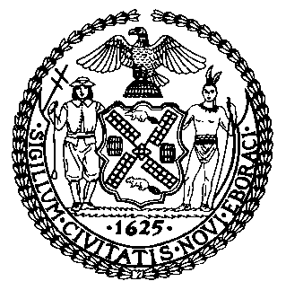 | The Council of the City of New York  Finance Division  Latonia Mckinney, Director  Fiscal Impact Statement  Int. No. 1553-A  Committee: Public Safety
Title: A Local Law to amend the administrative code of the city of New York, in relation to prohibiting unfinished frames or receivers | Sponsors: By Council Members Rosenthal, Miller, Richards, The Public Advocate (Mr. Williams), Levine, Chin, Kallos, Lander, Louis, Barron and Ayala
Summary of Legislation: Int. No. 1553-A would prohibit the possession of unfinished frames or receivers, which are used to create unlicensed untraceable firearms, also known as “ghost guns.”
Effective Date: This local law would take effect 120 days after it becomes law.
Fiscal Year In Which Full Fiscal Impact Anticipated: Fiscal 2021
Fiscal Impact Statement:

 | Effective FY20 | FY Succeeding  Effective FY21 | Full Fiscal  Impact FY21
Revenues (+) | $0 | $0 | $0
Expenditures (-) | 0 | 0 | 0
Net | 0 | 0 | 0

Impact on Revenues: It is anticipated that there would be no impact on revenues resulting from the enactment of this legislation.
Impact on Expenditures: It is anticipated that there would be no impact on expenditures resulting from the enactment of this legislation.
Source of Funds To Cover Estimated Costs: N/A
Source of Information: New York City Council Finance Division
New York Police Department

Estimate Prepared by: Nevin Singh, Financial Analyst

Estimate Reviewed by: Noah Brick, Assistant Council
Regina Poreda Ryan, Deputy Director

Legislative History: This legislation was introduced to the full Council on May 8, 2019 as Intro. No. 1548 and referred to the Committee on Public Safety (the Committee). The Committee heard the legislation on June 27, 2019, and the bill was laid over. The legislation was subsequently amended and the amended legislation, Proposed Intro. No. 1548-A, will be considered by the Committee on September 23, 2019. Upon a successful vote by the Committee, the bill will be submitted to the full Council for a vote on September 25, 2019.

Date Prepared: September 19, 2019

