THE COUNCIL OF THE CITY OF NEW YORK
RESOLUTION NO. 1574

Resolution approving the decision of the City Planning Commission on Application No. N 200179 ZRQ, for an amendment of the text of the Zoning Resolution (Preconsidered L.U. No. 736).

By Council Members Salamanca and Moya

WHEREAS, 63-68 RWKOP, LLC, filed an application pursuant to Section 201 of the New York City Charter, for an amendment of the text of the Zoning Resolution of the City of New York, modifying Appendix F for the purpose of establishing a Mandatory Inclusionary Housing area, which in conjunction with the related action would facilitate the development of a nine-story mixed-use building at 91-32 63rd Drive in the Rego Park neighborhood of Queens Community District 6 (Application No. N 200179 ZRQ) (the “Application”);

WHEREAS, the City Planning Commission filed with the Council on February 19, 2021, its decision dated February 17, 2021 (the “Decision”), on the Application;

WHEREAS, the Application is related to application C 200178 ZMQ (Pre. L.U. No. 735), a zoning map amendment to change an R4 zoning district with a C2-2 commercial overlay to an R7A zoning district with a C2-3 commercial overlay;

WHEREAS, the Decision is subject to review and action by the Council pursuant to Section 197-d of the City Charter;

WHEREAS, upon due notice, the Council held a public hearing on the Decision and Application on February 23, 2021;

WHEREAS, the Council has considered the land use implications and other policy issues relating to the Decision and Application; and

WHEREAS, the Council has considered the relevant environmental issues, including the Revised Negative Declaration issued February 12, 2020, which supersedes the Negative Declaration issued October 1st, 2020, and Revised Environmental Assessment Statement issued February 11, 2020 (CEQR No. is 20DCP107Q) which includes an (E) designation to avoid the potential for significant adverse impacts related to hazardous materials, air quality, and noise (E-568) (the “Revised Negative Declaration”).

RESOLVED:

The Council finds that the action described herein will have no significant impact on the environment as set forth in the (E) Designation (E-568) and Revised Negative Declaration.

Pursuant to Sections 197-d and 200 of the City Charter and on the basis of the Decision and Application, and based on the environmental determination and consideration described in the report, N 200179 ZRQ, incorporated by reference herein, and the record before the Council, the Council approves the Decision of the City Planning Commission.

Matter underlined is new, to be added;
Matter struck out is to be deleted;
Matter within # # is defined in Section 12-10;
* * * indicates where unchanged text appears in the Zoning Resolution.

* * *

APPENDIX F
Inclusionary Housing Designated Areas and Mandatory Inclusionary Housing Areas

* * *
QUEENS

* * *
Queens Community District 6

* * *

Map 2– [date of adoption]

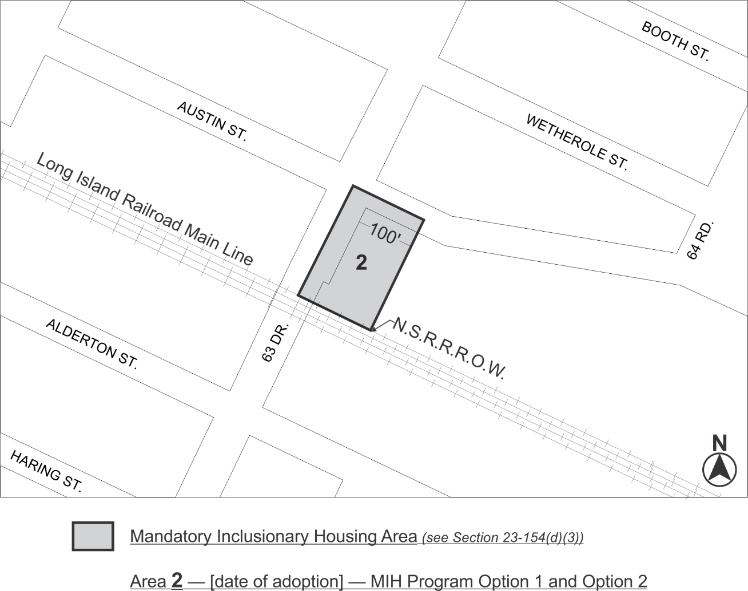

Portion of Community District 6, Queens

* * *

Adopted.

Office of the City Clerk, }
The City of New York, } ss.:

I hereby certify that the foregoing is a true copy of a Resolution passed by The Council of The City of New York on March 18, 2021, on file in this office.

.....................................................
City Clerk, Clerk of The Council

