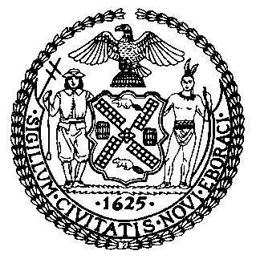 | The Council of the City of New York  Finance Division  Latonia McKinney, Director  Fiscal Impact Statement  Proposed Intro No. 1483-A  Committee: General Welfare
Title: A Local Law to amend the administrative code of the city of New York, in relation to a plan to accommodate pets of families and individuals experiencing homelessness in shelter | By Council Members Levin, Levine, Brannan, Holden, Chin, Ayala, Louis, Adams, Rivera, Salamanca, Gennaro and the Public Advocate (Mr. Williams)
Summary of Legislation: Proposed Intro No. 1483-A would require the Department of Homeless Services (DHS) to develop a plan to accommodate pets of homeless individuals and families with the objective of allowing homeless pet-owners to keep their pets and submit the plan to the Speaker of the Council no later than 180 days after the effective date of this bill. Such plan would include the steps DHS can take to prioritize the acquisition of facilities that will permit homeless pet-owners to keep their pets, as well as identifying existing providers that will permit homeless pet-owners to keep their pets. The bill would also require that DHS collaborate with the Human Resources Administration (HRA) to outline steps to address accommodating pets of homeless individuals and families in HRA shelter facilities.

Effective Date: This local law would take effect immediately.
Fiscal Year in which Full Fiscal Impact Anticipated: Fiscal 2023
Fiscal Impact Statement:
 | Effective FY22 | FY Succeeding  Effective FY23 | Full Fiscal Impact FY23
Revenues (+) | $0 | $0 | $0
Expenditures (-) | $0 | $0 | $0
Net | $0 | $0 | $0

Impact on Revenues: It is estimated that there would be no impact on revenues resulting from the enactment of this legislation.

Impact on Expenditures: It is estimated that there would be no impact on expenditures resulting from the enactment of this legislation. The Council expects that DHS will be able to use existing resources to comply with Proposed Intro No. 1483-A.

Source of Funds to Cover Estimated Costs: N/A

Sources of Information: New York City Council Finance Division
Mayor’s Office of Legislative Affairs

Estimate Prepared by: Frank Sarno, Financial Analyst

Estimate Reviewed by: Regina Poreda Ryan, Deputy Director
Dohini Sompura, Unit Head
Noah Brick, Assistant Counsel
Legislative History: This legislation was introduced to the full Council on March 28, 2019 and subsequently referred to the Committee on General Welfare (Committee). The Committee heard the legislation on February 28, 2020 and the bill was laid over. The legislation was subsequently amended and the amended version, Proposed Intro. No. 1483-A, will be considered by the Committee at a hearing on August 26, 2021. Upon a successful vote by the Committee, Proposed Intro. No. 1483-A will be submitted to the full Council for a vote on August 26, 2021.
Date Prepared: August 24, 2021

