THE COUNCIL OF THE CITY OF NEW YORK
RESOLUTION NO. 834

Resolution approving the decision of the City Planning Commission on Application No. N 190074 ZRK, for an amendment of the text of the Zoning Resolution (L.U. No. 365).

By Council Members Salamanca and Moya

WHEREAS, the City Planning Commission filed with the Council on February 25, 2019 its decision dated February 25, 2019 (the "Decision"), on the application submitted by 550 Clinton Partners LLC and 539 Vanderbilt Partners , LLC, pursuant to Section 201 of the New York City Charter, for an amendment of the text of the Zoning Resolution of the City of New York, modifying Appendix F for the purpose of establishing a Mandatory Inclusionary Housing Area which in conjunction with the related actions would facilitate the development of two new mixed-use buildings on the development site, one 4 stories and one 29 stories, with approximately 204,000 square feet of residential floor area and 33,000 square feet of commercial floor area and fund the restoration of the landmarked Church of St. Luke & St. Matthew at 809 Atlantic Avenue in the Fort Greene/Clinton Hill neighborhood of Brooklyn, Community District 2 (Application No. N 190074 ZRK) (the "Application");

WHEREAS, the Application is related to application C 190071 ZMK (L.U. No. 362), a zoning map amendment to change R7A/C2-4, R7A and R6A districts to an R9/C2-5 district and to change an R7A/C2-4 district to an R6A district; C 190072 ZSK (L.U. No. 363), a special permit pursuant to Zoning Resolution (ZR) Section 74-711 to modify bulk requirements; and C 190073 ZSK (L.U. No. 364), a special permit pursuant to ZR Section 74-533 to modify residential parking requirements;

WHEREAS, the Decision is subject to review and action by the Council pursuant to Section 197-d(b)(1) of the City Charter;
WHEREAS, upon due notice, the Council held a public hearing on the Decision and Application on March 6, 2019;

WHEREAS, the Council has considered the land use implications and other policy issues relating to the Decision and Application; and

WHEREAS, the Council has considered the relevant environmental issues, including the Revised Negative Declaration issued February 22nd, 2019 which supersedes the Negative Declaration issued September 24th, 2018, and Revised Environmental Assessment Statement issued February 22nd, 2019 (CEQR No. 18DCP179K) which include an (E) designation to avoid the potential for significant adverse impacts related to hazardous materials and air quality or noise (the “E” Designation (E-499));

RESOLVED:
The Council finds that the action described herein will have no significant impact on the environment as set forth in the (E) Designation (E-499) and Revised Negative Declaration.

Pursuant to Sections 197-d and 200 of the City Charter and on the basis of the Decision and Application, and based on the environmental determination and consideration described in the report, N 190074 ZRK, incorporated by reference herein, and the record before the Council, the Council approves the Decision of the City Planning Commission.

Matter underlined is new, to be added;
Matter struck out is to be deleted;
Matter within # # is defined in Section 12-10;
* * * indicates where unchanged text appears in the Zoning Resolution

* * *

APPENDIX F
Inclusionary Housing Designated Areas and Mandatory Inclusionary Housing Areas

* * *

Brooklyn

* * *

Brooklyn Community District 2

* * *

Map 3 - [date of adoption]

[EXISTING MAP]

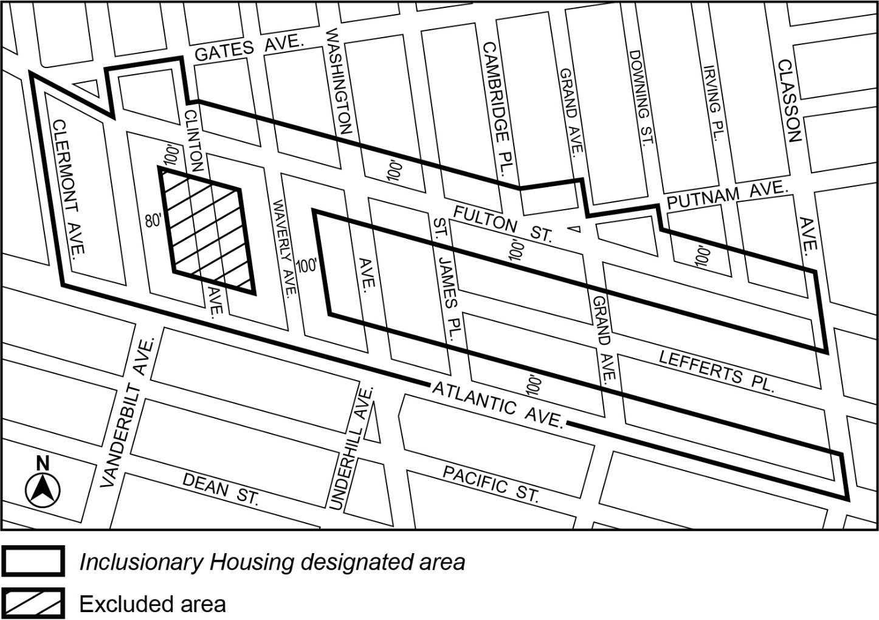

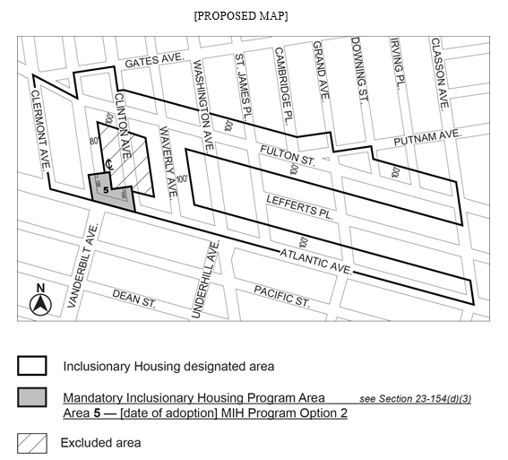
Portion of Community District 2, Brooklyn
Portion of Community District 2, Brooklyn

* * *

Adopted.

Office of the City Clerk, }
The City of New York, } ss.:

I hereby certify that the foregoing is a true copy of a Resolution passed by The Council of The City of New York on April 9, 2019, on file in this office.

.....…….........................................
City Clerk, Clerk of The Council

