THE COUNCIL OF THE CITY OF NEW YORK
RESOLUTION NO. 795

Resolution approving with modifications the decision of the City Planning Commission on Application No. N 190144 ZRX, for an amendment of the text of the Zoning Resolution (L.U. No. 351).

By Council Members Salamanca and Moya

WHEREAS, the City Planning Commission filed with the Council on February 8, 2019 its decision dated January 30, 2019 (the "Decision"), on the application submitted by the New York City Housing Authority, LLC, pursuant to Section 201 of the New York City Charter, for an amendment of the text of the Zoning Resolution of the City of New York, modifying APPENDIX F for the purpose of establishing a Mandatory Housing Inclusionary area, which in conjunction with the related action would facilitate a new 15-story, 110,354-square-foot building comprising 101 units of affordable housing and approximately 8,560 square feet of ground floor retail at 472 – 474 Willis Avenue in the Mott Haven neighborhood of the Bronx, Community District 1 (Application No. N 190144 ZRX), (the "Application");

WHEREAS, the Application is related to application C 190143 ZMX (L.U. No. 350), a zoning map amendment to change R6 and R6/C1-4 districts to R7X/C2-4 and R7X districts.

WHEREAS, the Decision is subject to review and action by the Council pursuant to Section 197-d(b)(1) of the City Charter;

WHEREAS, upon due notice, the Council held a public hearing on the Decision and Application on February 14, 2019;

WHEREAS, the Council has considered the land use implications and other policy issues relating to the Decision and Application; and

WHEREAS, the Council has considered the relevant environmental issues, including the negative declaration issued on October 10, 2018 (CEQR No. 18CHA005X) (the “Negative Declaration”).

RESOLVED:

The Council finds that the action described herein will have no significant impact on the environment as set forth in the Negative Declaration.

Pursuant to Sections 197-d and 200 of the City Charter and on the basis of the Decision and Application, and based on the environmental determination and consideration described in the report, N 190144 ZRX, incorporated by reference herein, and the record before the Council, the Council approves the Decision of the City Planning Commission with the following modifications.

Betances VI
Community District 1, The Bronx
07/10/18

* * *

Matter underlined is new, to be added;
Matter struck out is to be deleted;
Matter within # # is defined in Section 12-10;
Matter double struck out is old, deleted by the City Council;
Matter double-underlined is new, added by the City Council;
* * * indicates where unchanged text appears in the Zoning Resolution.

APPENDIX F

Inclusionary Housing Designated Areas and Mandatory Inclusionary Housing Areas

* * *

THE BRONX

* * *

The Bronx, Community District 1

* * *
Map 6 – [date of adoption]

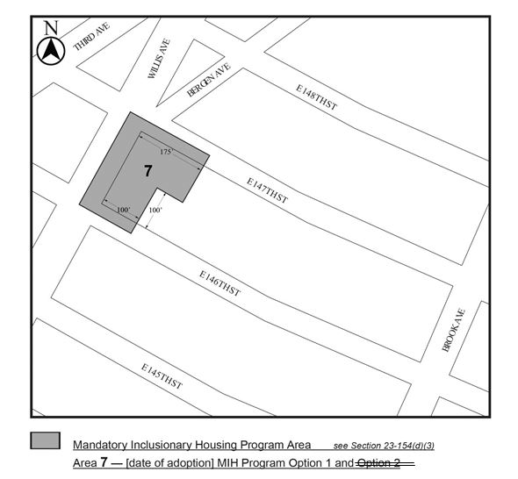
Portion of Community District 1, the Bronx

* * *

Adopted.

Office of the City Clerk, }
The City of New York, } ss.:

I hereby certify that the foregoing is a true copy of a Resolution passed by The Council of The City of New York on March 13, 2019, on file in this office.

..……….......................................
City Clerk, Clerk of The Council

