Staff: Committee on Sanitation & Solid Waste Management
Jessica Steinberg Albin, Senior Legislative Counsel
Ricky Chawla, Senior Legislative Policy Analyst
Andrew Lane-Lawless, Finance Analyst

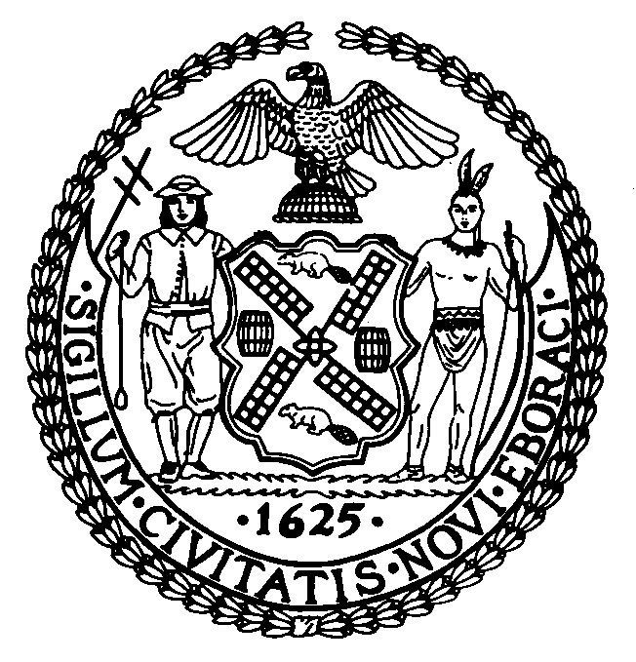

The New York City Council
Andrea Vazquez, Legislative Director

Committee Report of the Infrastructure Division
Brad Reid, Deputy Director

Committee on Sanitation & Solid Waste Management
Hon. Sandy Nurse, Chair

September 20, 2022

Oversight: The State of NYC Recycling

INT. NO. 494: By Council Members Nurse, Joseph, Abreu, Restler, Cabán, Holden, Bottcher, De La Rosa, Sanchez, Stevens, Richardson Jordan, Dinowitz, Menin, Won, Powers, Marte, Hudson, Barron, Louis, Gennaro, Ossé, Schulman, Avilés, Ayala, Ung, Riley, Salamanca, Velázquez, Brooks-Powers and Rivera (by request of the Manhattan Borough President)

TITLE: A Local Law in relation to a study of single-use plastics

- Introduction

On September 20, 2022, the Committee on Sanitation and Solid Waste Management (“Committee”), chaired by Council Member Sandy Nurse, will hold an oversight hearing on the state of recycling in New York City (“City”). The Committee will also consider: Int. No. 494, sponsored by Council Member Nurse, in relation to the establishment of a comprehensive study on single-use plastics in the City. The Committee expects to receive testimony from representatives of the New York City Department of Sanitation (“DSNY”), environmental advocates, and interested members of the public.

- Background
Residential, School, and NYCHA Waste Streams
In March 2018, DSNY released the “2017 NYC Residential, School, and NYCHA Waste Characterization Study” (“2017 Study”). Waste characterization studies such as the 2017 Study are required by Local Law 40 of 2010, with the next comprehensive citywide multi-season study due by January 31, 2024. These studies document the composition and volume of materials that City residents discard as refuse and assess how much of this material could have been diverted from landfill. Additionally, these studies help evaluate the progress made towards both the recycling diversion goals established by Local Law 40 and the goal of sending zero waste to landfills by 2030 set by the administration of former Mayor Bill de Blasio.
The 2017 Study groups the materials in the waste stream into four main categories of materials. First, the “recyclables” category includes clean paper and cardboard; commingled metal, glass, and plastic recycling (“MGP”); and cartons. Second, the “organics” category includes food scraps, food-soiled paper, and yard waste. Third, the “other divertable materials” [sic] category includes textiles, plastic shopping bags, harmful household products, and electronic waste (“e-waste”). Finally, an “other” category includes materials “for which there are no or very limited options for beneficial use at this time.” These materials include “small scale building material scrap (construction and demolition debris), furniture and household wood products, treated wood and lumber, carpeting, various plastic film, flexible and foam products, multi-material items, disposable diapers, and animal by-products.”
According to the 2017 Study, on a per household basis, the average household discarded 2,280 pounds of “aggregate discards” (or overall waste) per year in 2005, 2,000 pounds in 2013, and 1,990 pounds in 2017. The cause of this steady decline is attributed in part to a reduction in refuse and an increase in paper and MGP recycling. However, during this period, there was an increase in the waste stream of non-bottle rigid plastic waste, food scraps, food soiled paper, harmful household products, and textiles.
Figures 1, 2, and 3 below show the 2017 composition of aggregate discards for residences, schools, and New York City Housing Authority (“NYCHA”) communities. For each of these three sectors, a considerable amount of waste was suitable for either organics or recycling collection, but was instead discarded as refuse. For the residential sector, 68% of the waste collected could have been diverted from landfill, as 34% was suitable for organics collection and another 34% for recycling collection. For schools, 86% of the waste could have been diverted from landfill as it was comprised of either organics (51%) or recyclables (35%). For NYCHA, 55% of the waste could have been diverted from landfill as it was comprised of either organics (32%) or recyclables (33%). Additionally, when considering the “other divertable materials” category (textiles, plastic shopping bags, harmful household products, and e-waste), another 9% of residential refuse could have been diverted from landfill, as well as 2% of school refuse, and 12% of NYCHA refuse.
Figure 1: Composition of Residential Curbside Aggregate Discards, 2017
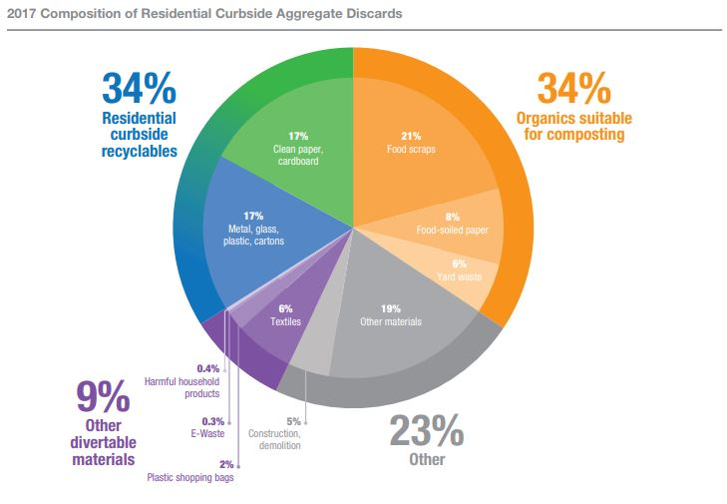
Source: New York City Department of Sanitation, “2017 NYC Residential, School, and NYCHA Waste Characterization Study” (March 2018)
Image description: Figure 1 shows that for residential curbside collected waste, 34% consisted of curbside recyclable materials, 34% consisted of organics suitable for composting, and 9% consisted of other “divertable” materials, including textiles, e-waste, harmful household products, and plastic shopping bags. The remaining 23% consisted of other materials, 5% of which was construction and demolition material.

Figure 2: Composition of Schools Aggregate Discards, 2017
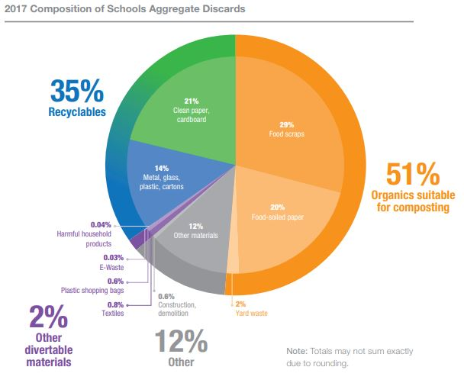

Source: New York City Department of Sanitation, “2017 NYC Residential, School, and NYCHA Waste Characterization Study” (March 2018)
Image description: Figure 2 shows that for school curbside collected waste, 35% consisted of curbside recyclable materials, 51% consisted of organics suitable for composting, and 2% consisted of other “divertable” materials, including textiles, e-waste, harmful household products, and plastic shopping bags. The remaining 12% consisted of other materials, 0.8% of which was construction and demolition material.

Figure 3: Composition of NYCHA Refuse, 2017
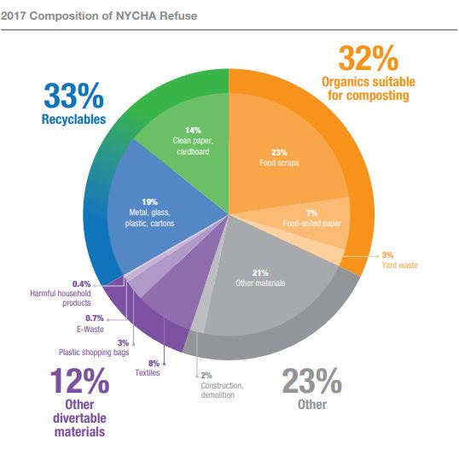
Source: New York City Department of Sanitation, “2017 NYC Residential, School, and NYCHA Waste Characterization Study” (March 2018)
Image description: Figure 3 shows that for NYCHA curbside collected waste, 33% consisted of curbside recyclable materials, 32% consisted of organics suitable for composting, and 12% consisted of other divertible materials, including textiles, e-waste, harmful household products, and plastic shopping bags. The remaining 23% consisted of other materials, 2% of which was construction and demolition material.
City Landfill Diversion and Zero Waste Goals
Local Law 19 of 1989 codified goals for the diversion from landfill of DSNY-managed solid waste and curbside and containerized waste. By July 1, 2020, the goal was to recycle 33% of DSNY-managed solid waste and 25% of curbside and containerized waste. The City fell far short of those goals in 2020, with an actual diversion rate of 21.6% of DSNY-managed solid waste and 18.5% of curbside and containerized waste. In 2021, the DSNY-managed solid waste diversion rate fell to 17.9%, and the diversion rate of curbside and containerized waste fell to 17.8%.
The City is part of a growing movement by cities across the world to set goals to achieve zero waste (“Zero Waste”). In 2015, the administration of then-Mayor Bill de Blasio committed to send Zero Waste to landfill by 2030, as part of the City’s OneNYC: The Plan for a Strong and Just City. To measure progress towards the Zero Waste goal, the de Blasio administration committed to tracking waste reduction and waste diversion from landfills, and to setting a target of reducing the amount of waste disposed by 90% by 2030, from a 2005 baseline. The de Blasio administration developed eight initiatives to reach Zero Waste: (1) expand the organics program; (2) enhance the City’s curbside recycling program; (3) reduce the use of plastic bags and other non-compostable waste; (4) give every New Yorker the opportunity to recycle and reduce waste; (5) make all schools Zero Waste schools; (6) expand opportunities to reuse and recycle textiles and e-waste; (7) develop an equitable blueprint for a Save-As-You-Throw program to reduce waste; and (8) reduce commercial waste by 90% by 2030.
Non-Curbside Collection Materials
There are materials that end up in residential refuse streams that could be diverted from landfill, but are not consistently part of DSNY’s curbside collection program. Some such materials are e-waste, textiles, and harmful household products. In 2016, DSNY created the donateNYC portal, which facilitates the donation of unwanted materials that can be reused by assisting residents in locating partnering donation sites. In 2017, partner donation sites diverted more than 98,230,000 pounds of materials from landfills (see Figure 4 below). It is unclear, however, how much of this material was diverted through the use of or support from donateNYC, or through the everyday operations of each partner donation site.

Figure 4: 2017 donateNYC Partner Impact, Reusable Items Diverted from Landfill
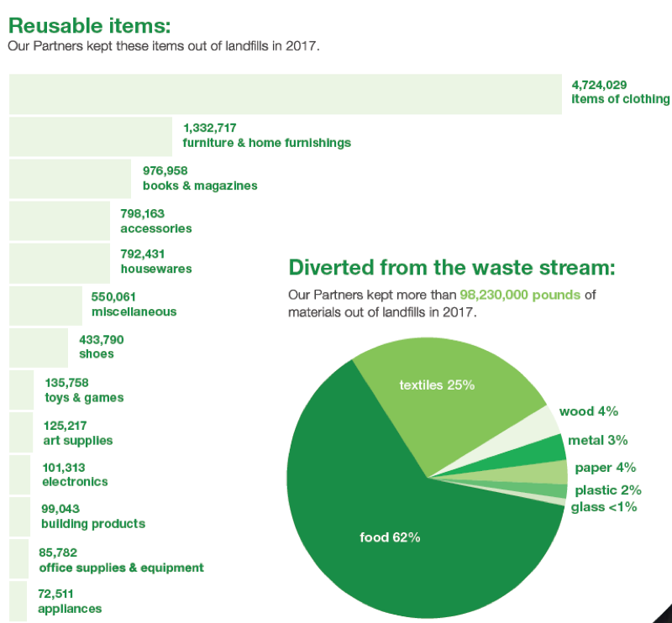

Image Description: Figure 4 shows that donateNYC partners diverted more than 98,230,000 pounds of material from landfills in 2017. Of this amount, 62% was food, 25% was textiles, 4% was paper, 4% was wood, 3% was metal, 2% was plastic, and less than 1% was glass. Excluding food items, the highest numbers of diverted materials from landfill by donateNYC partners were 4,724,029 items of clothing, 1,332,717 furniture and home furnishing items, and 976,958 books and magazines.
In accordance with Local Law 176 of 2017, DSNY added the donateNYC Food Portal (“Food Portal”) to donateNYC in 2018. The Food Portal allows donors to post listings of available food, and an algorithm notifies the nearest registered food businesses and nonprofit organizations that food is available; it is a tool to reduce food waste and support organizations that can use or redistribute the food in their communities. It is unclear, however, how many businesses and organizations participate in the program and how much food has been distributed through connections made via the Food Portal.
Regarding textiles, the refashionNYC program is operated by DSNY in partnership with Housing Works, and offers in-building collection for apartment buildings with 10 or more units. This program allows New Yorkers to donate clothing or other fabric material at participating apartment buildings, businesses, schools, and non-profits that are then regularly collected. As of 2015, refashionNYC served more than 100,000 households in 553 apartment buildings and complexes. It is unclear, however, how many apartment buildings and other institutions currently participate. As of October 2019, refashionNYC had diverted some 9,878 tons from landfill since the 2011 program launch. DSNY also provides residents with information on clothing and textile drop-off locations, textile reuse and swap events, and businesses and organizations that provide mail-back programs.
The City also created ecycleNYC to help facilitate the diversion of e-waste from landfill. Although it contributes less than 1% of the total waste stream, e-waste contains many toxic materials, including mercury, cadmium, lead, and other heavy metals. Recycling e-waste not only keeps these toxins from polluting the air, soil, and water – it also reduces energy and water use associated with manufacturing new materials. In January 2015, a New York State law banning the disposal of e-waste took effect, fully barring the City from collecting these materials as refuse. Under this law, disposing of e-waste improperly can result in a $100 fine.
DSNY’s ecycleNYC program does allow apartment buildings with 10 or more units to sign up for e-waste collection with DSNY. Currently, buildings already part of the ecycleNYC program can make pick-up appointments with DSNY, while buildings interested in enrolling can submit applications. DSNY also launched a pilot program that provided curbside collection of e-waste for disposal in certain neighborhoods. This pilot first launched in Staten Island and expanded to areas of Brooklyn, Queens, and the Bronx in 2017, 2018, and 2019 respectively. Due to the COVID-19 pandemic, the e-waste curbside collection pilot program was suspended in 2020. Currently, only residents in Staten Island can request curbside pickup of their e-waste.
DSNY also hosts Solvents, Automotive, Flammables, and Electronics (“SAFE”) disposal events, held in each borough to give residents an opportunity to drop off electronics and other household hazardous waste, including chemicals and prescription drugs. DSNY normally holds SAFE disposal events in each borough throughout the year, but due to the COVID-19 pandemic, DSNY suspended these events in June 2020. DSNY resumed SAFE disposal events in September 2021. In October 2019, DSNY reported that its SAFE disposal events collected 450 tons of hazardous items such as paint, automotive products, and unwanted medications in that year.
Single-Use Plastics
According to a 2017 study published in the Science Advances journal, as of 2015, of approximately 6,300 Mt of plastic waste that had been generated worldwide, only about 9% was recycled or beneficially reused, 12% was incinerated, and the remaining 79% was either sent to landfill or lost in the natural environment. By 2017, approximately 8,300 million metric tons (“Mt”) of virgin plastics had been produced. It is estimated that if current production and waste management trends continue, roughly 12,000 Mt of plastic waste will be in landfills or in the natural environment by 2050.
Single-use plastics are a class of products that are designed to be discarded immediately after use. This category includes items such as plastic straws, cutlery, disposable cups and plates, plastic food containers, plastic shopping bags, and packaging materials. While some single-use plastics serve vital purposes, such as surgical gloves, packaging that helps keep surgical tools and medical supplies sterile, and straws for people with disabilities, these specific plastics represent a small fraction of the single-use plastics that are manufactured every year. To reduce single-use plastic and paper bag use, New York State has banned plastic bags for use by certain retail establishments, with some exemptions, including plastic bags used for garments, prescriptions, and bulk food items. Local Law 100 of 2019 requires a 5-cent fee on paper bags. Customers using the Supplemental Nutrition Assistance Program or the Special Supplemental Nutrition Program for Women, Infants, and Children are exempt from the 5-cent fee on paper bags.
Bioplastics, or plastics that are manufactured with some proportion of plant-based material, have been touted as a possible solution for reducing the volume of plastic created while preserving the convenience afforded by single-use plastics. Unfortunately, bioplastics are generally more expensive to produce than traditional plastics, can be inferior in terms of strength and other properties, can require specialized facilities to properly recycle, and can present fouling issues when included in more traditional plastic recycling streams. Also, while bioplastics can be composted, doing so requires the use of high-temperature industrial composting facilities.
Another proposed solution to the issue of the increasing amount of plastic waste manufactured every year is chemical recycling, via processes such as pyrolysis and depolymerization. Advocates of chemical recycling state that pyrolysis has the potential to significantly increase recycling rates, due to the process’s ability to utilize mixtures of waste plastics unlike mechanical recycling and its ability to process novel materials, such as bioplastics. Some environmental advocates, however, suggest that chemical recycling, including pyrolysis, is plastic and fossil fuel industries’ attempt to “greenwash” heavily energy-intensive and highly polluting processes by which plastics are turned back into combustible fossil fuels while the remaining highly toxic byproducts are incinerated. A study by the environmental advocacy group Natural Resources Defense Council found that of eight “chemical recycling” plants examined in the United States, most were not recycling any plastic; facilities were generating high levels of hazardous air pollutants and large quantities of hazardous waste; and the facilities tended to be located in communities that were disproportionately comprised of low-income individuals, people of color, or both, presenting significant ethical and environmental justice concerns.
A study published by Pew Trusts in 2020 suggests that significantly addressing the issue of growing plastic waste would require middle- and low-income countries to focus on expanding collection of plastic waste, maximizing reduction and substitution of plastics, making investments in sorting and recycling infrastructure, and pursuing efforts to reduce leakage from waste sites; and high-income countries to focus on incentivizing reductions in plastic usage, boosting recycling rates, the cessation of plastic waste exports, and addressing microplastic leakage.
Extended producer responsibility, a system which requires the manufacturers of products and packaging to be financially responsible for the cost of collecting and recycling the waste they create, has also been touted as a potential solution to the issue of growing plastic waste, as the financial burden of addressing the waste they create would incentivize manufacturers to pursue more environmentally friendly packaging options.
Organics
In August of 2022, Mayor Eric Adams announced the expansion of the City’s curbside organics collection program, stating that beginning on October 3, 2022, all residential buildings in the borough of Queens would automatically receive weekly collection of leaf and yard waste, food scraps, and food-soiled paper products. This expansion marks the first time that an entire borough would receive this service, and would result in the largest municipal organics collection program in the United States. The rationales for selecting Queens as the site of the first borough-wide organics collection program were the diversity of communities and housing stock, the presence of large leaf and yard waste districts in the east and dense multifamily homes in the west, and the concentration of historically underserved neighborhoods that have borne the cost of environmental injustice.

- Legislation
Below is a brief summary of the legislation being heard today by this Committee. This summary is intended for informational purposes only and does not substitute for legal counsel. For more detailed information, review the full text of the bill, which is included below.
Int. No. 494-2022, A Local Law in relation to a study of single-use plastics
Int. No. 494 would require DSNY to conduct a comprehensive study of waste policy initiatives aimed at reducing the sale, distribution, and use of single-use plastic items, including a review of how reduced access to single-use plastic products would affect marginalized communities, an assessment of alternatives to single-use plastic items, and a comprehensive review of the recyclability of single-use plastic items, among other considerations. This local law would also require DSNY to submit a final report of its findings to the Mayor and the Speaker of the City Council by December 1, 2023, including recommendations for legislation or regulatory actions that would achieve the objective of reducing single-use plastics in the City. This local law would take effect immediately.

[This page intentionally left blank]

Int. No. 494

By Council Members Nurse, Joseph, Abreu, Restler, Cabán, Holden, Bottcher, De La Rosa, Sanchez, Stevens, Richardson Jordan, Dinowitz, Menin, Won, Powers, Marte, Hudson, Barron, Louis, Gennaro, Ossé, Schulman, Avilés, Ayala, Ung, Riley, Salamanca, Velázquez, Brooks-Powers and Rivera (by request of the Manhattan Borough President)

A Local Law in relation to a study of single-use plastics

Be it enacted by the Council as follows:

Section 1. As used in this local law, the following terms have the following meanings:
Plastic. The term “plastic” means a synthetic material made from organic polymers, including, but not limited to, polypropylene and polystyrene, that can be molded into shape while soft, and then set into a rigid or slightly elastic form.
Single-use. The term “single-use” means a product that is designed and intended to be used only once for drinking, eating, or packaging retail goods for sale or delivery; and is generally recognized by the public as an item that is to be discarded after one use.
§ 2. Single-use plastics study. 1. The department of sanitation shall, in consultation with the department of consumer and worker protection, the department of health and mental hygiene, the department of environmental protection, the department of small business services and the mayor's office for people with disabilities, conduct a comprehensive study of new waste policy initiatives that would reduce the sale, distribution and use of single-use plastic items and advance environmental justice in the city in such sale, distribution and use. In conducting the study, the department of sanitation, at a minimum, shall:
(a) Conduct a thorough review of the research and literature on reducing single-use plastic items and on the impact of such items on marginalized communities;
(b) Review laws or regulations in other jurisdictions aimed at reducing consumer reliance on single-use plastic items and on advancing environmental justice through the reduction of such items, including any effectiveness data and reports available that review the implementation of such laws or regulations;
(c) Conduct interviews of scientists, experts, government officials and representatives of not-for-profit organizations, including environmental justice organizations, with relevant expertise;
(d) Assess the alternatives to single-use plastic items, including availability, cost and whether such alternatives are compatible with the overall goal of waste reduction, the city’s existing recycling and composting programs and with advancing environmental justice in the city;
(e) Conduct a comprehensive review of the recyclability of single-use plastic items, whether through use of city-operated recycling facilities or facilities operated by other entities, and identify categories of single-use plastics that should be prioritized for reduction. As part of this review, the department shall examine the market demand for post-consumer recycled materials and identify opportunities for increasing such market demand;
(f) Consult with representatives of affected groups including, but not limited to, consumers, including people with disabilities and people especially impacted by environmental and health hazards resulting from the use and disposal of single-use plastic items in the city, business owners, trade associations and labor unions; and
(g) Retain any experts such department may require to carry out the study.
§ 3. The department of sanitation shall on December 1, 2023 submit a final report of its findings to the mayor and the speaker of the council. The report shall include recommendations for legislation or regulatory actions that would achieve the objective of reducing single-use plastics in the city and advancing environmental justice through such reduction.
§ 4. This local law takes effect immediately and remains in effect until the department of sanitation has submitted to the mayor and the speaker of the council the report required by section 3 of this local law.

Session 12
SJ
LS #1283
LS #8872
5/26/22 5:28 PM

Session 11
AEM/NKA/BAM
LS # 7044
Proposed Int. 1407-A

New York City Department of Sanitation, “2017 NYC Residential, School, and NYCHA Waste Characterization Study,” (March 2018) http://dsny.wpengine.com/wp-content/uploads/2018/04/2017-Waste-Characterization-Study.pdf
Local Law 40 of 2010; Admin Code § 16-316.1(b).
New York City Department of Sanitation, "2017 NYC Residential, School, and NYCHA Waste Characterization Study," (March 2018) http://dsny.wpengine.com/wp-content/uploads/2018/04/2017-Waste-Characterization-Study.pdf
Id.
Id.
Id.
Id.
Id.
Id.
Id.
Id.
Id.
Id. at 47
Id. at 11, 40, and 47
New York City, N.Y., Code § 16-305 Recycling of department-managed solid waste
New York City, N.Y., Code § 16-305 Recycling of department-managed solid waste
DSNY Collections FY20 https://dsny.cityofnewyork.us/wp-content/uploads/2020/09/about_dsny-non-dsny-collections-FY2020.pdf
DSNY Collections FY21 https://dsny.cityofnewyork.us/wp-content/uploads/2021/04/about_dsny_collections_FYTD-feb2021.pdf
C40 Cities, “Advancing Towards Zero Waste Declaration,” available at https://www.c40.org/other/zero-waste-declaration (last visited Feb. 27, 2019). (Signatories: San Francisco, Auckland, Boston, Copenhagen, Dubai, London, Los Angeles, Melbourne, Milan, Montreal, New York City, Paris, Philadelphia, Portland, Rotterdam, Stockholm, Sydney, Tel Aviv, Tokyo, Toronto, Vancouver, Washington D.C, Catalonia, Navarra, Newburyport, San Jose, Santa Monica, Wales).
One New York: The Plan for a Strong and Just City (April 2015) at 176, available at http://www.nyc.gov/html/onenyc/downloads/pdf/publications/OneNYC.pdf
Id.
Id. at 176-87
New York City Department of Sanitation, "2017 NYC Residential, School, and NYCHA Waste Characterization Study," (March 2018) http://dsny.wpengine.com/wp-content/uploads/2018/04/2017-Waste-Characterization-Study.pdf
New York City Department of Sanitation, "donateNYC" https://www1.nyc.gov/assets/donate/about/donatenyc.shtml (last accessed on April 17, 2021)
New York City Department of Sanitation, "2017-18 donateNYC Partnership Report" https://www1.nyc.gov/assets/donate/docs/2018%20Annual%20Report-single-page-view-FINAL-reduced.pdf
Id. at 5
Local Law 176 of 2017, https://legistar.council.nyc.gov/LegislationDetail.aspx?ID=2984602&GUID=5268FF91-55DD-4407-BF0A-53B7E330EF3E&Options=&Search=
New York City Department of Sanitation. “DonateNYC: Donate Food for businesses and nonprofits.” https://www1.nyc.gov/assets/donate/site/DonateFood/About (last accessed April 12, 2021).
See New York City Department of Sanitation, "2019 Annual Report" https://dsny.cityofnewyork.us/wp-content/uploads/2019/10/2019_Annual_Report_Final-1.pdf at 12.
"OneNYC: The Plan for a Strong and Just City" at 184, https://onenyc.cityofnewyork.us/wp-content/uploads/2018/04/OneNYC-1.pdf
New York City Department of Sanitation “Donate Goods” https://www1.nyc.gov/assets/dsny/site/services/donate-goods (last accessed on April 14, 2021)
"OneNYC: The Plan for a Strong and Just City" at 184, https://onenyc.cityofnewyork.us/wp-content/uploads/2018/04/OneNYC-1.pdf
New York City Department of Sanitation, "2019 Annual Report" https://dsny.cityofnewyork.us/wp-content/uploads/2019/10/2019_Annual_Report_Final-1.pdf
New York City Department of Sanitation “Donate Goods” https://www1.nyc.gov/assets/dsny/site/services/donate-goods/textiles (last accessed on April 14, 2021)
"OneNYC: The Plan for a Strong and Just City" at 184, https://onenyc.cityofnewyork.us/wp-content/uploads/2018/04/OneNYC-1.pdf
Id.
Id.
New York City Department of Sanitation “Guidelines for Electronics Disposal” https://www1.nyc.gov/assets/dsny/site/services/electronics/overview-electronics-guidelines (last accessed on April 14, 2021)
New York City Department of Sanitation “Overview of ecycleNYC” https://www1.nyc.gov/assets/dsny/site/services/electronics/overview-electronics-ecycle (last accessed on April 14, 2021)
Id.
OneNYC Progress Report 2018 at 67, https://onenyc.cityofnewyork.us/wp-content/uploads/2018/05/OneNYC_Progress_2018.pdf; New York City Department of Sanitation, "2019 Annual Report" at 16 https://dsny.cityofnewyork.us/wp-content/uploads/2019/10/2019_Annual_Report_Final-1.pdf.
New York City Council, Department of Sanitation Fiscal 2021 Executive Budget Fact Sheet, (May 2020), available at https://legistar.council.nyc.gov/LegislationDetail.aspx?ID=4429900&GUID=99F493D9-E2E7-4EE1-AD34-5D7CC6334204&Options=&Search=
DSNY, Electronics, Batteries, and Textiles Pickup Request, https://www1.nyc.gov/assets/dsny/site/contact/e-waste-pickup-request#:~:text=DSNY%20%2D%20E%2DWaste%20Pickup%20Request&text=DSNY%20is%20making%20it%20easy,up%20directly%20from%20their%20homes
"OneNYC: The Plan for a Strong and Just City" at 184, https://onenyc.cityofnewyork.us/wp-content/uploads/2018/04/OneNYC-1.pdf
New York City Department of Sanitation,, SAFE Disposal Events, available at https://www1.nyc.gov/assets/dsny/site/services/harmful-products/safe-disposal
NYC Department of Sanitation (DSNY) – COVID-19 Updates, available at https://www.brooklyncb5.org/news-listing/nyc-department-of-sanitation-dsny-covid-19-updates/
New York City Department of Sanitation, SAFE Disposal Events, available at https://www1.nyc.gov/assets/dsny/site/services/harmful-products/safe-disposal.
New York City Department of Sanitation, "2019 Annual Report" at 16 https://dsny.cityofnewyork.us/wp-content/uploads/2019/10/2019_Annual_Report_Final-1.pdf
Geyer et al. Production, use, and fate of all plastics ever made. Science Advances. July, 2017. https://www.science.org/doi/10.1126/sciadv.1700782?cookieSet=1
Id.
Id.
Courtney Lindwall. Single Use Plastics 101. NRDC. https://www.nrdc.org/stories/single-use-plastics-101
Id.
According to New York State Environmental Conservation Law, Article 27, Title 28, Section 27-2801, "Exempt bag" means a bag: (a) used solely to contain or wrap uncooked meat, fish, or poultry; (b) bags used by a customer solely to package bulk items such as fruits, vegetables, grains, or candy; (c) bags used solely to contain food sliced or prepared to order; (d) bags used solely to contain a newspaper for delivery to a subscriber; (e) bags sold in bulk to a consumer at the point of sale; (f) trash bags; (g) food storage bags; (h) garment bags; (i) bags prepackaged for sale to a customer; (j) plastic carryout bags provided by a restaurant, tavern or similar food service establishment, as defined in the state sanitary code, to carryout or deliver food; or (k) bags provided by a pharmacy to carry prescription drugs.
New York State Legislature. Bag Waste Reduction Law. Chapter 43-B, Article 27, Title 28. https://www.nysenate.gov/legislation/laws/ENV/A27T28; and New York City Council. Local Law 100 of 2019 https://legistar.council.nyc.gov/LegislationDetail.aspx?ID=3917691&GUID=CEACB88C-E6E9-4CB4-A7EF-0772C7972008&Options=&Search=
Id.
Jim Robbins. Why Bioplastics Will Not Solve the World’s Plastic Problem. Augist 31, 2020. Yale 360. https://e360.yale.edu/features/why-bioplastics-will-not-solve-the-worlds-plastics-problem
Id.
Id.
Qureshi et al. Pyrolysis of plastic waste: Opportunities and challenges. Journal of Analytical and Applied Pyrolysis. November 2020. https://www.sciencedirect.com/science/article/abs/pii/S0165237019308241. Pyrolysis is the chemical decomposition of material by heating it to a high temperature in a nonreactive atmosphere. Pyrolysis. Encyclopedia of Forensic Sciences (2d Edition) 2013. https://www.sciencedirect.com/topics/biochemistry-genetics-and-molecular-biology/pyrolysis
Depolymerization is a process that converts polymers, or macromolecules, into component monomers, or smaller molecules. Depolymerization. Coal and Coalbed Gas 2014. https://www.sciencedirect.com/topics/earth-and-planetary-sciences/depolymerization
Id.
Veena Singla. Chemical Recycling of Plastic: A Burning Issue. NRDC. March, 2022. https://www.nrdc.org/experts/veena-singla/chemical-recycling-plastic-burning-issue
Veena Singla. Recycling Lies: Chemical Recycling of Plastic is Just Greenwashing Incineration. NRDC. September, 2022. https://www.nrdc.org/resources/recycling-lies-chemical-recycling-plastic-just-greenwashing-incineration
Breaking the Plastic Wave: A comprehensive assessment of pathways towards reducing ocean plastic pollution. Page 10. Pew Charitable Trusts. July 2020. https://www.pewtrusts.org/-/media/assets/2020/07/breakingtheplasticwave_summary.pdf
Id.
New York City Office of the Mayor. Mayor Adams Announces NYC to Soon be Home to Largest Composting Program in Nation, Providing Every Household in Queens With Weekly Curbside Composting https://www1.nyc.gov/office-of-the-mayor/news/578-22/mayor-adams-nyc-soon-be-home-largest-composting-program-nation-providing-every#/0
Id.
Id.

