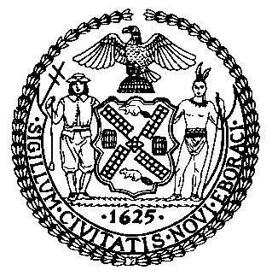 | The Council of the City of New York  Finance Division  Tanisha Edwards, Esq., Chief Financial Officer and Deputy Chief of Staff to the Speaker  Fiscal Impact Statement  Proposed Int. No:173-A  Committee: Parks and Recreation
Title: A Local Law to amend the administrative code of the city of New York, in relation to reporting on park and playground inspections conducted by the department of parks and recreation | Sponsor(s): By Council Members Krishnan, Cabán, Stevens, Hanif, Brewer, Narcisse, Won, Restler, Marte, Hudson, Menin, Nurse, Farías and Yeger

Summary of Legislation: Proposed Int. No. 173-A would require the Department of Parks and Recreation (DPR) to issue a report to the Mayor and the Council that would identify parks and playgrounds under its jurisdiction that have routinely failed DPR inspections and submit a plan to the Council on how the issues at such parks and playgrounds will be corrected.

Effective Date: This local law would take effect 90 days after it becomes law.

Fiscal Year In Which Full Fiscal Impact Anticipated: Fiscal 2024.

Fiscal Impact Statement:

 | Effective FY23 | FY Succeeding  Effective FY24 | Full Fiscal  Impact FY24
Revenues | $0 | $0 | $0
Expenditures | $0 | $0 | $0
Net | $0 | $0 | $0

Impact on Revenues: It is estimated that there would be no impact on revenues resulting from the enactment of this legislation.

Impact on Expenditures: It is anticipated that there would be no impact on expenditures resulting from the enactment of this legislation because DPR would utilize existing resources to implement the provisions of this local law.

Source of Funds To Cover Estimated Costs: N/A

Source of Information: New York City Council Finance Division
Mayor’s Office of Legislative Affairs

Estimate Prepared By: Chima Obichere, Unit Head

Estimate Reviewed By: Eisha Wright, Deputy Director
Malcom Butehorn, Counsel

Legislative History: This legislation was introduced to the full Council on April 14, 2022 as Intro. No. 173 and was referred to the Committee on Parks and Recreation (the Committee). A hearing was held by the Committee on April 22, 2022 and the bill was laid over. The legislation was subsequently amended, and the amended version, Proposed Int. No. 173-A, will be considered by the Committee on May 4, 2022. Following a successful Committee vote, Proposed Int. No. 173-A will be submitted to the full Council for a vote on May 5, 2022.

Date Prepared: May 3, 20222019.

