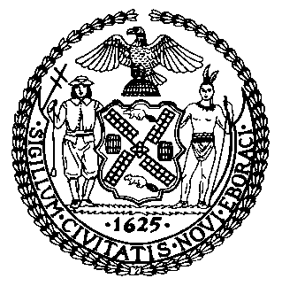 | The Council of the City of New York  Finance Division  Latonia Mckinney, Director  Fiscal Impact Statement  Proposed Int. No. 1451-A  Committee: Cultural Affairs
Title: A Local Law in relation to the creation of a task force regarding a museum about New York city’s African-American civil rights history | Sponsors: By Council Members Cabrera, Holden, Van Bramer, Cornegy, Rosenthal, Powers, Cumbo, Miller, Ampry-Samuel, Rose, Grodenchik, Reynoso, Richards, Kallos, Louis, Chin, Gibson and Ulrich
Summary of Legislation: Proposed Int. No. 1451-A would create a task force of 11 members on a museum about New York city’s African-American civil rights history. The bill would require the task force to consider a plan related to the feasibility of establishing a museum about New York city’s African-American civil rights history, potential sites for the museum, resources that would be necessary for the museum to provide outreach to the five boroughs, the level of coordination among appropriate stakeholders that would be necessary for the implementation and operation of a museum about New York city’s African-American civil rights history and any other considerations deemed necessary by the task force to be relevant to develop the required report. No later than March 1, 2021, the task force would be required to submit and post online a report that contains its findings, conclusions and any recommendations related to establishing such a museum, as well as any minutes of task force meetings. The bill would require the task force to dissolve upon submission of the required report.

Effective Date: This local law would take effect immediately and would be deemed repealed upon the task force issuing the required report.
Fiscal Year In Which Full Fiscal Impact Anticipated: Fiscal 2021
Fiscal Impact Statement:

 | Effective FY20 | FY Succeeding  Effective FY21 | Full Fiscal  Impact FY21
Revenues (+) | $0 | $0 | $0
Expenditures (-) | $0 | $0 | $0
Net | $0 | $0 | $0

Impact on Revenues: It is anticipated that there would be no impact on revenues resulting from the enactment of this legislation.
Impact on Expenditures: It is estimated that there would be no fiscal impact on expenditures as each member of the task force would serve without compensation and would together compile the findings and conclusions for the required report.
Source of Funds To Cover Estimated Costs: N/A
Source of Information: New York City Council Finance Division
Mayor’s Office of Legislative Affairs
Estimate Prepared by: Aliya Ali, Principal Financial Analyst

Estimate Reviewed by: Stephanie Ruiz, Assistant Counsel
Nathan Toth, Deputy Director
Crilhien Francisco, Unit Head
Legislative History: This legislation was introduced to the Council on February 28, 2019 as Int. No. 1451, and was referred to the Committee on Cultural Affairs (Committee). A hearing was held by the Committee on October 31 2019, and the legislation was laid over. The legislation was subsequently amended and the amended version, Proposed Int. No. 1451-A, will be voted on by the Committee at a hearing on February 24, 2020. Upon successful vote by the Committee, Proposed Int. No. 1451-A will be submitted to the full Council for a vote on February 27, 2020.
Date Prepared: February 20, 2020

