THE COUNCIL OF THE CITY OF NEW YORK
RESOLUTION NO. 1132

Resolution approving with modifications the decision of the City Planning Commission on Application No. N 190151 ZRQ, for an amendment of the text of the Zoning Resolution (L.U. No. 532).

By Council Members Salamanca and Moya

WHEREAS, Cipico Construction, Inc., filed an application pursuant to Section 201 of the New York City Charter, for an amendment of the text of the Zoning Resolution of the City of New York, modifying Appendix F for the purpose of establishing a Mandatory Inclusionary Housing area, which in conjunction with the related actions would facilitate a proposed large-scale general development on a full block bounded by Vernon Boulevard and Broadway to the north, 11th Street to the east, 33rd Road to the south and 10th Street to the west in Astoria, Queens Community District 1 (Application No. N 190151 ZRQ), (the “Application”);

WHEREAS, the City Planning Commission filed with the Council on September 13, 2019 its decision dated September 11, 2019 (the “Decision”), on the Application;

WHEREAS, the Application is related to applications C 100421 ZMQ (L.U. No. 531), a zoning map amendment changing from an R5 District to an R6B District and an R7X/C1-3 District and C 190386 ZSQ (L.U. No. 533), a special permit pursuant to Section 74-743 of the Zoning Resolution, to permit the distribution of total allowable floor area without regard for zoning lot lines and to modify the minimum base height requirements of Section 23-664;

WHEREAS, the Decision is subject to review and action by the Council pursuant to Section 197-d of the City Charter;

WHEREAS, upon due notice, the Council held a public hearing on the Decision and Application on September 18, 2019;

WHEREAS, the Council has considered the land use implications and other policy issues relating to the Decision and Application; and

WHEREAS, the Council has considered the relevant environmental issues, including the negative declaration issued April 22nd, 2019 (CEQR No. 12DCP139Q), which includes an (E) designation to avoid the potential for significant adverse impacts related to air quality, noise, and hazardous materials (E-518) (the “Negative Declaration”).

RESOLVED:

The Council finds that the action described herein will have no significant impact on the environment as set forth in the (E) Designation (E-518) and Negative Declaration.

Pursuant to Section 200 of the City Charter and on the basis of the Decision and Application, and based on the environmental determination and consideration described in the report, N 190151 ZRQ, incorporated by reference herein, and the record before the Council, the Council approves the Decision of the City Planning Commission with the following modifications:

* * *
Matter underlined is new, to be added;
Matter struck out is to be deleted;
Matter within # # is defined in Section 12-10;
Matter double struck out is old, deleted by the City Council;
Matter double-underlined is new, added by the City Council
* * * indicates where unchanged text appears in the Zoning Resolution.

* * *

APPENDIX F
Inclusionary Housing Designated Areas and Mandatory Inclusionary Housing Areas

* * *

QUEENS

* * *
Queens Community District 1

Map 1- (10/31/18) [date of adoption]

[PROPOSED MAP]

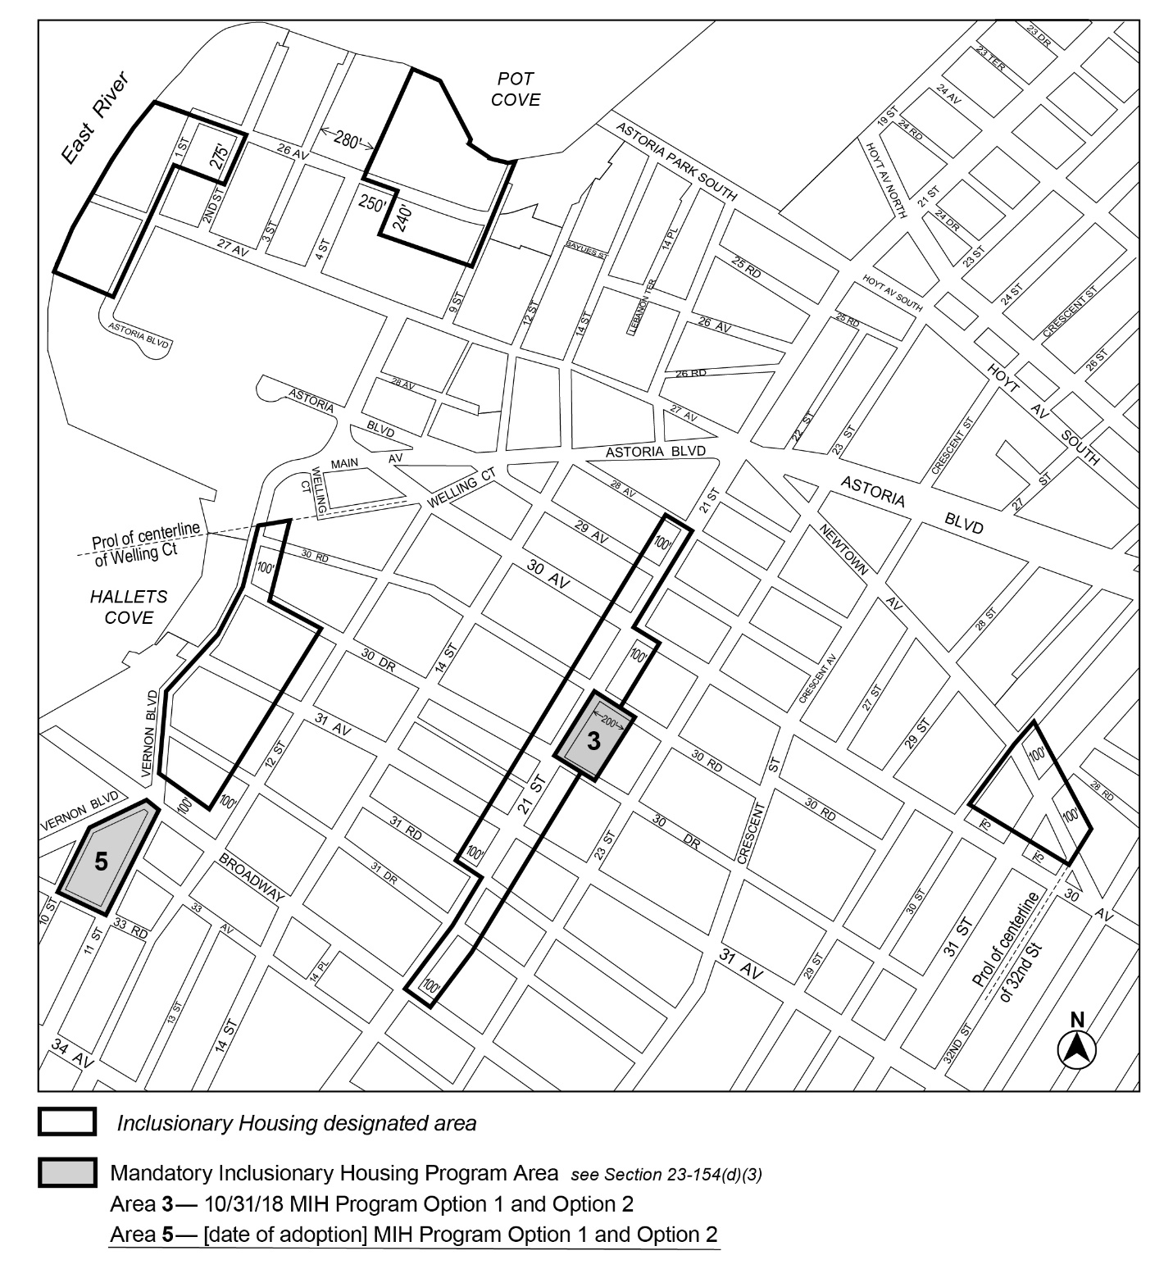
Area 5 – [date of adoption] – MIH Program Option 1 and Option 2

Portion of Community District 1, Queens

* * *

Adopted.

Office of the City Clerk, }
The City of New York, } ss.:

I hereby certify that the foregoing is a true copy of a Resolution passed by The Council of The City of New York on October 17, 2019, on file in this office.

.....................................................
City Clerk, Clerk of The Council

